JSS SCIENCE & TECHNOLOGY UNIVERSITY (SJCE)
MYSORE–570006
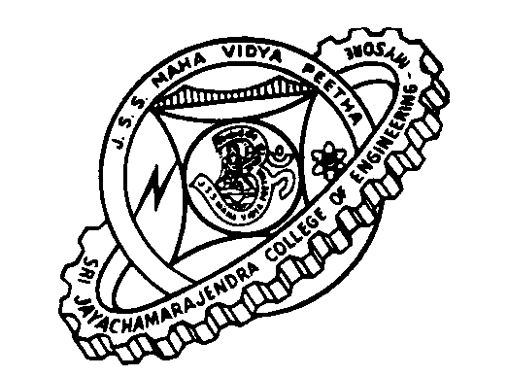
Date: 26.09.2016
BE SECOND TEST TIME-TABLE

 |  | 7:30 | 8:45 | 10:00 | 11:15 | 12:30 | 1:45 | 3:00 | 4:15
6/10/2016  Thursday | I |  | MA110 |  |  |  | CH110  PH110
6/10/2016  Thursday | III |  |  | MA310 |  |  |  | IS310
6/10/2016  Thursday | V |  |  |  | IS510 |  |  |  | IS520
6/10/2016  Thursday | VII | IS710 |  |  |  | IS720
7/10/2016  Friday | I |  | EC110  CV110 |  |  |  | CS110  EE110
7/10/2016  Friday | III |  |  | IS320 |  |  |  | IS330
7/10/2016  Friday | V |  |  |  | IS530 |  |  |  | IS540
7/10/2016  Friday | VII | IS730 |  |  |  | IS743
8/10/2016  Saturday | I |  | ME110 |  |  |  | HU110  HU120
8/10/2016  Saturday | III |  |  | IS340 |  |  |  | IS350
8/10/2016  Saturday | V |  |  |  | IS550 |  |  |  | IS562/3
8/10/2016  Saturday | VII | IS751

ROOMNUMBERS
I SEMESTER |  |  |  | III /V/VII SEMESTERS
A | NPS001, NPS002 | H | EV107, EV108 | CSE‘A’ | CS001, CS002 | CV | EV104, EV105
B | PS201,  PS202 | I | EV109,  EV110 | CSE‘B’ | CS101,  CS102 | CTM | EV202,  EV203
C | PS005, PS006 | J | EV005, EV006 | EC‘A’ | EV107, EV108 | ENV | EV005, EV006
D | PS203,  PS204 | K | EV104,  EV105 | EC‘B’ | EV109,  EV110 | IP | IP109,  IP110
E | PS205, PS206 | L | IP109, IP110 | EE | NPS001, NPS002 | ME | ME201, ME202
F | NPSD1/D2 | M | EV202,  EV203 | ISE | IS001,  IS002 | PST | PS005,  PS006
G | PS208A1,  PS208A2 | N | EV204,  EV205 | IT | IT201,  IT203 | BT | EV204,  EV205
 |  | O | PS106A1,  PS106A2

PRINCIPAL

