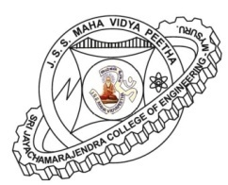

JSS Mahavidyapeetha
Sri Jayachamarajendra college of Engineering, JSS TI Campus, Mysuru – 570 006
DEPARTMENT OF CONSTRUCTION TECHNOLOGY AND MANAGEMENT

Cordially Invite you to the
Inauguration

Of

A NATIONAL LEVEL TECHNICAL SYMPOSIUM 2017

Inauguration
Dr. K. Prakash
Professor and Head, Dept. of Civil Engineering,
SJCE, Mysuru

Chief Guest
Er. R. Vedhachalam
Technical adviser, HBK Holding State of Qatar

Presided by
Dr. T. N. Nagabhushan
Principal, SJCE, Mysuru

Prof. Sunil Kumar M. S & Prof. Thanu H.P  Assistant Professors, CT&M | Dr. G. P. Chandradhara  HOD, CT&M

Date : 17th April, 2017 (Monday)
Time : 10.00 am
Venue : IS/CS Seminar Hall, Golden Jubilee Block, SJCE, Mysuru.

