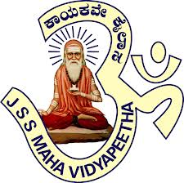
JSS Mahavidyapeetha
Sri Jayachamarajendra College of Engineering
JSS STU Mysuru

9th October 2017

To the attention of Engineering Students

JSS Centre for Management Studies (JSS CMS) has organized an Introductory Talk on forming a Toastmasters Club at SJCE Campus. The regional representatives of the club will address the students on forming the club at SJCE Campus.

DATE: 14th October 2017, Saturday
Time : 2.15 PM to 3.15 PM
Venue: Seminar Hall, JSS CMS

Interested students may attend the Introductory Talk by registering their name.
For registration contact: Steve-9916387087, Ponnanna-7899501010, Sowmya- 8553817487

ABOUT-TOASTMASTERS

Toastmasters International is a world leader in communication and leadership development. The organization has more than 345,000 memberships, of the 15,900 clubs in 142 countries. Since 1924, Toastmasters International has helped people from diverse backgrounds become more confident speakers, communicators and leaders.
Every Toastmasters club meets on a regular basis, at least 12 times a year. Each club meets for between one and two hours, having a structured format, with various members participating in the different roles in the meetings. These communication and leadership projects and roles are designed to help people learn the arts of speaking, listening, and thinking.
Nearly one-third of all Fortune 500 companies now offer in-house Toastmasters clubs to help employees become better communicators and leaders (Apple, AT&T, Bank of America, The Coca-Cola Company, Exxon Mobil, Google, Microsoft and The Walt Disney Company)

