ELEMENTS OF PRODUCTION ENGINEERING – I (IP340) 3RD SEM.
DEPT. OF I&PE, S.J.C.E. MYS DK

WELDING PROCESS

Introduction (https://www.youtube.com/watch?v=4iPF0pMjKjA)
Welding which is the process of joining two metallic components for the desired purpose, can be defined as the process of joining two similar or dissimilar metallic components with the application of heat, with or without the application of pressure and with or without the use of filler metal.
Heat may be obtained by chemical reaction, electric arc, electrical resistance, frictional heat, sound and light energy. If no filter metal is used during welding then it is termed as ‘Autogenous Welding Process'. During ‘Bronze Age' parts were joined by forge welding to produce tools, weapons and ornaments etc, however, present day welding processes have been developed within a period of about a century. First application of welding with carbon electrode was developed in 1885 while metal arc welding with bare electrode was patented in 1890. However, these developments were more of experimental value and applicable only for repair welding but proved to be the important base for present day manual metal arc (MMAW) welding and other arc welding processes.
In the meantime resistance butt welding was invented in USA in the year 1886. Other resistance welding processes such as spot and flash welding with manual application of load were developed around 1905. With the production of cheap oxygen in 1902, oxy – acetylene welding became feasible in Europe in 1903. When the coated electrodes were developed in 1907, the manual metal arc welding process become viable for production/fabrication of components and assemblies in the industries on large scale.

Subsequently other developments are as follows:
• Thermite Welding (1903)
• Cellulosic Electrodes (1918)
• Arc Stud Welding (1918)
• Seam Welding of Tubes (1922)
• Mechanical Flash Welder for Joining Rails (1924)
• Extruded Coating for MMAW Electrodes (1926)
• Submerged Arc Welding (1935)
• Air Arc Gouging (1939)
• Inert Gas Tungsten Arc (TIG) Welding (1941)
• Iron Powder Electrodes with High Recovery (1944)
• Inert Gas Metal Arc (MIG) Welding (1948)
• Electro Slag Welding (1951)
• Flux Cored Wire with CO 2 Shielding (1954)
• Electron Beam Welding (1954)
• Constricted Arc (Plasma) for Cutting (1955)
• Friction Welding (1956)
• Plasma Arc Welding (1957)
• Electro Gas Welding (1957)
• Short Circuit Transfer for Low Current, Low Voltage Welding with CO 2 Shielding (1957) • Vacuum Diffusion Welding (1959)
• Explosive Welding (1960)
• Laser Beam Welding (1961)
• High Power CO₂ Laser Beam Welding (1964) all welded ‘Liberty ' ships failure in 1942, gave a big jolt to application of welding. However, it had drawn attention to fracture problem in welded structures.
Applications:
Although most of the welding processes at the time of their developments could not get their place in the production except for repair welding, however, at the later stage these found proper place in manufacturing/production. Presently welding is widely being used in fabrication of pressure vessels, bridges, building structures, aircraft and space crafts, railway coaches and general applications. It is also being used in shipbuilding, automobile, electrical, electronic and defense industries, laying of pipe lines and railway tracks and nuclear installations etc.
General Applications: Welding is vastly being used for construction of transport tankers for transporting oil, water, milk and fabrication of welded tubes and pipes, chains, LPG cylinders and other items. Steel furniture, gates, doors and door frames, body and other parts of white goods items such as refrigerators, washing machines, microwave ovens and many other items of general applications are fabricated by welding.
Pressure Vessels: One of the first major use of welding was in the fabrication of pressure vessels. Welding made considerable increases in the operating temperatures and pressures possible as compared to riveted pressure vessels.
Bridges: Early use of welding in bridge construction took place in Australia. This was due to problems in transporting complete riveted spans or heavy riveting machines necessary for fabrication on site to remote areas. The first all welded bridge was erected in UK in 1934. Since then all welded bridges are erected very commonly and successfully.
Ship Building: Ships were produced earlier by riveting. Over ten million rivets were used in ‘Queen Mary' ship which required skills and massive organization for riveting but welding would have allowed the semiskilled/ unskilled labour and the principle of prefabrication. Welding found its place in ship building around 1920 and presently all welded ships are widely used. Similarly submarines are also produced by welding.
Building Structures: Arc welding is used for construction of steel building leading to considerable savings in steel and money. In addition to building, huge structures such as steel towers etc also require welding for fabrication.
Aircraft and Spacecraft: Similar to ships, aircrafts were produced by riveting in early days but with the introduction of jet engines welding is widely used for aircraft structure and for joining of skin sheet to body. Space vehicles which have to encounter frictional heat as well as low temperatures require outer skin and other parts of special materials. These materials are welded with full success achieving safety and reliability.
Railways: Railways use welding extensively for fabrication of coaches and wagons, wheel tyres laying of new railway tracks by mobile flash butt welding machines and repair of cracked/damaged tracks by Thermit welding.
Automobiles: Production of automobile components like chassis, body and its structure, fuel tanks and joining of door hinges require welding.
Electrical Industry: Starting from generation to distribution and utilization of electrical energy, welding plays important role. Components of both hydro and steam power generation system, such as penstocks, water control gates, condensers, electrical transmission towers and distribution system equipment are fabricated by welding. Turbine blades and cooling fins are also joined by welding.
Electronic Industry: Electronic industry uses welding to limited extent such as for joining leads of special transistors but other joining processes such as brazing and soldering are widely being used. Soldering is used for joining electronic components to printed circuit boards. Robotic soldering is very common for joining of parts to printed circuit boards of computers, television, communication equipment and other control equipment etc.
Nuclear Installations: Spheres for nuclear reactor, pipe line bends joining two pipes carrying heavy water and other components require welding for safe and reliable operations.
Defence Industry: Defence industry requires welding for joining of many components of war equipment. Tank bodies fabrication, joining of turret mounting to main body of tanks are typical examples of applications of welding.
MicroJoining: It employs the processes such as microplasma, ultrasonic, laser and electron beam welding, for joining of thin wire to wire, foil to foil and foil to wire, such as producing junctions of thermocouples, strain gauges to wire leads etc. Apart from above applications welding is also used for joining of pipes, during laying of crude oil and gas pipelines, construction of tankers for their storage and transportation. Offshore structures, dockyards, loading and unloading cranes are also produced by welding.

Classification of Welding Processes: Welding processes can be classified based on following criteria; 1. Welding with or without filler material.
2. Source of energy of welding.
3. Arc and Nonarc welding.
4. Fusion and Pressure welding.
1. Welding can be carried out with or without the application of filler material. Earlier only gas welding was the fusion process in which joining could be achieved with or without filler material. When welding was done without filler material it was called ‘autogenous welding'. However, with the development of TIG, electron beam and other welding processes such classification created confusion as many processes shall be falling in both the categories.
2. Various sources of energies are used such as chemical, electrical, light, sound, mechanical energies, but except for chemical energy all other forms of energies are generated from electrical energy for welding. So this criterion does not justify proper classification.
3. Arc and Nonarc welding processes classification embraces all the arc welding processes in one class and all other processes in other class. In such classification it is difficult to assign either of the class to processes such as electro slag welding and flash butt welding, as in electro slag welding the process starts with arcing and with the melting of sufficient flux the arc extinguishes while in flash butt welding tiny arcs i.e. sparks are established during the process and then components are pressed against each other. Therefore, such classification is also not perfect.
4. Fusion welding and pressure welding is most widely used classification as it covers all processes in both the categories irrespective of heat source and welding with or without filler material. In fusion welding all those processes are included where molten metal solidifies freely while in pressure welding molten metal if any is retained in confined space under pressure (as may be in case of resistance spot welding or arc stud welding) solidifies under pressure or semisolid metal cools under pressure. This type of classification poses no problems so it is considered as the best criterion. Processes falling under the categories of fusion and pressure welding are shown in Figures 2.1 and 2.2.

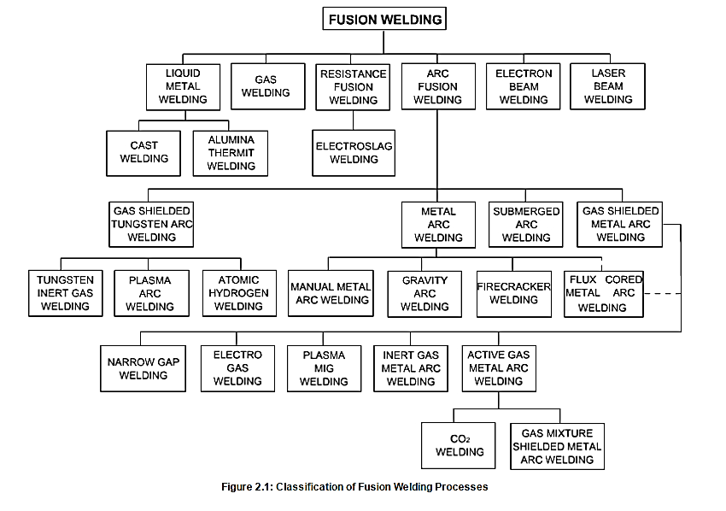

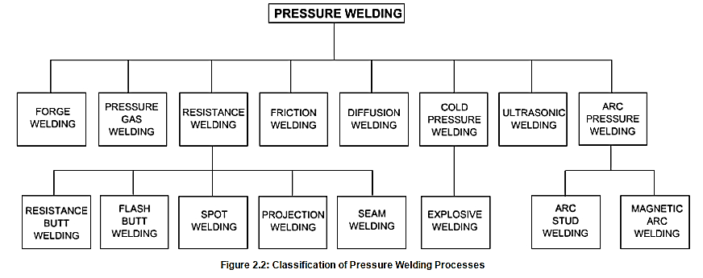

Manual Metal Arc Welding:

Manual metal arc welding (MMAW) or shielded metal arc welding (SMAW) is the oldest and most widely used process being used for fabrication. The arc is struck between a flux covered stick electrode and the work pieces. The work pieces are made part of an electric circuit, known as welding circuit. It includes welding power source, welding cables, electrode holder, earth clamp and the consumable coated electrode. Figure Shows details of welding circuit.
Fig 5.1: Manual Metal Arc Welding Circuit

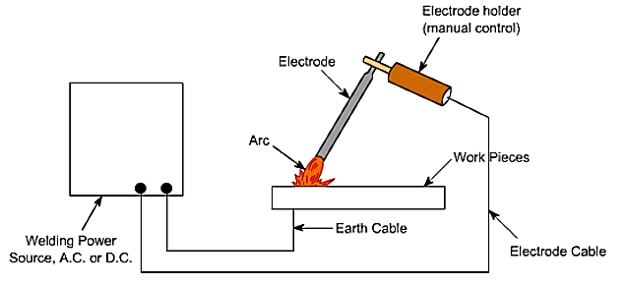
Fig: Manual Metal Arc Welding Circuit

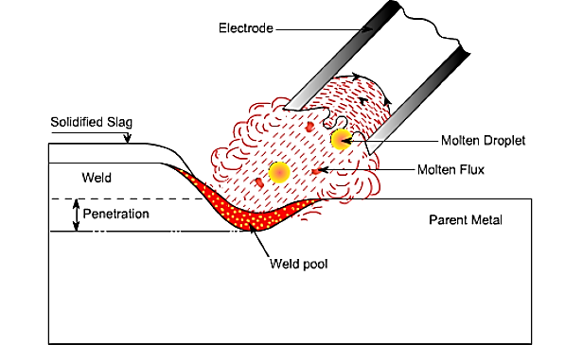
Fig: Molten Metal and Flux Transfer to Weld Pool

Figure 5.2 shows the fine molten droplets of metal and molten flux coming from the tip of the coated electrode. The flux melts along with the metallic core wire and goes to weld pool where it reacts with molten metal forming slag which floats on the top of molten weld pool and solidifies after solidification of molten metal and can be removed by chipping and brushing. Welding power sources used may be transformer or rectifier for AC or DC supply. The requirement depends on the type of electrode coating and sometimes on the material to be welded. The constant current or drooping type of power source is preferred for manual metal arc welding since it is difficult to hold a constant arc length. The changing arc length causes arc voltage to increase or decrease, which in turn produces a change in welding current. The steeper the slope of the volt-ampere curve within the welding range, the smaller the current change for a given change in arc voltage. This results into stable arc, uniform penetration and better weld seam in spite of fluctuations of arc length. The welding voltages range from 20 to 30 V depending upon welding current i.e. higher the current, higher the voltage. Welding current depends on the size of the electrode i.e. core diameter. The approximate average welding current for structural steel electrodes is 35.d (where d is electrode diameter in mm) with some variations with the type of coating of electrode.

Submerged Arc Welding

Submerged arc welding is an arc welding process in which heat is generated by an arc which is produced between bare consumable electrode wire and the work piece. The arc and the weld zone are completely covered under a blanket of granular, fusible flux which melts and provides protection to the weld pool from the atmospheric gases. The molten flux surrounds the arc thus protecting arc from the atmospheric gases. The molten flux flows down continuously and fresh
Flux melts around the arc. The molten flux reacts with the molten metal forming slag and improves its properties and later floats on the molten/solidifying metal to protect it from atmospheric gas contamination and retards cooling rate. Process of submerged arc welding is
Illustrated in Figure 7.1.
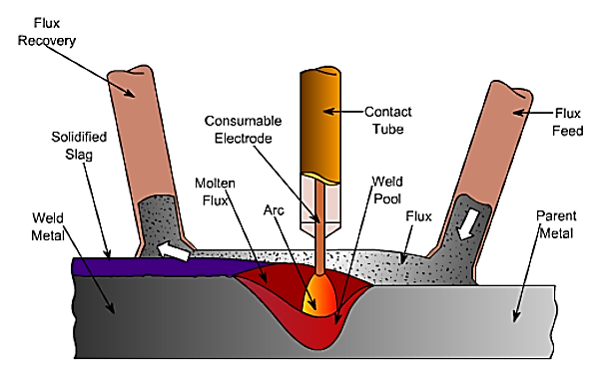
Fig: Process of Submerged Arc Welding
Gas Metal Arc Welding (GMAW)

Gas metal arc welding (GMAW) is the process in which arc is struck between bare wire electrode and work piece. The arc is shielded by a shielding gas and if this is inert gas such as argon or helium then it is termed as metal inert gas (MIG) and if shielding gas is active gas such as CO2 or mixture of inert and active gases then process is termed as metal active gas (MAG) welding. Figure 9.1 illustrates the process of GMA welding. Fig
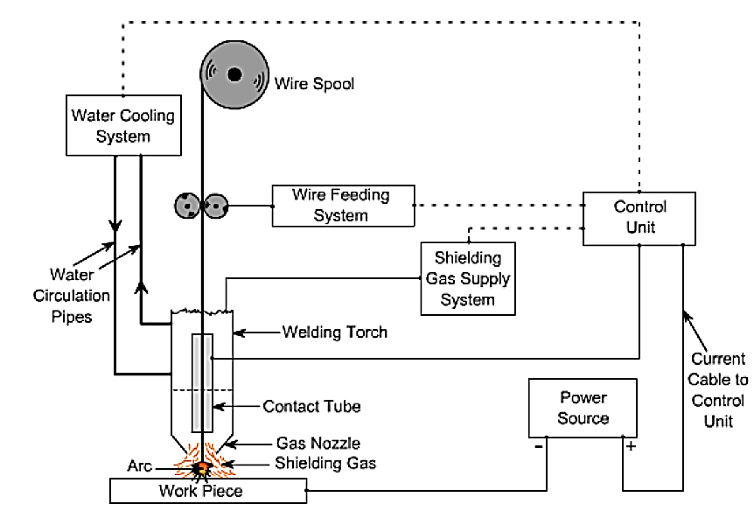
Fig: GMA PROCESS
Direct current flat characteristic power source is the requirement of GMAW process. The electrode wire passing through the contact tube is to be connected to positive terminal of power source so that stable arc is achieved. If the electrode wire is connected to negative terminal then it shall result into unstable spatter arc leading to poor weld bead. Flat characteristic leads to self-adjusting or self-regulating arc leading to constant arc length due to relatively thinner electrode wires. GMA welding requires consumables such as filler wire electrode and shielding gas. Solid filler electrode wires are normally employed and are available in sizes 0.8, 1.0, 1.2 and 1.6 mm diameter. Similar to submerged arc welding electrode wires of mild steel and low alloyed steel, are coated with copper to avoid atmospheric corrosion, increase current carrying capacity and for smooth movement through contact tube. The electrode wire feeding system is shown in Figure 9.2.

TIG Welding
Tungsten Inert Gas (TIG) or Gas Tungsten Arc (GTA) welding is the arc welding process in which arc is generated between non consumable tungsten electrode and work piece. The tungsten electrode and the weld pool are shielded by an inert gas normally argon and helium. Figures 10.1 & 10.2 show the principle of tungsten inert gas welding process.
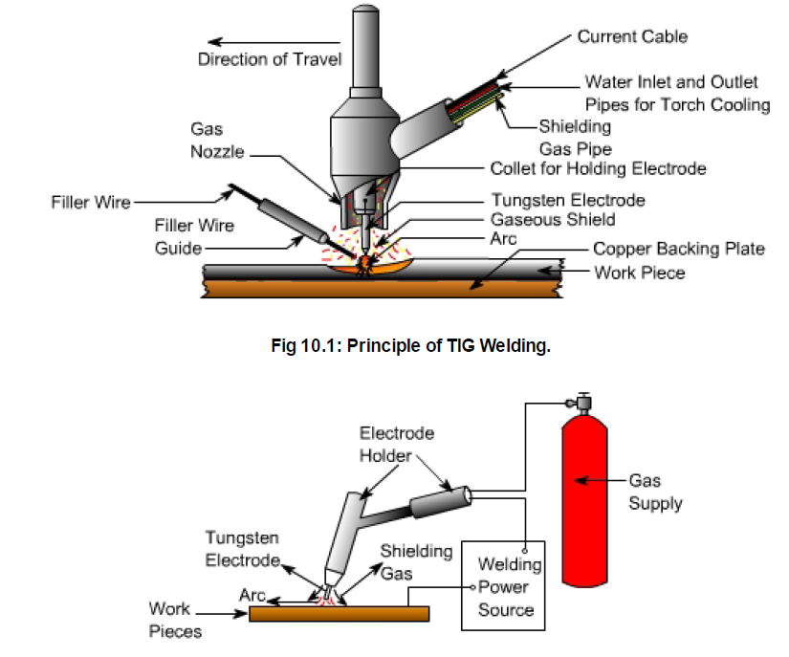
Fig: TIG welding process
The tungsten arc process is being employed widely for the precision joining of critical components which require controlled heat input. The small intense heat source provided by the tungsten arc is ideally suited to the controlled melting of the material. Since the electrode is not consumed during the process, as with the MIG or MMA welding processes, welding without filler material can be done without the need for continual compromise between the heat input from the arc and the melting of the filler metal. As the filler metal, when required, can be added directly to the weld pool from a separate wire feed system or manually, all aspects of the process can be precisely and independently controlled i.e. the degree of melting of the parent metal is determined by the welding current with respect to the welding speed, whilst the degree of weld bead reinforcement is determined by the rate at which the filler wire is added to the weld pool. In TIG torch the electrode is extended beyond the shielding gas nozzle. The arc is ignited by high voltage, high frequency (HF) pulses, or by touching the electrode to the workpiece and withdrawing to initiate the arc at a preset level of current. Selection of electrode composition and size is not completely independent and must be considered in relation to the operating mode and the current level. Electrodes for DC welding are pure tungsten or tungsten with 1 or 2% thoria, the thoria being added to improve electron emission which facilitates easy arc ignition. In AC welding, where the electrode must operate at a higher temperature, a pure tungsten or tungstenzirconia electrode is preferred as the rate of tungsten loss is somewhat lesser than with thoriated electrodes and the zirconia aids retention of the ‘balled' tip.

Special Types of Welding Process

LASER BEAM WELDING (LBW)

Laser Beam Welding is a fusion welding process in which two metal pieces are joined together by the use of laser. The laser beams are focused to the cavity between the two metal pieces to be joined. The laser beams have enough energy and when it strikes the metal pieces produce heat that melts the material from the two metal pieces and fills the cavity. After cooling a strong weld is formed between the two pieces. It is a very efficient welding process and can be automated with robotics machinery easily. This welding technique is mostly used in the automotive industry.

Working Principle
It works on the principle that when electrons of an atom gets excited by absorbing some energy. And then after some time when it returns back to its ground state, it emits a photon of light. The concentration of this emitted photon increased by stimulated emission of radiation and we get a high energy concentrated laser beam.

Main Parts
The main parts or equipment of laser beam welding are:
- Laser Machine: It is a machine that is used to produce a laser for welding. The main components of the laser machine are shown below.
- Power Source: A high voltage power source is applied across the laser machine to produce a laser beam.
- CAM: It is a computer-aided manufacturing in which the laser machine is integrated with the computers to perform the welding process. All the controlling action during the welding process by laser is done by CAM. It speeds up the welding process to a greater extent.
- CAD: It is called as Computer-aided Design. It is used to design the job for welding. Here computers are used to design the workpiece and how the welding is performed on it.
- Shielding Gas: A shielding gas may be used during the welding process in order to prevent the w/p from oxidation.

Types of Laser Used
- Gas lasers: It uses mixtures of gases as a lasing medium to produce laser. Mixtures of gases such as nitrogen, helium, and co₂ are used as the lasing medium.
- Solid-state laser: it uses several solid media such as synthetic ruby crystal (chromium in aluminum oxide), neodymium in glass (Nd: glass), and neodymium in yttrium aluminum garnet (Nd-YAG, most commonly used).
- Fiber laser: The lasing medium in this type of laser is optical fiber itself.

Characteristics of Laser Beam Welding
- The power density of laser beam welding is high. It is of the order 1 MW/cm². Because of this high energy density, it has small heat-affected zones. The rate of heating and cooling is high.
- The laser beams produced are coherent ( having the same phase) and monochromatic ( i.e. having the same wavelength).
- It is used to weld smaller sizes spot, but the spot sizes can vary from .2mm to 13 mm.
- The depth of penetration of the LBW depends upon the amount of power supply and location of the focal point. It is proportional to the amount of power supply. When the focal point is kept slightly below the surface of the workpiece, the depth of penetration is maximized.
- Pulsed or continuous laser beams are used for welding. Thin materials are weld by using millisecond-pulses and continuous laser beams are used for deep welds.
- It is a versatile process because it is capable of welding carbon steels, stainless steel, HSLA steel, aluminum, and titanium. Due to the high cooling rate, the problem of cracking is there when welding high-carbon steels.
- It produces high-quality weld.
- This welding process is most popular in the automotive industry.
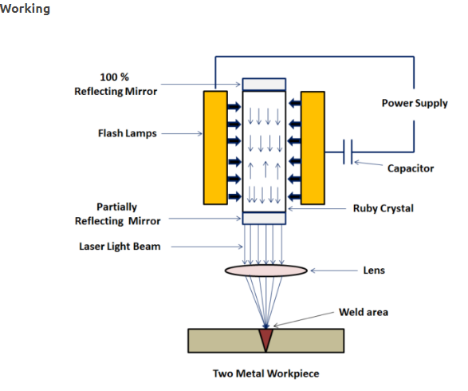

- First, the setup of welding machine at the desired location (in between the two metal pieces to be joined) is done.
- After setup, a high voltage power supply is applied to the laser machine. This starts the flash lamps of the machine and it emits light photons. The energy of the light photon is absorbed by the atoms of ruby crystal and electrons get excited to their higher energy level. When they return back to their ground state (lower Energy state) they emit a photon of light. This light photon again stimulates the excited electrons of the atom and produces two photons. This process keeps continue and we get a concentrated laser beam.
- This high concentrated laser beam is focused to the desired location for the welding of the multiple pieces together. Lens is used to focus the laser to the area where welding is needed. CAM is used to control the motion of the laser and workpiece table during the welding process.
- As the laser beam strikes the cavity between the two metal pieces to be joined, it melts the base metal from both the pieces and fuses them together. After solidification, we get a strong weld.
- This is how a laser Beam Welding Works.
ELECTRON BEAM WELDING (EBW)
Electron Beam Welding Process is a fusion welding process in which a high-velocity electron beam is used to join two metals together. The high-velocity electron beam when strikes the weld area of two metal pieces and very intense heat is generated which melts the metal and they fuse together to form a strong weld. The whole process is carried out in a vacuum chamber to prevent it from contamination.

Working Principle
It works on the principle that when a high-velocity beam of electron that has Kinetic energy strikes the two metal pieces, the kinetic energy of the electron transformed into heat. The intensity of heat produced is so much that it melts the two metal pieces and fuse them together to form a strong weld.
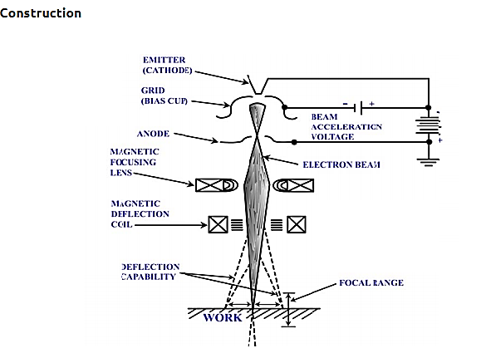

Working of Electron Beam Welding Process
- In Electron Beam welding, the electron is produced by the cathode of the electron gun.
After cathode, a cup grid is provided. It prevents the divergence of electron and control it.
- Because of the high voltage applied across the cathode and anode. The anode which is positively charged attracts the electron from the cup grid.
- The anode accelerates the electron and its velocity increases and reaches the range of 50000 – 200000 km/s. From the anode, the high-velocity electron beam is passed through the magnetic lens and deflector coils.
- The magnetic lens focuses the electron beam to the desired location on the workpiece. And the deflector coil deflects the beam to the required weld area. As the high-velocity electron beam strikes the workpiece, intense heat is produced and it melts the metal of the two workpieces and fills the weld area. The molten weld solidifies and forms a strong weld joint.

Welding Defects
The defects in the weld can be defined as irregularities in the weld metal produced due to incorrect welding parameters or wrong welding procedures or wrong combination of filler metal and parent metal. Weld defect may be in the form of variations from the intended weld bead shape, size and desired quality. Defects may be on the surface or inside the weld metal. Certain defects such as cracks are never tolerated but other defects may be acceptable within permissible limits. Welding defects may result into the failure of components under service condition, leading to serious accidents and causing the loss of property and sometimes also life. Various welding defects can be classified into groups such as cracks, porosity, solid inclusions, lack of fusion and inadequate penetration, imperfect shape and miscellaneous defects.
- Cracks: Cracks may be of micro or macro size and may appear in the weld metal or base metal or base metal and weld metal boundary. Different categories of cracks are longitudinal cracks, transverse cracks or radiating/star cracks and cracks in the weld crater. Cracks occur when localized stresses exceed the ultimate tensile strength of material. These stresses are developed due to shrinkage during solidification of weld metal.
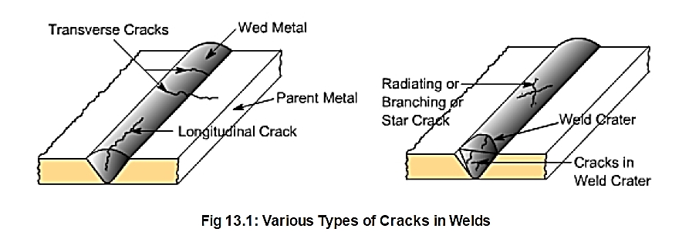
Cracks may be developed due to poor ductility of base metal, high sulphur and carbon contents, high arc travel speeds i.e. fast cooling rates, too concave or convex weld bead and high hydrogen contents in the weld metal.
- Porosity: Porosity results when the gases are entrapped in the solidifying weld metal. These gases are generated from the flux or coating constituents of the electrode or shielding gases used during welding or from absorbed moisture in the coating. Rust, dust, oil and grease present on the surface of work pieces or on electrodes are also source of gases during welding. Porosity may be easily prevented if work pieces are properly cleaned from rust, dust, oil and grease.Futher, porosity can also be controlled if excessively high welding currents, faster welding speeds and long arc lengths are avoided flux and coated electrodes are properly baked.
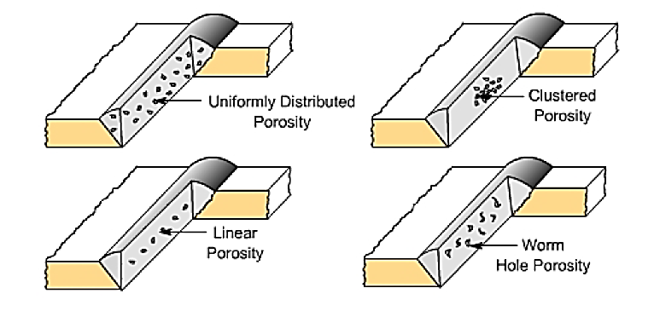

- Solid Inclusion Solid inclusions may be in the form of slag or any other non-metallic material entrapped in the weld metal as these may not able to float on the surface of the solidifying weld metal. During arc welding flux either in the form of granules or coating after melting, reacts with the molten weld metal removing oxides and other impurities in the form of slag and it floats on the surface of weld metal due to its low density. However, if the molten weld metal has high viscosity or too low temperature or cools rapidly then the slag may not be released from the weld pool and may cause inclusion. Slag inclusion can be prevented if proper groove is selected, all the slag from the previously deposited bead is removed, too high or too low welding currents and long arcs are avoided.
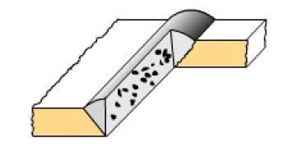
Fig: Slag Inclusion in Weldments.
- Lack of Fusion and Inadequate or incomplete penetration:
Lack of fusion is the failure to fuse together either the base metal and weld metal or subsequent beads in multipass welding because of failure to raise the temperature of base metal or previously deposited weld layer to melting point during welding. Lack of fusion can be avoided by properly cleaning of surfaces to be welded, selecting proper current, proper welding technique and correct size of ELECTORDE
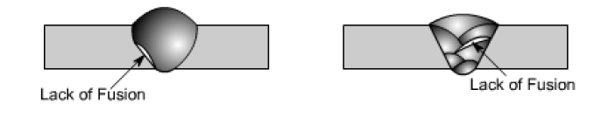
Incomplete penetration means that the weld depth is not upto the desired level or root faces have not reached to melting point in a groove joint. If either low currents or larger arc lengths or large root face or small root gap or too narrow groove angles are used then it results into poor penetration.

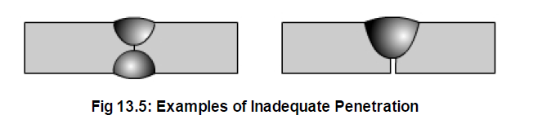

- Imperfect Shape
Imperfect shape means the variation from the desired shape and size of the weld bead. During undercutting a notch is formed either on one side of the weld bead or both sides in which stresses tend to concentrate and it can result in the early failure of the joint. Main reasons for undercutting are the excessive welding currents, long arc lengths and fast travel speeds. Underfilling may be due to low currents, fast travel speeds and small size of electrodes. Overlap may occur due to low currents, longer arc lengths and slower welding speeds.
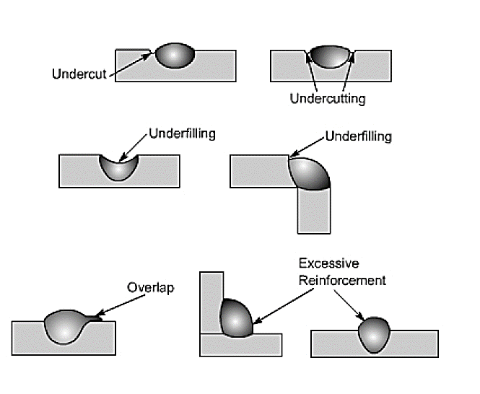
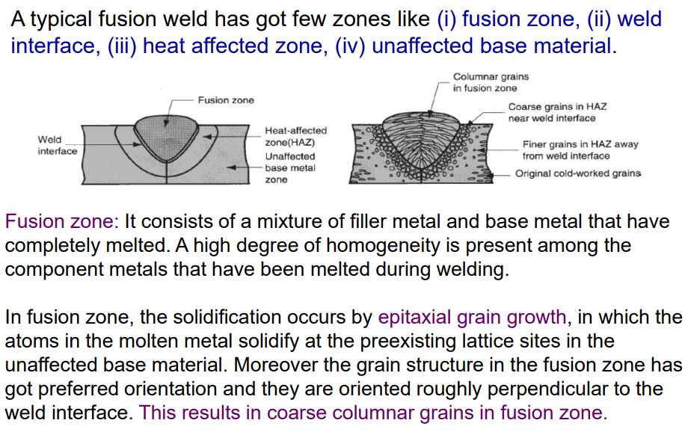Nondestructive Testing (NDT)
METALLURGICAL JOINING OF WELDING PROCESS
Nondestructive testing (NDT) is the process of inspecting, testing, or evaluating materials, components or assemblies for discontinuities, or differences in characteristics without destroying the serviceability of the part or system. In other words, when the inspection or test is completed the part can still be used.
In contrast to NDT, other tests are destructive in nature and are therefore done on a limited number of samples ("lot sampling"), rather than on the materials, components or assemblies actually being put into service.
These destructive tests are often used to determine the physical properties of materials such as impact resistance, ductility, yield and ultimate tensile strength, fracture toughness and fatigue strength, but discontinuities and differences in material characteristics are more effectively found by NDT.
Today modern nondestructive tests are used in manufacturing, fabrication and in-service inspections to ensure product integrity and reliability, to control manufacturing processes, lower production costs and to maintain a uniform quality level. During construction, NDT is used to ensure the quality of materials and joining processes during the fabrication and erection phases, and in-service NDT inspections are used to ensure that the products in use continue to have the integrity necessary to ensure their usefulness and the safety of the public.
It should be noted that while the medical field uses many of the same processes, the term "nondestructive testing" is generally not used to describe medical applications.

NDT Test Methods
Test method names often refer to the type of penetrating medium or the equipment used to perform that test. Current NDT methods are: Acoustic Emission Testing (AE), Electromagnetic Testing (ET), Laser Testing Methods (LM), Leak Testing (LT), Magnetic Flux Leakage (MFL), Liquid Penetrant Testing (PT), Magnetic Particle Testing (MT), Neutron Radiographic Testing (NR), Radiographic Testing (RT), Thermal/Infrared Testing (IR), Ultrasonic Testing (UT), Vibration Analysis (VA) and Visual Testing (VT).
The six most frequently used test methods are MT, PT, RT, UT, Each of these test methods will be described here, followed by the other, less often used test methods.

MAGNETIC PARICLE TESTING
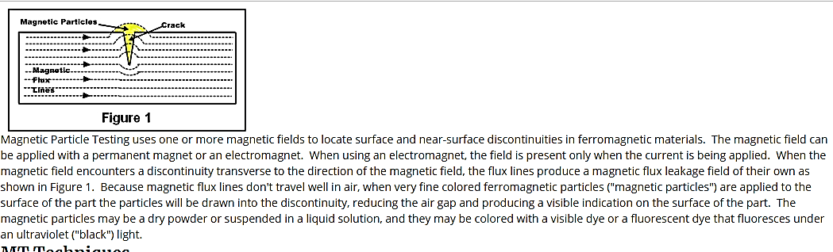

LIQUID PENTRANT TESTING
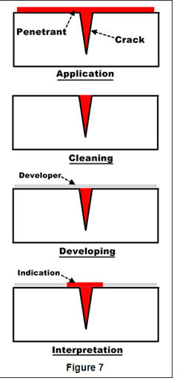

The basic principle of liquid penetrant testing is that when a very low viscosity (highly fluid) liquid (the penetrant) is applied to the surface of a part, it will penetrate into fissures and voids open to the surface. Once the excess penetrant is removed, the penetrant trapped in those voids will flow back out, creating an indication. Penetrant testing can be performed on magnetic and non-magnetic materials, but does not work well on porous materials. Penetrants may be "visible", meaning they can be seen in ambient light, or fluorescent, requiring the use of a "black" light. The visible dye penetrant process is shown in Figure 7. When performing a PT inspection, it is imperative that the surface being tested is clean and free of any foreign materials or liquids that might block the penetrant from entering voids or fissures open to the surface of the part. After applying the penetrant, it is permitted to sit on the surface for a specified period of time (the "penetrant dwell time"), then the part is carefully cleaned to remove excess penetrant from the surface. When removing the penetrant, the operator must be careful not to remove any penetrant that has flowed into voids. A light coating of developer is then be applied to the surface and given time ("developer dwell time") to allow the penetrant from any voids or fissures to seep up into the developer, creating a visible indication. Following the prescribed developer dwell time, the part is inspected visually, with the aid of a black light for fluorescent penetrants. Most developers are fine-grained, white talcum-like powders that provide a color contrast to the penetrant being used.

ULTRASONIC TESTING
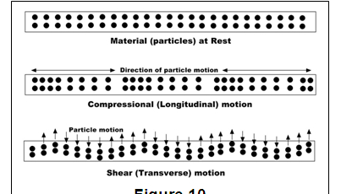
Ultrasonic testing uses the same principle as is used in naval SONAR and fish finders. Ultra-high frequency sound is introduced into the part being inspected and if the sound hits a material with a different acoustic impedance (density and acoustic velocity), some of the sound will reflect back to the sending unit and can be presented on a visual display. By knowing the speed of the sound through the part (the acoustic velocity) and the time required for the sound to return to the sending unit, the distance to the reflector (the indication with the different acoustic impedance) can be determined. The most common sound frequencies used in UT are between 1.0 and 10.0 MHz, which are too high to be heard and do not travel through air. The lower frequencies have greater penetrating power but less sensitivity (the ability to "see" small indications), while the higher frequencies don't penetrate as deeply but can detect smaller indications.
The two most commonly used types of sound waves used in industrial inspections are the compression (longitudinal) wave and the shear (transverse) wave, as shown in Figure 10. Compression waves cause the atoms in a part to vibrate back and forth parallel to the sound direction and shear waves cause the atoms to vibrate perpendicularly (from side to side) to the direction of the sound. Shear waves travel at approximately half the speed of longitudinal waves.
Sound is introduced into the part using an ultrasonic transducer ("probe") that converts electrical impulses from the UT machine into sound waves, then converts returning sound back into electric impulses that can be displayed as a visual representation on a digital or LCD screen (on older machines, a CRT screen). If the machine is properly calibrated, the operator can determine the distance from the transducer to the reflector, and in many cases, an experienced operator can determine the type of discontinuity (like slag, porosity or cracks in a weld) that caused the reflector. Because ultrasound will not travel through air (the atoms in air molecules are too far apart to transmit ultrasound), a liquid or gel called "couplant" is used between the face of the transducer and the surface of the part to allow the sound to be transmitted into the part.

RADIGRAPHY TESTING

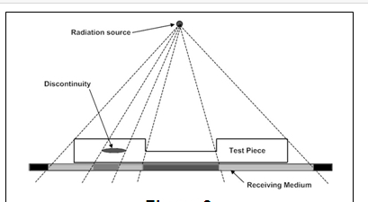

Industrial radiography involves exposing a test object to penetrating radiation so that the radiation passes through the object being inspected and a recording medium placed against the opposite side of that object. For thinner or less dense materials such as aluminum, electrically generated x-radiation (X-rays) are commonly used, and for thicker or denser materials, gamma radiation is generally used.
Gamma radiation is given off by decaying radioactive materials, with the two most commonly used sources of gamma radiation being Iridium-192 (Ir-192) and Cobalt-60 (Co-60). IR-192 is generally used for steel up to 2-1/2 - 3 inches, depending on the Curie strength of the source, and Co-60 is usually used for thicker materials due to its greater penetrating ability.
The recording media can be industrial x-ray film or one of several types of digital radiation detectors. With both, the radiation passing through the test object exposes the media, causing an end effect of having darker areas where more radiation has passed through the part and lighter areas where less radiation has penetrated. If there is a void or defect in the part, more radiation passes through, causing a darker image on the film or detector, as shown in Figure 8
INTRODUCTION ABOUT WELDING, SOLDERING AND BRAZING PROCESS WITH COMPARISION
Brazing and soldering, in essence, are the same in that they both melt the filler metal (braze or solder) only, not the base materials. The liquid filler metal wets the base materials through capillary action. When the liquid filler metal solidifies, it is bonded to the base materials, creating a joint. What differentiates soldering and brazing is the melting temperature of the filler metal; brazing is hotter.
Each process has its advantages and disadvantages, from a processing and application perspective.

Welding
There are numerous types of welding processes, including:
- Arc
- Electron Beam
- Friction
- Laser
- Resistance
Welding has been used to join most metals known to humankind, but the process is extensively used for common manufacturing materials, such as aluminium, steel and titanium. Welded components are in use all around us in everyday life, such as in aeroplanes, bridges, buildings, cars and ships.

Advantages of Welding Include:
- Produces stronger joints than brazing or soldering
- Produces welded joints that are better suited for high-temperature applications
- Being able to join thin and thick sections of metal (depending on process type)

Disadvantages of Welding Include:
- Producing greater thermal distortion and residual stresses in the joint compared to soldering and brazing
- Requiring a post-processing heat treatment to relieve joint residual stress (depending on application and process)
- Only being able to join similar base materials (for most processes, but not all)

Soldering
Solders are melted using heat from a temperature-controlled soldering iron. The solder melts at a temperature below 450°C. A flux is used in soldering to clean the metal surfaces, allowing easier flow of the liquid filler metal over the base material.
Base materials suitable for joining by soldering include brass, copper, iron, gold and silver. Filler metals used in soldering were once lead based, however, owing to regulations, lead-based solders are increasingly replaced with non-lead versions, which may consist of antimony, bismuth, copper, indium, tin or silver.
Soldering is widely used in the electronics industry for making electrical connections, such joining copper to printed circuit boards (PCB). Plumbers also use the process to join copper pipes. One high-value application of soldering is for the assembly of jewellery.

Advantages of Soldering Include:
- Having a lower power input and processing temperature compared to welding and brazing
- Being able to join dissimilar base materials
- Being able to join thin walled parts
- Having minimal thermal distortion and residual stresses in the joints
- Not needing a post-processing heat treatment

Disadvantages of Soldering Include:
- Producing lower strength of joints compared to welding and brazing, making them undesirable for load-bearing applications
- Not being able to join large sections
- Producing joints that are unsuitable for high-temperature applications
- Fluxes may contain toxic components

Brazing
Brazing is considered as a high-temperature version of soldering. There are several brazing variants, including torch brazing, vacuum brazing, furnace brazing and induction brazing. Regardless of the type, the braze filler metal melts at a temperature above 450°C, but always below that of the base materials to be joined. The filler metal, while heated slightly above melting point, is protected by a suitable atmosphere, which is often supplied by a flux. The flux, as with soldering, also helps to clean the metal surfaces.
Base materials suitable for brazing include aluminium, copper, gold, nickel, silver and steel. Primary filler metals used in brazing include aluminium, cobalt, copper, gold, nickel or silver. These primary filler metals are often alloyed with other elements to obtain desirable properties and performance.
Brazing is a commercially accepted process used in a wide range of industries due to its flexibility and the high integrity to which joints may be produced. This makes it reliable in critical and non-critical applications, and it is one of the most widely used joining methods.

Advantages of Brazing Include:
- Having a lower power input and processing temperature than welding
- Producing joints with minimal thermal distortion and residual stresses when compared to welding
- Not needing a post-processing heat treatment
- Being able to join dissimilar base materials
- Producing stronger joints than soldering

Disadvantages of Brazing Include:
- Producing lower strength joints compared to welding
- Producing joints that are not as well suited to high-temperature applications as welds
- Fluxes may contain toxic components

