ELEMENTS OF PRODUCTION ENGINEERING – I 3RD SEM.
I&PE.S.J.C.E. MYS DK

1.1 INTRODUCTION

Manufacturing is the backbone of any industrialized nation. Manufacturing and technical staff in industry must know the various manufacturing processes, materials being processed, tools and equipments for manufacturing different components or products with optimal process plan using proper precautions and specified safety rules to avoid accidents. Beside above, all kinds of the future engineers must know the basic requirements of workshop activities in term of man, machine, material, methods, money and other infrastructure facilities needed to be positioned properly for optimal shop layouts or plant layout and other support services effectively adjusted or located in the industry or plant within a well planned manufacturing organization.
The complete understanding of basic manufacturing processes and workshop technology is highly difficult for any one to claim expertise over it. The study deals with several aspects of workshops practices also for imparting the basic working knowledge of the different engineering materials, tools, equipments, manufacturing processes, basic concepts of electromechanical controls of machine tools, production criteria’s, characteristics and uses of various testing instruments and measuring or inspecting devices for checking components or products manufactured in various manufacturing shops in an industrial environment. It also describes and demonstrates the use of different hand tools (measuring, marking, holding and supporting tools, cutting etc.), equipments, machinery and various methods of manufacturing that facilitate shaping or forming the different existing raw materials into suitable usable forms. It deals
with the study of industrial environment which involves the practical knowledge in the area of ferrous and non ferrous materials, their properties and uses. It should provide the knowledge of basic workshop processes namely bench work and fitting, sheet metal, carpentry, pattern making, mould making, foundry, smithy, forging, metal working and heat treatment, welding, fastening, machine shop, surface finishing and coatings, assembling inspection and quality control. It emphasizes on basic knowledge regarding composition, properties and uses of different raw materials, various production processes, replacement of or improvement over a large number of old processes, new and compact designs, better accuracy in dimensions, quicker methods of production, better surface finishes, more alternatives to the existing
materials and tooling systems, automatic and numerical control systems, higher mechanization and greater output.

MANUFACTURING PROCESS AND PRODUCTION PROCESS

Manufacturing is derived from the Latin word manufactus, means made by hand. In modern context it involves making products from raw material by using various processes, by making use of hand tools, machinery or even computers. It is therefore a study of the processes
Required to make parts and to assemble them in machines. Process Engineering, in its application to engineering industries, shows how the different problems related to development
of various machines may be solved by a study of physical, chemical and other laws governing the manufacturing process. The study of manufacturing reveals those parameters which can be most efficiently being influenced to increase production and raise its accuracy. Advance manufacturing engineering involves the following concepts—
1. Process planning.
2. Process sheets.
3. Route sheets.
4. Tooling.
5. Cutting tools, machine tools (traditional, numerical control (NC), and computerized
Numerical control (CNC).
6. Jigs and Fixtures.
7. Dies and Moulds.
8. Manufacturing Information Generation.
9. CNC part programs.
10. Robot programmers.
11. Flexible Manufacturing Systems (FMS), Group Technology (GT) and Computer
Integrated manufacturing (CIM).

PRODUCTION PROCESS
It is the process followed in a plant for converting semi- finished products or raw materials into finished products or raw materials into finished products. The art of converting raw material into finished goods with application of different types of tools, equipment’s, machine tools, manufacturing set ups and manufacturing processes, is known as production. Generally there are three basic types of production system that are given as under.
1. Job production
2. Batch production
3. Mass production
Job production comprises of an operator or group of operators to work upon a single job and complete it before proceeding to the next similar or different job. The production requirement in the job production system is extremely low. It requires fixed type of layout for developing same products. Manufacturing of products (less in number say 200 to 800) with variety of

Similar parts with very little variation in size and shape is called batch production. Whenever the production of batch is over, the same manufacturing facility is used for production of other batch product or items. The batch may be for once or of periodical type or of repeated kinds after some irregular interval. Such manufacturing concepts are leading to GT and FMS technology. Manufacturing of products in this case requires process or functional layout. Whereas mass production involves production of large number of identical products (say more than 50000) that needs line layout type of plant layout which is highly rigid type and involves automation and huge amount of investment in special purpose machines to increase the production

CLASSIFICATION OF MANUFACTURING PROCESS:
The manufacturing processes can be classified as: 1. Forming Processes 2. Moulding Processes 3. Machining Processes 4. Assembly Processes 5. Finishing Processes.

1. Forming Processes:
In the metal industry, some of the primary forming operations may take place such as the rolling of basic shapes in steel, aluminium etc. Some of the common shapes so obtained from these processes are bars, sheets, billets, I-beams etc. Which are standard shapes. These shapes can be used for further processing. Other forming processes may be drop-forging, stamping, extrusion, press work, punching, drawing etc.

2. Moulding Processes:
Some products require moulding processes such as sand casting, die-casting etc. to get basic shape or form which may or may not require further processing. The selection of the particular process will depend upon to size of the job, quantity to be produced, accuracy, and complexity desired and economy
Machining process
Metal machining is accomplished through basic machine tool processes which involve the generation of cylindrical surfaces, flat surfaces, complex curves and holes. The machine tools selected to accomplish this task depend on the size and shape of the part to be machined, the quality of finish required and production rate required.
The examples of such processes are: turning, shaping, drilling, boring, grinding etc. In these machining operations metal is removed from the part in the form of small chips by the cutting action of tool. The cutting action is accomplished by either rotating or reciprocating action of the tool relating to the part.

4. Assembly Processes:
These processes assemble the parts and materials using welding, riveting, soldering, brazing, mechanical fastening and adhesive joining etc.

5. Finishing Processes:
These processes are carried out for the aesthetic aspects, to achieve accuracy, surface finish or to increase life of the product. Such processes include cleaning, blasting, deburring, puffing, honing, lapping, polishing, painting etc.

CONCEPT OF METAL CASTING

What is Metal Casting
Metal casting is defined as the process in which molten metal is poured into a mould that contains a hollow cavity of a desired geometrical shape and allowed to cool down to form a solidified part.
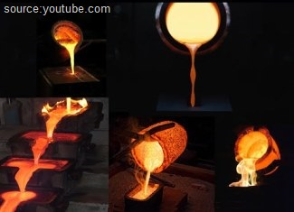
Figure 1. Metal-casting
Primarily, casting produces ingots and shapes. An ingot is a casting produced into a simple shape and intended for further processing such as metal extrusion, forging, etc. Shape casting is for near or net shape castings to produce complex geometries which are closer to the
finalpart.

Types of Metal Casting
Metal casting can be divided into two groups by the basic nature of the mould design. i.e. expendable mould and permanent mould castings. It can be further subdivided into groups depending on their pattern material.
- Expendable Mould
  - Permanent pattern
    - Sand casting
    - Plaster moulding
    - Shell mould
    - Ceramic mould

  - Expendable pattern
    - Lost foam
    - Investment casting
- Permanent mould
  - Gravity casting
  - Low pressure/vacuum
  - Die casting
Following factors need to be considered before choosing a suitable metal casting for a given engineering product design.
- Part shape and size
- Required quantity
- Required tolerance
- Material

Expendable mould casting
Expendable mould casting, as the name suggests uses a temporary non-reusable mould to produce the final casting as the mould will be broken to get the casting out. These moulds are typically made of materials such as sand, ceramics & plaster. These are generally bonded using binders called bonding agent to improve its properties. Complex intricate geometries can be cast using expendable mould casting.
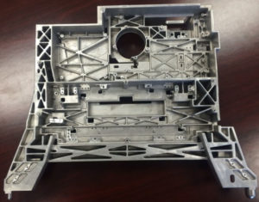
Figure aluminium alloy a356 copier frame plaster mould aluminium casting(credit_link)

Permanent mould casting
Sometimes called non-expendable mould casting, permanent mould casting uses permanent moulds that are reused after each production cycle. Although permanent mould casting produces repeatable parts due to re-use of the same mould, it can only produce simple castings as the mould needs to be opened to remove the castings.
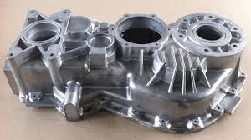
Figure 3. Permanent mould casting (credit – Alibaba)

Composite mould casting
As the name suggests these uses both expendable and re-useable casting moulds to produce castings. These normally include materials such as sand, wood, graphite and metal.
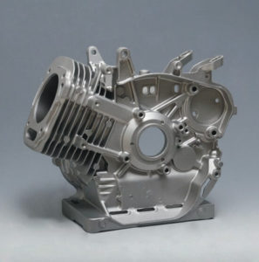
Figure 4. Composite mould casting (credit – highlywell-china)

How does metal casting work

Metal casting steps: the following basic steps involved casting process
- Patternmaking – A replica of the part to be cast is made using a suitable material such as wood, metal plastic or plaster.
- Mould making – Mould making is a multi-step process in which patterns and cores are used to create a mould. The type and how the moulds are made would vary depending on the type of metal casting. For example, sand casting uses sand inside a flask to create moulds and die casting uses hardened tool steel moulds.
- Metal melting & pouring – Liquid is then melted and poured into the mould cavity either by gravity or by high pressure. Then the cast is allowed to solidify before the cast parts are removed from the mould. Again, the cast part removal will vary depending on the type of metal casting.
- Post processing – In this final step, the cast metal object is removed from the mould and then fettled. During the fettling, the object is cleaned of any moulding material, and rough edges are removed. The following fig clearly illustrated the casting process

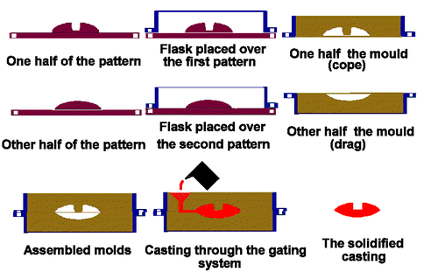

Fig : Basic steps involved during casting process

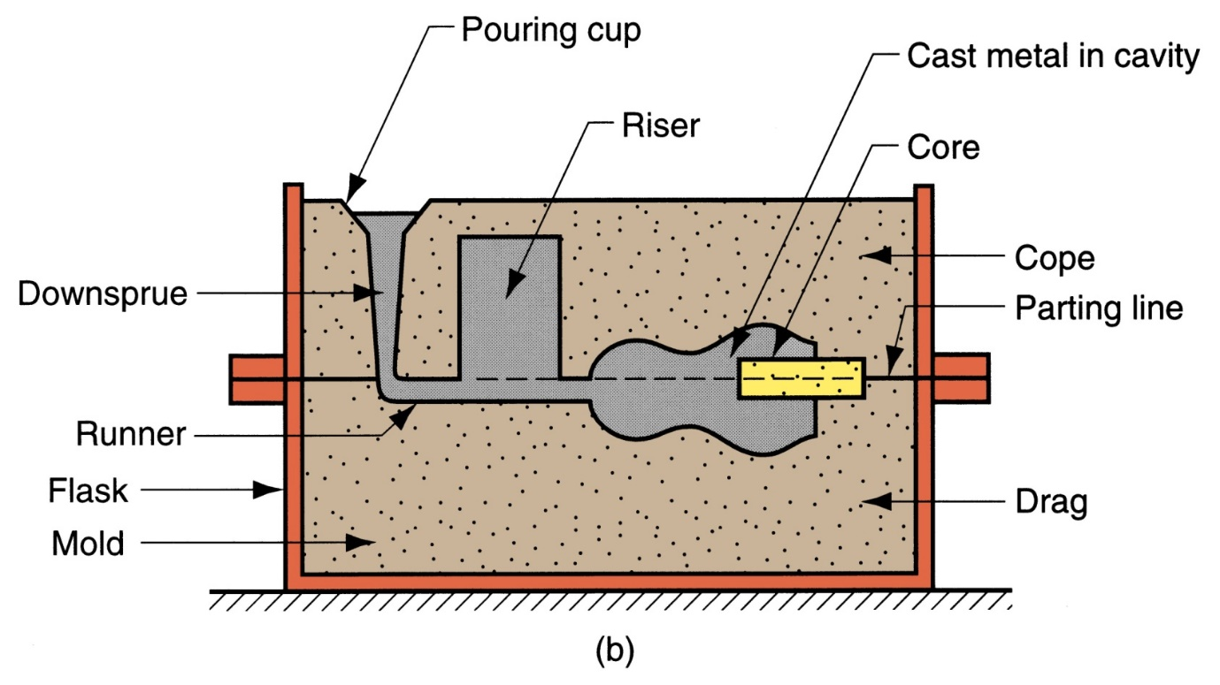
Schematic representation of casting process

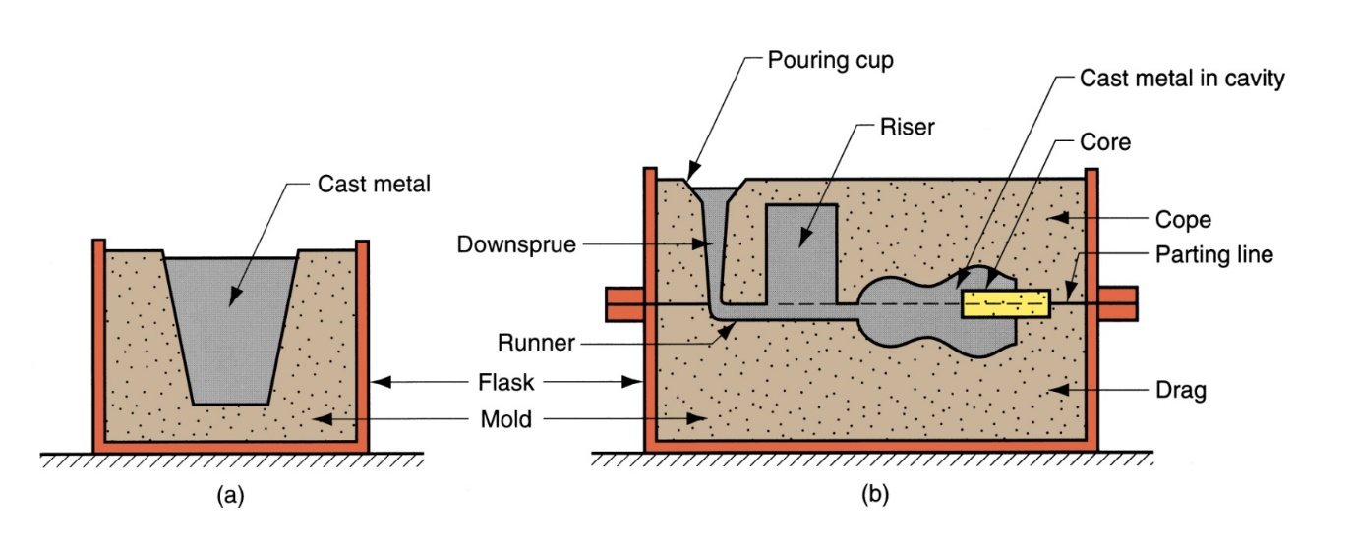
Fig: Two forms of mold: (a) open mold, simply a container in the shape of the desired part; and (b) closed mold, in which the mold geometry is more complex and requires a gating system (passageway) leading into the cavity

Terms Used In Casting Process:
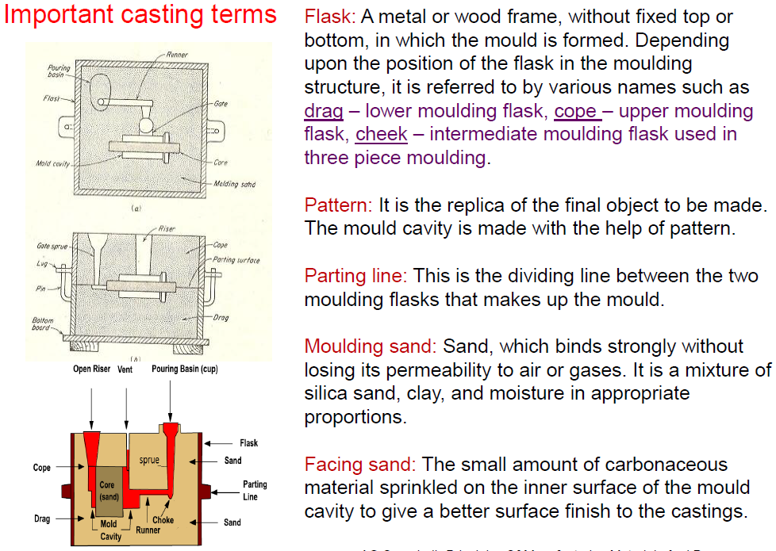
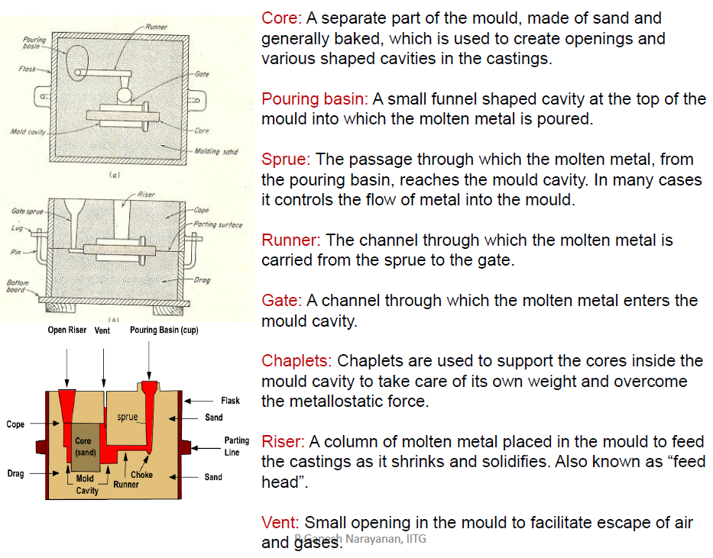

Elements of the gating system
One of the most common metal casting process is Sand casting and its mould is made of two halves. Contained inside a box called flask, the upper half is called the cope and the bottom half is called the drag. As shown in the image (Figure 5) below the flask is also divided into two halves. The line that separates the two halves is called the parting line.
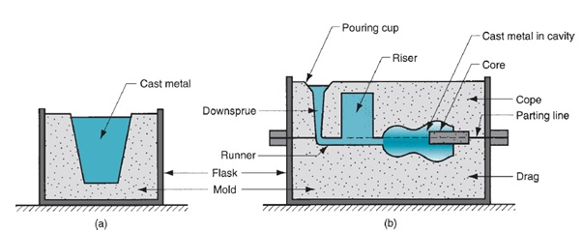Figure 5 Metal casting gating system (source: Groover (2010))
The gating system is the channel or the path by which the molten metal flows into the cavity. As shown above, the gating system consists of a pouring cup and a down sprue through which the metal enters the runner that leads into the main cavity. Pouring cup minimises the splash and turbulence when the metal flows through the sprue which is tapered to aid the flow. Most of the casting suffers from shrinkage during cooling and to minimise the shrinkage issue, a riser is used. A riser is a simple reservoir in the mould that feeds molten material to the shrinking sections to compensate as it solidifies. There are four different types of risers, viz. top riser, side riser, blind riser and open riser.

Material suitability
Although almost all the metals can be used, the most commons ones are iron, steel, aluminium, magnesium and copper-based alloys such as bronze. Zinc, aluminium, magnesium and brass are widely used in die casting whereas aluminium alloy, brass alloy, cast iron and cast steel are very popular sand-casting materials.

Typical application
Nearly every engineering product we use from washing machines to pillar drills, cars to bicycles are manufactured using metal parts which are most likely to be made using one of the metal casting processes. This age-old manufacturing process has improved its precision and tolerances over time. Typically, castings are used to make car engine blocks, crankshafts, power tool housings such as, pillar drills, plumbing parts, turbine blades, metal statues, some gears and gearbox housings.

Advantages and disadvantages of metal casting
As with any other manufacturing processes, a basic understanding of the process, its underlying science, its pros and cons are essential for manufacturing low-cost quality engineer products.

Advantages of metal casting
- Metal casting can produce complex shapes
- Features like internal cavities or hollow sections can be easily achieved
- Large components can be produced in one-piece cast
- Materials that are difficult or expensive to manufacture using other manufacturing process can be cast
- Compared to other manufacturing processes, casting is cheaper for medium to large quantities
- Almost all the metals can be cast
- Near net shape often without or very minor post-processing
Because of the above reasons metal casting is one of the important net shape manufacturing technologies. Others include net shape forging, stamping of sheet metal, additive manufacturing and metal injection moulding.

Disadvantages of metal casting
- Relatively coarse surface finish and hence wider tolerance has to be allowed and
not suitable for mating interfaces
- Metal casting such as shell moulding has a limit in terms of size and the pattern
- Patterns are time-consuming and expensive to make although additive
manufacturing processes such as binder jetting are being used lately to make a mould
- Die casting can be very expensive for smaller to medium quantities due to high
die cost
- Part size and material choices depend on the casting process chosen. For instance, only non-ferrous metal can be used for permanent mould castings

Application of castings in different fields
- Transport : Automobile, aerospace, railways and shipping
- Heavy Equipment : Construction, farming and mining
- Machine Tools : Machining, casting, plastics molding, forging, extrusion and forming
- Plant Machinery : Chemical, petroleum, paper, sugar, textile, steel and thermal plants
- Defence : Vehicles, artillery, munitions, storage and supporting equipment
- Electrical Equipment Machines : Motors, generators, pumps and compressors
- Hardware : Plumbing industry pipes, joints, valves and fittings
- Household : Appliances, kitchen and gardening equipment, furniture and fittings
- Art Objects : Sculptures, idols, furniture, lamp stands and decorative items

SOLIDFICATION OF METALS:

Solidification Time: Chvorinov's Rule.
The amount of heat that must be removed from a casting to cause it to solidify is directly proportional to the amount of superheating and the amount of metal in the casting, or the casting volume. Conversely, the ability to remove heat from a casting is directly related to the amount of exposed surface area through which the heat can be extracted and the insulating value of the mould. These observations are reflected in Chvorinov's rule, which states that ts, the total solidification time, can be computed by:
TST = B (V/A)n where n = 1.5 to 2.0
The total solidification time is the time from pouring to the completion of solidification; V is the volume of the casting; A is the surface area; and B is the mould constant, which depends on the characteristics of the metal being cast (its density, heat capacity, and heat of fusion), the mould material (its density, thermal conductivity, and heat capacity), the mould thickness, and the amount of superheat.
Test specimens can be cast to determine B for a given mould material, metal, and condition of casting. This value can then be used to compute the solidification times for other castings made under the same conditions. Since a riser and a casting are both within the same mould and fill with the same metal under the same conditions, Chvorinov's rule can be used to ensure that the casting will solidify before the riser. This is necessary if the liquid within the riser is to effectively feed the casting to compensate for solidification shrinkage.
Some factors affecting solidification process
- Due to chilling action of mold wall, a thin skin of solid metal is formed at the interface immediately after pouring
- Skin thickness increases to form a shell around the molten metal as solidification progresses
- Rate of freezing depends on heat transfer into mold, as well as thermal properties of the metal
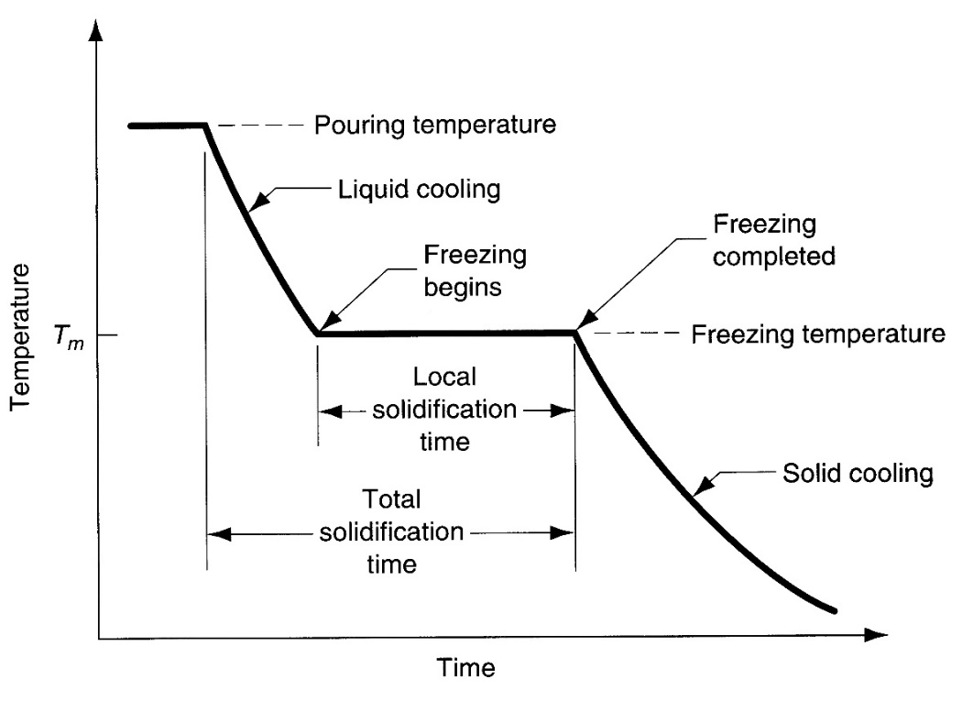
Cooling curve for a pure metal during casting
Problems on Solidification Time: Chvorinov's Rule.

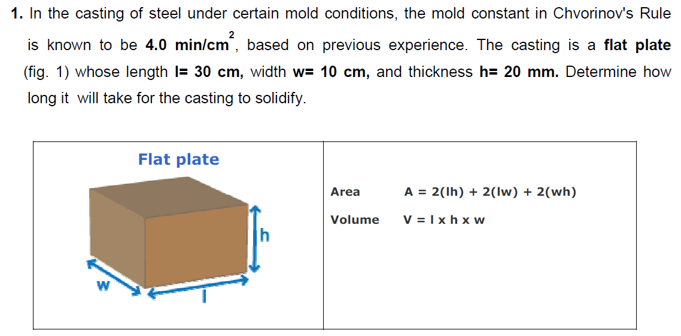

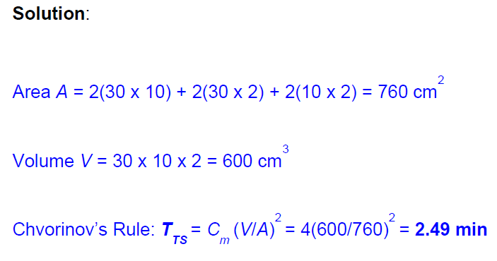
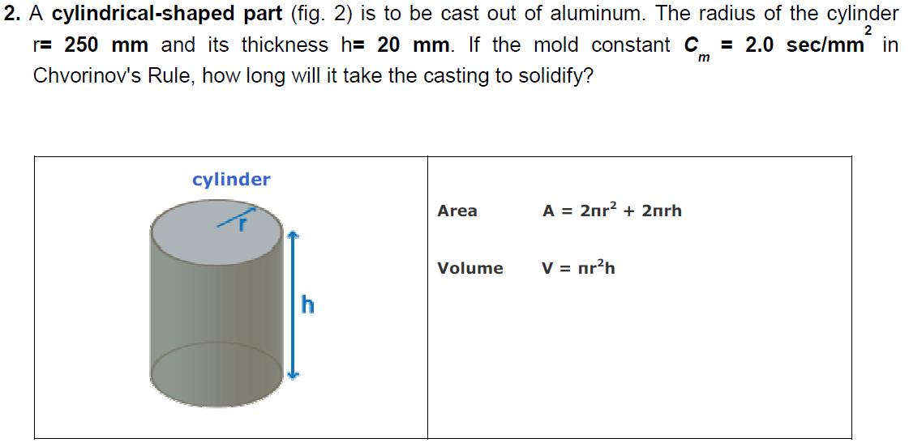

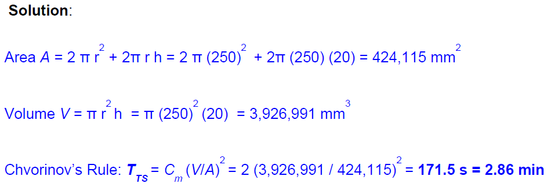

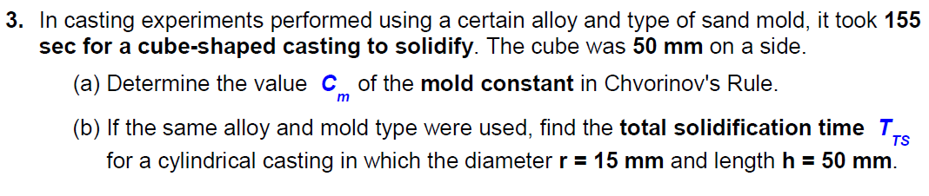
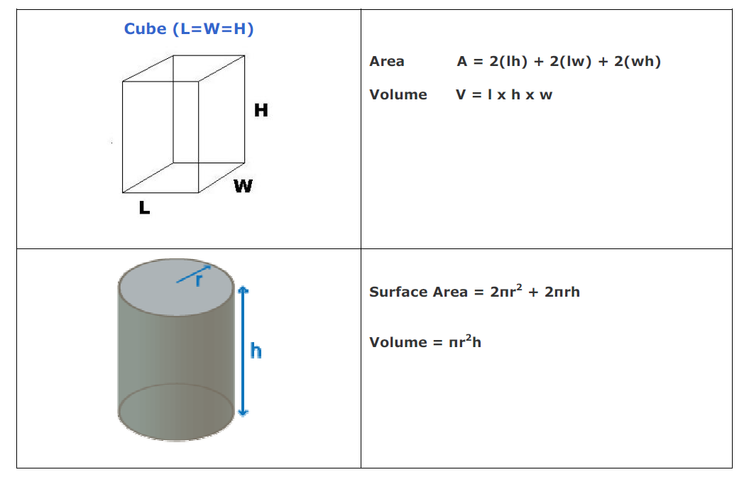
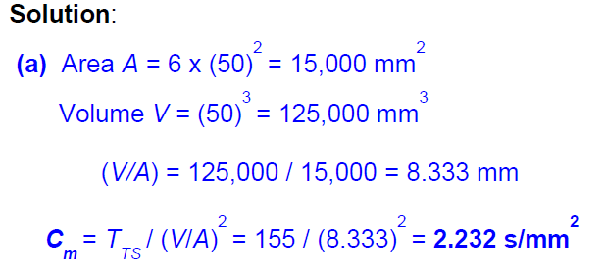

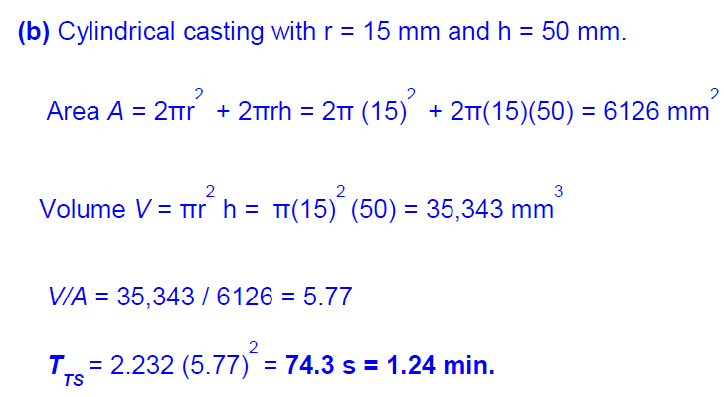

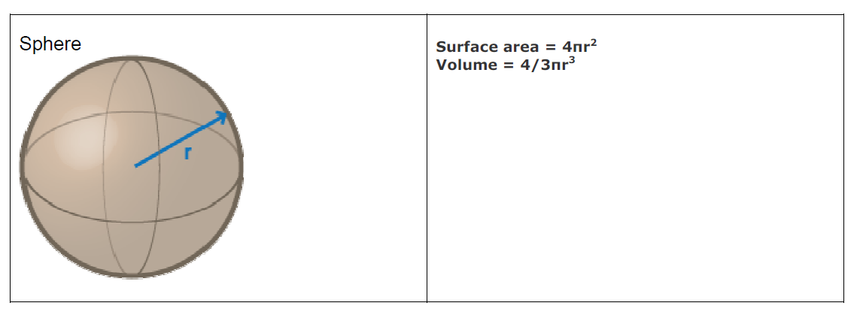
  - A molten drop of liquid metal which is in spherical form will solidify in 10 sec.
With 2 mm radius. What is the solidification time of same molten mass having double radius.

Solution:

Given: 1) t_{s1} = 10 sec. R₁ =-2mm
2) t_{s2} =? R₂ ₌ 2R₁

AS drop shape is sphere $\frac{V}{AS}=\left[\frac{D}{6}\right]=\left[\frac{R}{3}\right]$ $ts α \left(\frac{V}{AS}\right)$²

t_{s2} / t_{s1} = (R₂/3)² / (R₁/3)² = R₂² / R₁² = (2R₁)² / R₁ ²

ts₂ = ts₁ x 4 = 4 x 10 = 40 sec.

- A cubical casting will solidify in 5min. what is solidification time of same molten drop which is 8 times heavier than original casting

Solution:
Given: 5min, t_{s2} =?
Shape is cubical (V/ As = a/6)
Molten drop = 8 original casting m₂ = 8 m₁
ρ₂V₂ = 8 ρ₁V₁

V₂ = 8 V₁
a₂³ ₌ 8 a₁³
a₂ = 2a₁
t_{s1} $α$ $\left(\frac{V}{AS}\right)$² $α$ $\left(\frac{a}{6}\right)$²

ts₂ / ts₁ = a₂² / a₁² = 4a₁²/ a₁²

t_{s2} = 4 x t_{s1} = 4 x 5 = 20 min.

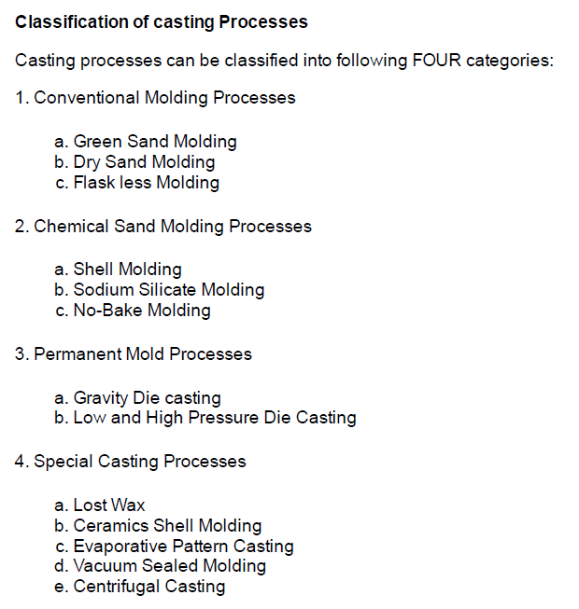

Sand Casting Process

Definition of Sand Casting: In sand casting which is also known as sand molded casting, an object is produced by sand mold. The process involves pouring of the molten metal in to the mold cavity. The molten metal is then cooled to the room temperature. The metal is solidified. After cooling, the metal object is separated from the mold.

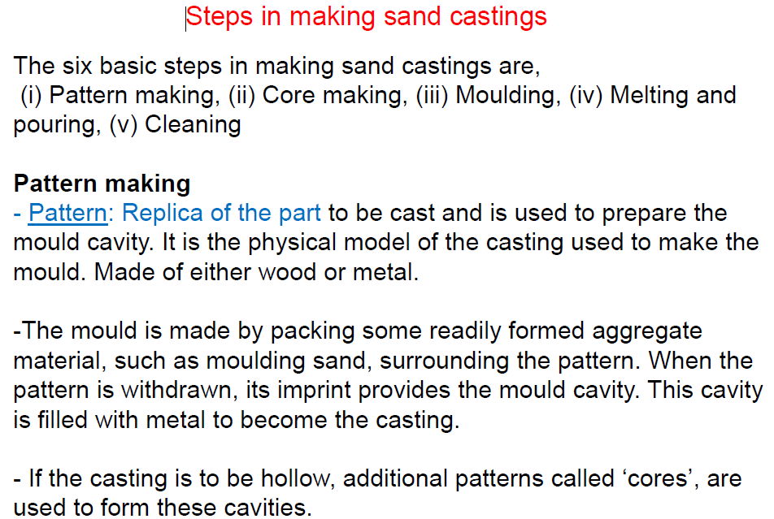

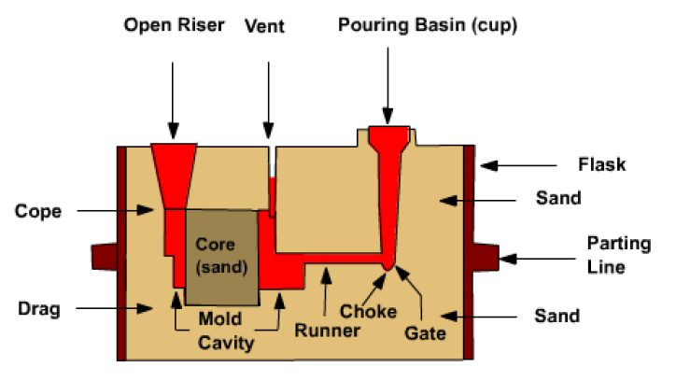
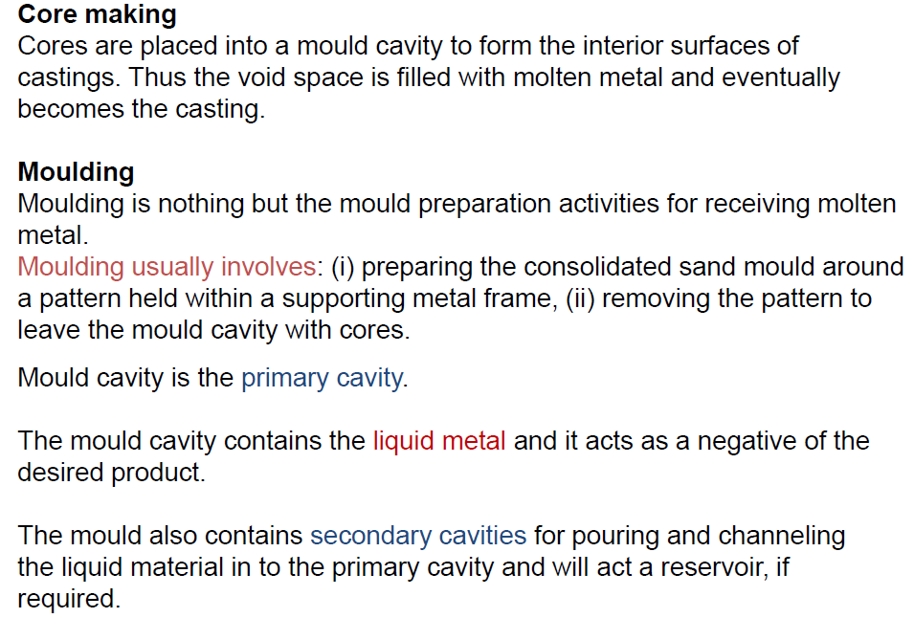
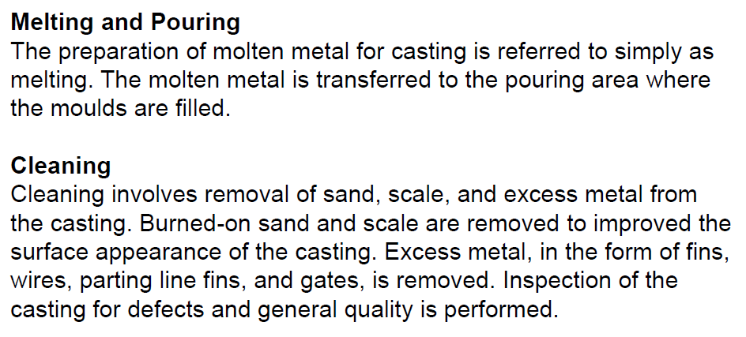
Process:

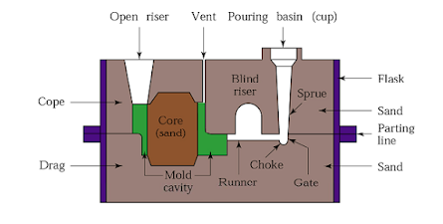
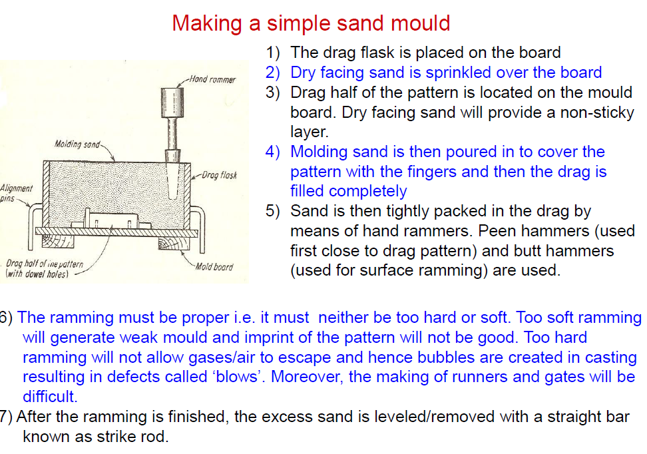
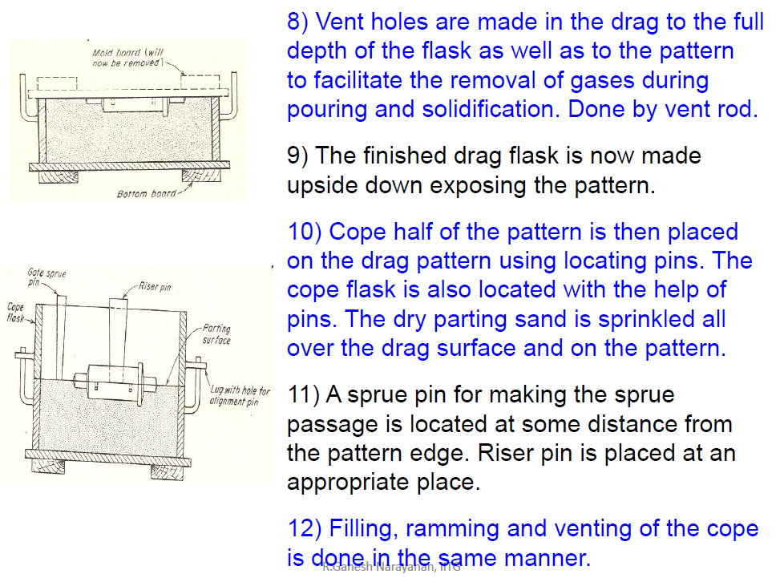
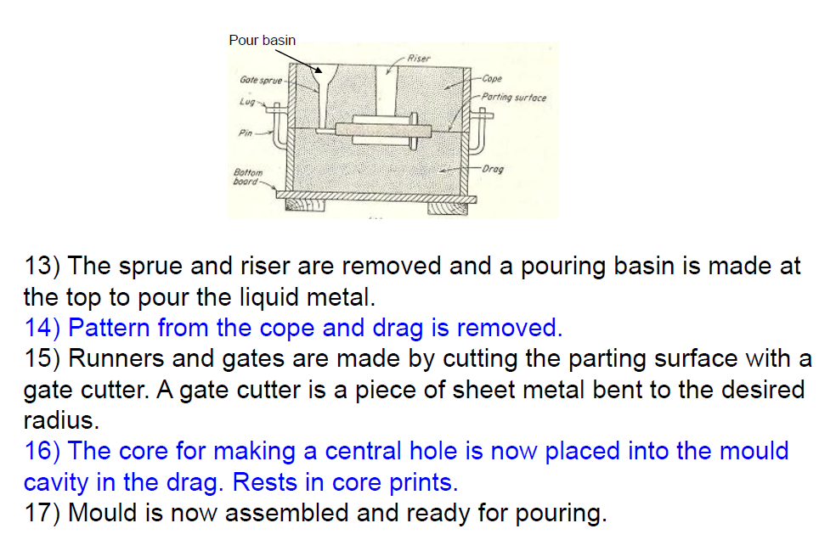

Sand casting advantages and disadvantages

Advantages of Sand casting
- Large parts can be produced
- Complex shapes can be casted easily
- Large selection of metal to choose from
- Tooling and equipment cost is low compared to some other metal forming processes
- Scrap metal can be recycled
- Short lead compared to other similar processes

Disadvantages of Sand casting
- Low material strength
- Low dimensional accuracy
- Poor surface finish
- High porosity
- Secondary machining operation often required
- Processing cost is high compared to tooling and material cost
- Safety hazards to humans and environmental problems
- Removal of pattern of the thin and small parts is very difficult
CONCEPT OF PATTERN
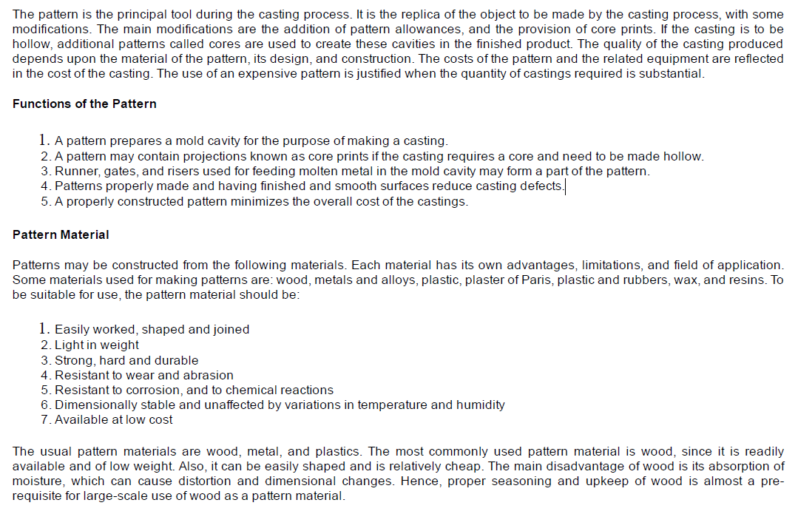

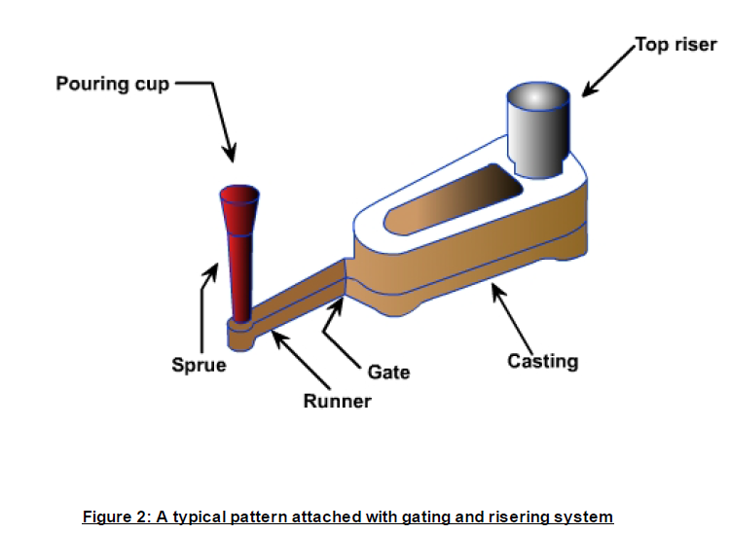

Pattern Allowances: Pattern allowance is a vital feature as it affects the dimensional characteristics of the casting. Thus, when the pattern is produced, certain allowances must be given on the sizes specified in the finished component drawing so that a casting with the particular specification can be made. The selection of correct allowances greatly helps to reduce machining costs and avoid rejections. The allowances usually considered on patterns and core boxes are as follows:
1. Shrinkage or contraction allowance
2. Draft or taper allowance
3. Machining or finish allowance
4. Distortion or camber allowance
5. Rapping allowance

The explanation of the above 5 types of allowances is as follows…

1. Shrinkage Allowance:
During cooling of the material in the Casting process, in all the three stages, the material is getting shrinking (reducing its dimensions or volume). But, shrinkage allowance taking place in 1st two stages is called Liquid Shrinkage.
- Shrinkage in 3rd – the stage is called Solid shrinkage.
- Liquid shrinkages are always compensated by providing a riser in the casting process.
- Liquid shrinkages are always specified as “% by Volume”.
- Out of the different metals cast in the industry, “Aluminum(Al) ” is having the highest liquid shrinkage which is about 6%.
- Solid shrinkage is specified as (Percentage/Dimensions).
- Solid shrinkage is influenced by four factors.

2. Machining Allowance:
The extra dimension provided on the casting and it will be removed by machining after the casting has been completed is called Machining Allowance.

3. Draft Allowance:
Making the vertical surfaces of the pattern into inclined surfaces is called Draft Allowance.

4. Shake Allowance:
To maintain the required size of the casting, the original size of the pattern has to be reduced by an amount called Shake Allowance.

5. Distortion Allowance:
To get the vertical legs of U shaped[Distortion Allowance complete]. the original pattern has to be bend inverse so that during solidification, the legs are bending outwards and becoming vertical legs.
The amount by which the legs are bending Inverse is called as Distortion or Bending allowance. This is the complete explanation of all types of allowances in a detailed manner.

Shrinkage or Contraction Allowance:
All most all cast metals shrink or contract volumetrically on cooling. The metal shrinkage is of two types: i. Liquid Shrinkage: it refers to the reduction in volume when the metal changes from liquid state to solid state at the solidus temperature. To account for this shrinkage riser, which feed the liquid metal to the casting, are provided in the mold.
ii. Solid Shrinkage: it refers to the reduction in volume caused when metal loses temperature in solid state. To account for this, shrinkage allowance is provided on the patterns. The rate of contraction with temperature is dependent on the material. For example steel contracts to a higher degree compared to aluminum. To compensate the solid shrinkage, a shrink rule must be used in laying out the measurements for the pattern. A shrink rule for cast iron is 1/8 inch longer per foot than a standard rule. If a gear blank of 4 inch in diameter was planned to produce out of cast iron, the shrink rule in measuring it 4 inch would actually measure 4 1/ 24 inch, thus compensating for the shrinkage. The various rate of contraction of various materials are given
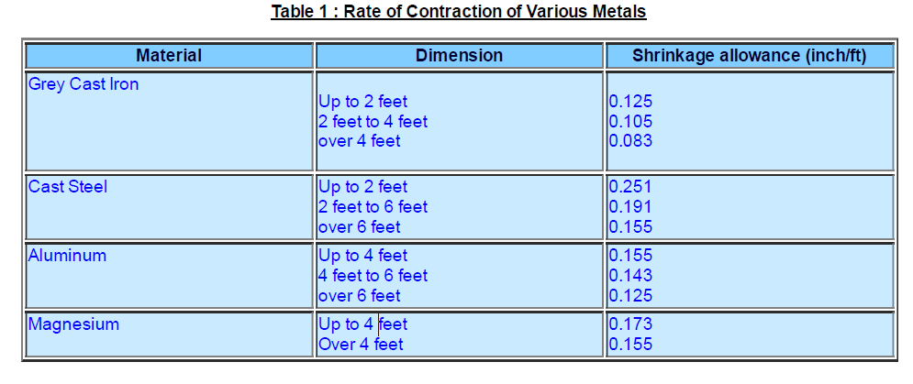
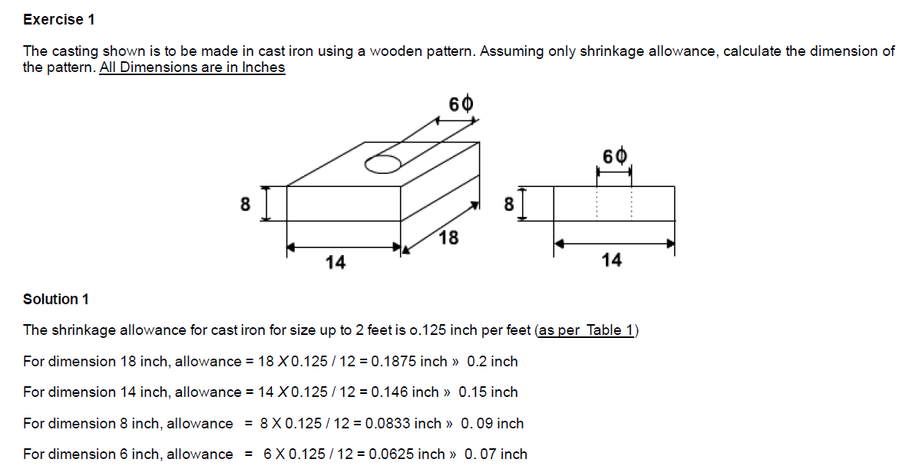
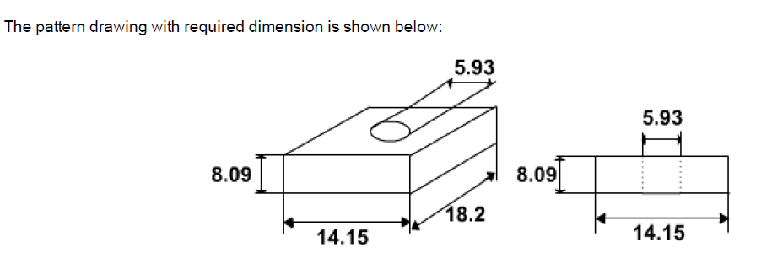

Draft or Taper Allowance
By draft is meant the taper provided by the pattern maker on all vertical surfaces of the pattern so that it can be removed from the sand without tearing away the sides of the sand mold and without excessive rapping by the molder. Figure 3 (a) shows a pattern having no draft allowance being removed from the pattern. In this case, till the pattern is completely lifted out, its sides will remain in contact with the walls of the mold, thus tending to break it. Figure 3 (b) is an illustration of a pattern having proper draft allowance. Here, the moment the pattern lifting commences, all of its surfaces are well away from the sand surface. Thus the pattern can be removed without damaging the mold cavity.
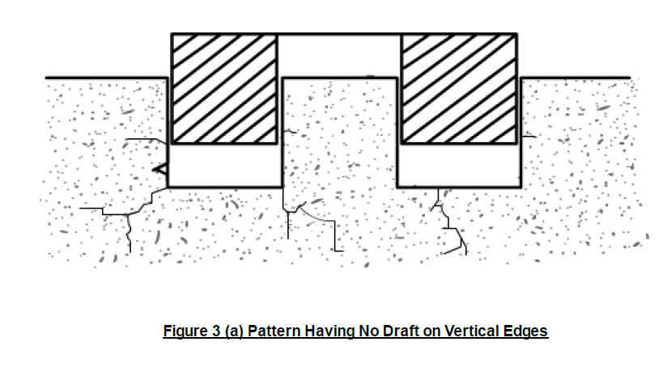
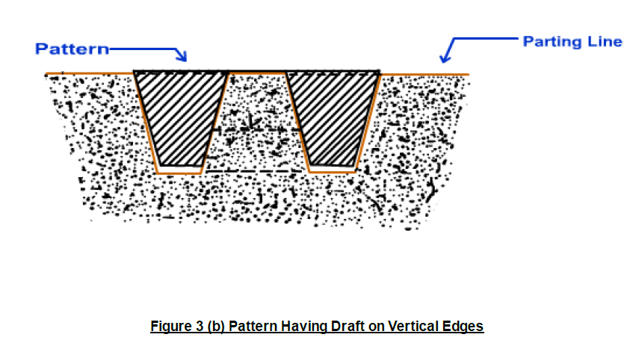

Draft allowance varies with the complexity of the sand job. But in general inner details of the pattern require higher draft than outer surfaces. The amount of draft depends upon the length of the vertical side of the pattern to be extracted the intricacy of the pattern; The method of molding and pattern material. Table 2 provides a general guide lines for the draft allowance.

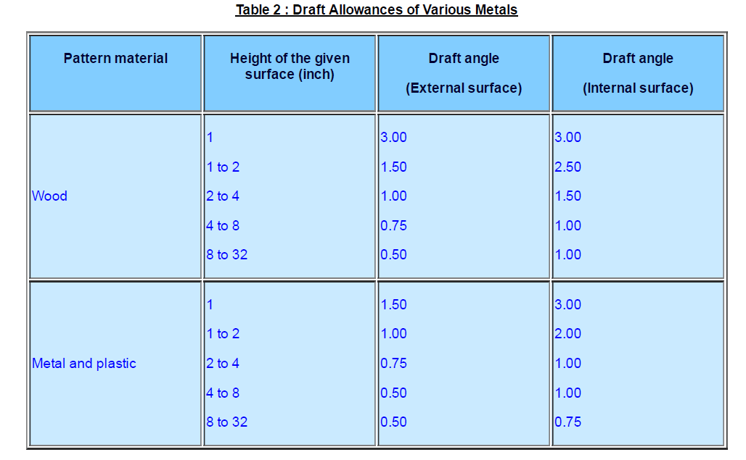

Machining or Finish Allowance The finish and accuracy achieved in sand casting are generally poor and therefore when the casting is functionally required to be of good surface finish or dimensionally accurate, it is generally achieved by subsequent machining. Machining or finish allowances are therefore added in the pattern dimension. The amount of machining allowance to be provided for is affected by the method of molding and casting used viz. hand molding or machine molding, sand casting or metal mold casting. The amount of machining allowance is also affected by the size and shape of the casting; the casting orientation; the metal and the degree of accuracy and finish required. The machining allowances recommended for different metal is given in Table 3
.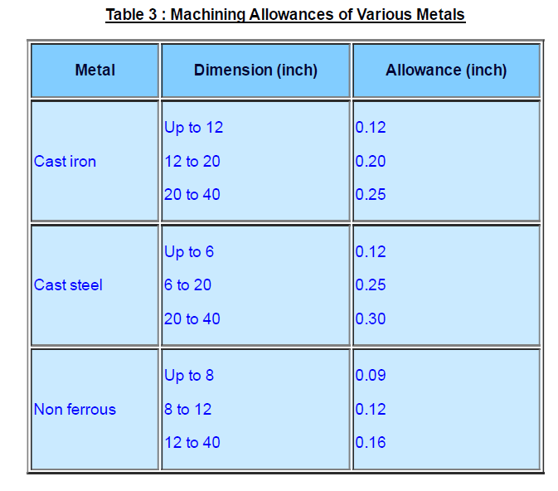
Exercise 2 The casting shown is to be made in cast iron using a wooden pattern. Assuming only machining allowance, calculate the dimension of the pattern. All Dimensions are in Inches

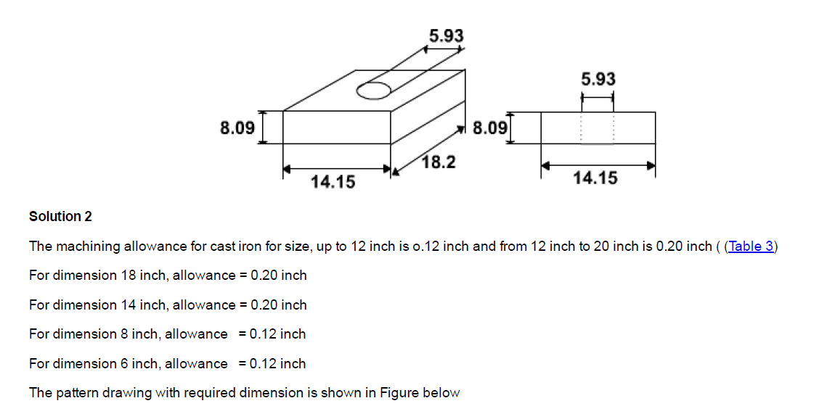
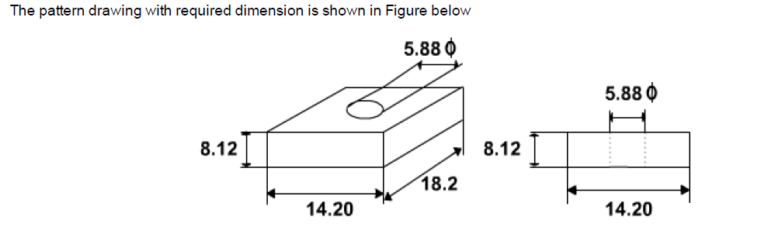

Distortion or Camber Allowance Sometimes castings get distorted, during solidification, due to their typical shape. For example, if the casting has the form of the letter U, V, T, or L etc. it will tend to contract at the closed end causing the vertical legs to look slightly inclined. This can be prevented by making the legs of the U, V, T, or L shaped pattern converge slightly (inward) so that the casting after distortion will have its sides vertical ( Figure 4). The distortion in casting may occur due to internal stresses. These internal stresses are caused on account of unequal cooling of different section of the casting and hindered contraction. Measure taken to prevent the distortion in casting include:
I.Modification of casting design
ii. Providing sufficient machining allowance to cover the distortion affect iii. Providing suitable allowance on the pattern, called camber or distortion allowance (inverse reflection)
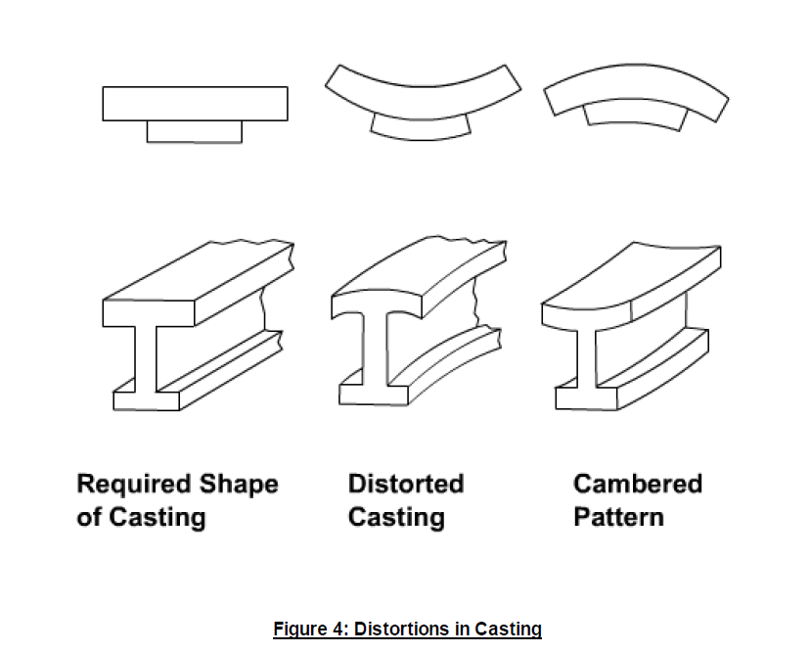
Rapping Allowance Before the withdrawal from the sand mold, the pattern is rapped all around the vertical faces to enlarge the mold cavity slightly, which facilitate its removal. Since it enlarges the final casting made, it is desirable that the original pattern dimension should be reduced to account for this increase. There is no sure way of quantifying this allowance, since it is highly dependent on the foundry personnel practice involved. It is a negative allowance and is to be applied only to those dimensions that are parallel to the parting plane.
Core and Core Prints Castings are often required to have holes, recesses, etc. of various sizes and shapes. These impressions can be obtained by using cores. So where coring is required, provision should be made to support the core inside the mold cavity. Core prints are used to serve this purpose. The core print is an added projection on the pattern and it forms a seat in the mold on which the sand core rests during pouring of the mold. The core print must be of adequate size and shape so that it can support the weight of the core during the casting operation. Depending upon the requirement a core can be placed horizontal, vertical and can be hanged inside the mold cavity. A typical job, its pattern and the mold cavity with core and core print is shown in Figure 5
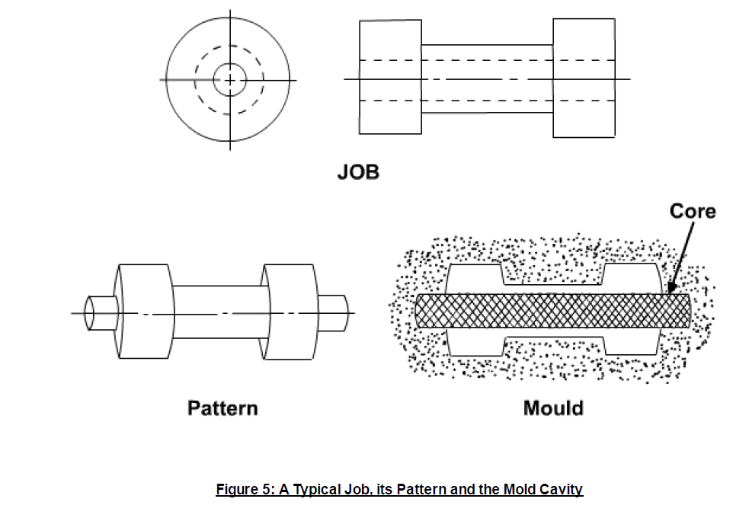
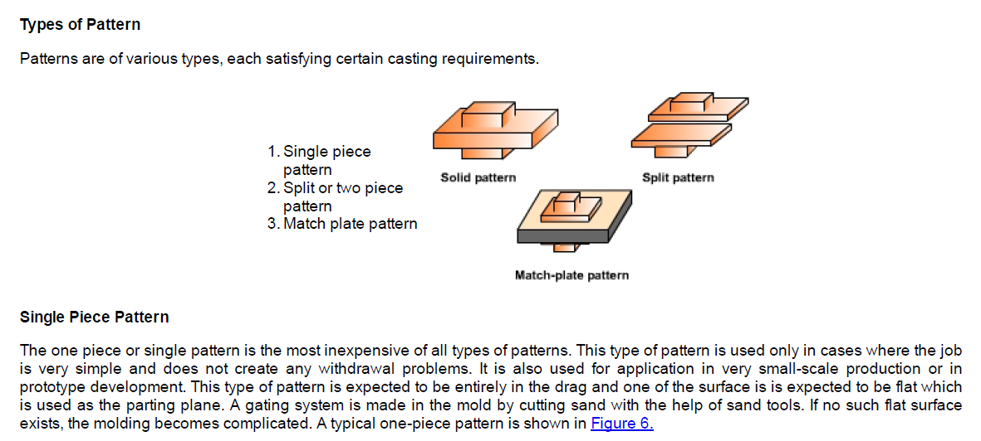

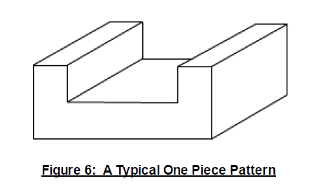

Split or Two Piece Pattern Split or two piece pattern is most widely used type of pattern for intricate castings. It is split along the parting surface, the position of which is determined by the shape of the casting. One half of the pattern is molded in drag and the other half in cope. The two halves of the pattern must be aligned properly by making use of the dowel pins, which are fitted, to the cope half of the pattern. These dowel pins match with the precisely made holes in the drag half of the pattern. A typical split pattern of a cast iron wheel Figure 7 (a) is shown in Figure 7 (b).
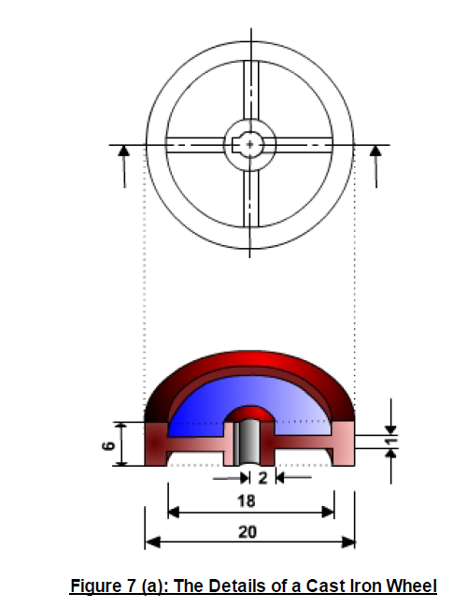
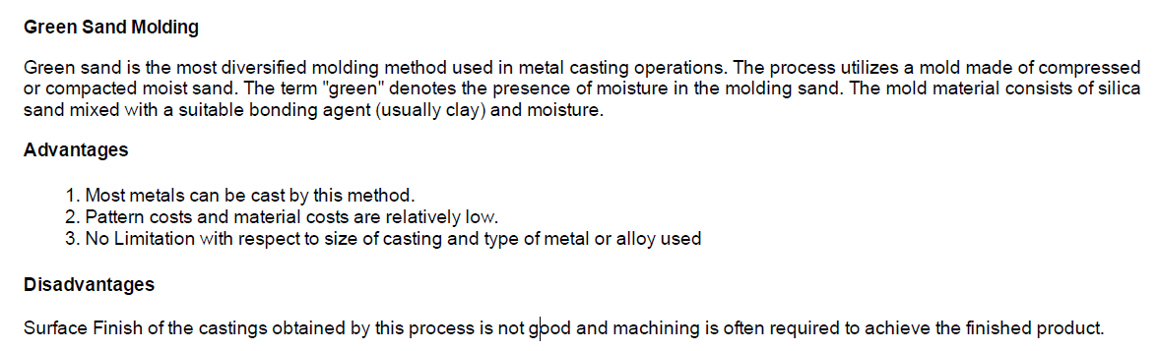
Molding Material and Properties
A large variety of molding materials is used in foundries for manufacturing molds and cores. They include molding sand, system sand or backing sand, facing sand, parting sand, and core sand. The choice of molding materials is based on their processing properties. The properties that are generally required in molding materials are: Refractoriness
It is the ability of the molding material to resist the temperature of the liquid metal to be poured so that it does not get fused with the metal. The refractoriness of the silica sand is highest.
Permeability During pouring and subsequent solidification of a casting, a large amount of gases and steam is generated. These gases are those that have been absorbed by the metal during melting, air absorbed from the atmosphere and the steam generated by the molding and core sand. If these gases are not allowed to escape from the mold, they would be entrapped inside the casting and cause casting defects. To overcome this problem the molding material must be porous. Proper venting of the mold also helps in escaping the gases that are generated inside the mold cavity.
Green Strength The molding sand that contains moisture is termed as green sand. The green sand particles must have the ability to cling to each other to impart sufficient strength to the mold. The green sand must have enough strength so that the constructed mold retains its shape.
Dry Strength When the molten metal is poured in the mold, the sand around the mold cavity is quickly converted into dry sand as the moisture in the sand evaporates due to the heat of the molten metal. At this stage the molding sand must posses the sufficient strength to retain the exact shape of the mold cavity and at the same time it must be able to withstand the metallostatic pressure of the liquid material.
Hot Strength As soon as the moisture is eliminated, the sand would reach at a high temperature when the metal in the mold is still in liquid state. The strength of the sand that is required to hold the shape of the cavity is called hot strength.
Collapsibility The molding sand should also have collapsibility so that during the contraction of the solidified casting it does not provide any resistance, which may result in cracks in the castings. Besides these specific properties the molding material should be cheap, reusable and should have good thermal conductivity.
Molding Sand Composition The main ingredients of any molding sand are:
Base sand,
Binder, and
Moisture
Binder Binders are of many types such as:
1. Clay binders,
2. Organic binders and
3. Inorganic binders
Clay binders are most commonly used binding agents mixed with the molding sands to provide the strength.
The most popular clay types are: Kaolinite or fire clay (Al2O3 2 SiO2 2 H2O) and Bentonite (Al2O3 4 SiO2 nH2O) of the two the Bentonite can absorb more water which increases its bonding power.
Moisture
Clay acquires its bonding action only in the presence of the required amount of moisture. When water is added to clay, it penetrates the mixture and forms a microfilm, which coats the surface of each flake of the clay. The amount of water used should be properly controlled. This is because a part of the water, which coats the surface of the clay flakes, helps in bonding, while the remainder helps in improving the plasticity.
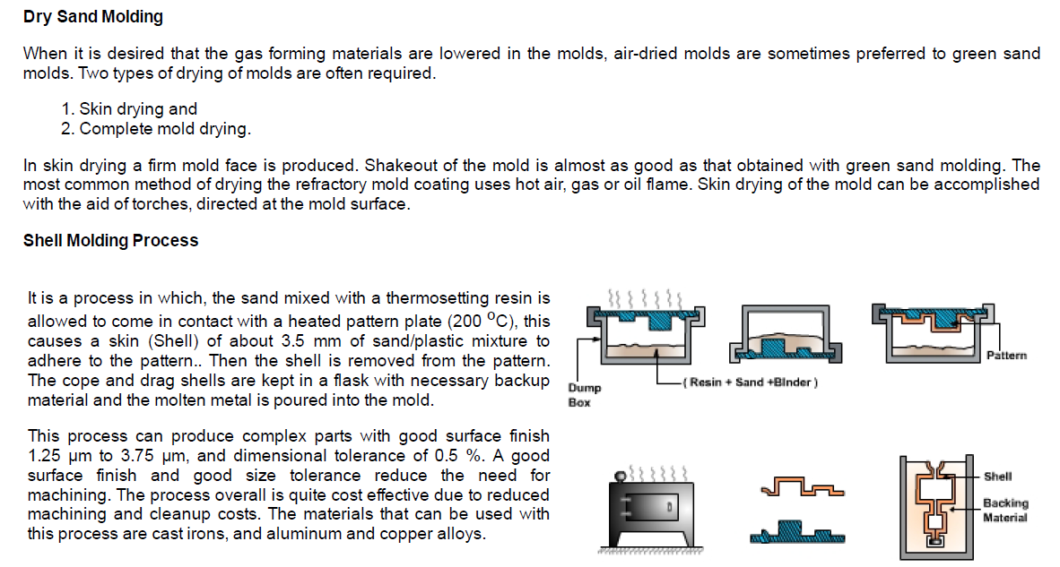

Comparative Advantages, Disadvantages and Applications for Various Casting Methods:

Sand Casting
Advantages | Disadvantages | Recommended Application
Least Expensive in small quantities (less than 100)  Ferrous and non - ferrous metals may be cast  Possible to cast very large parts.  &bull; Least expensive tooling | Dimensional accuracy inferior to other processes, requires larger tolerances  Castings usually exceed calculated weight  Surface finish of ferrous castings usually exceeds 125 RMS | Use when strength/weight ratio permits  Tolerances, surface finish and low machining cost does not warrant a more expensive process
Permanent and Semi-permanent Mold Casting
Less expensive than Investment or Die Castings  Dimensional Tolerances closer than Sand Castings  Castings are dense and pressure tight | Only non-ferrous metals may be cast by this process  Less competitive with Sand Cast process when three or more sand cores are required  Higher tooling cost than Sand Cast | Use when process recommended for parts subjected to hydrostatic pressure  Ideal for parts having low profile, no cores and quantities in excess of 300
Plaster Cast
Smooth "As Cast" finish (25 RMS)  Closer dimensional tolerance than Sand Cast  &bull; Intricate shapes and fine details including thinner "As Cast" walls are possible  &bull; Large parts cost less to cast than by Investment process | More costly than Sand or Permanent Mold-Casting  Limited number of sources  Requires minimum of 1 deg. draft | Use when parts require smooth "As Cast" surface finish and closer tolerances than possible with Sand or Permanent Mold Processes
Investment Cast
Close dimensional tolerance  Complex shape, fine detail, intricate core sections and thin walls are possible  Ferrous and non-ferrous metals may be cast  As-Cast" finish (64 - 125 RMS) | Costs are higher than Sand, Permanent Mold or Plaster process Castings | Use when Complexity precludes use of Sand or Permanent Mold Castings  The process cost is justified through savings in machining or brazing  Weight savings justifies increased cost
Die Casting
Good dimensional tolerances are possible  Excellent part-part dimensional consistency  Parts require a minimal post machining | Economical only in very large quantities due to high tool cost  Not recommended for hydrostatic pressure applications  For Castings where penetrant (die) or radiographic inspection are not required.  Difficult to guarantee minimum mechanical properties | Use when quantity of parts justifies the high tooling cost  Parts are not structural and are subjected to hydrostatic pressure

