Department of Electronics and Communication Engineering

Shri Jayachamarajendra college of Engineering, Mysuru-570006
BASIC ELECTRONICS/DIGITAL CIRCUITS LABORATORY
- Staff In-Charge : Dr. S B Rudraswamy ,Assistant Professor

Prof .Anupama, Assistant Professor
- Technical / Supporting Staff : K. S. Jayashree
Assistant Instructor
M J Philip
Mechanic
- Facilities Available:
CROs, signal generators, regulated power supplies, Multimeters. Breadboards, soldering facilities, CRO probes and other accessories. Power Supply, Measuring instruments and Electronic Components. Logic system trainer kits with associated accessories.
- Utilization :
This lab has state-of-the-art electronic equipment like Digital Storage Oscilloscopes, Large Bandwidth Signal Generators, high quality consumables and workbenches, measuring instruments and components. This lab trains the students in designing and understanding working of basic circuits like diodes, rectifiers, transistors which are needed for building large circuits for practical applications. They may also be used for student project works. This laboratory has high quality IC trainer kits and integrated circuits chips to train the students in designing and developing digital electronic circuits. The lab uses trainer kits and Logic gates to teach the students about Digital Electronic
Circuits.

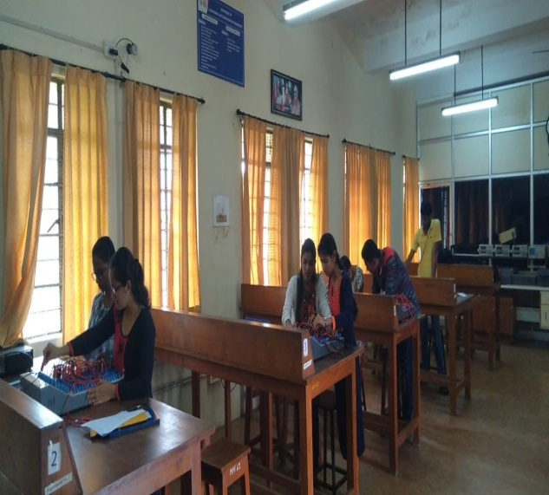
Digital Electronics Lab

