Department of Electronics and Communication Engineering

Shri Jayachamarajendra college of Engineering, Mysuru-570006
e-yantra Lab
Staff In-Charge : Dr. Sudarshan Patil Kulkarni
Professor
Shashidhar.R
Assistant Professor
- Facilities Available :
SJCE Robotics Lab established with support from TEQIP and e-Yantra is an advanced laboratory to execute state of the art projects. e-Yantra is a project initiated at IIT Bombay and sponsored by Ministry of Human Resources and Development, Government of India. Under this project, with additional support from TEQIP-2, Sri Jayachamarajendra College of Engineering of JSSSTU, has set up this Robotics laboratory with advanced robotic kits and equipments with a cost of Rs 25 Lakhs.

- Utilization :

Students design and execute projects throughout the year.

e-Yantra, IIT Bombay organizes mainly two types of competitions every year: (a)e-Yantra Robotics Competition (eYRC) (b) e-Yantra Ideas Competition (eYIC).

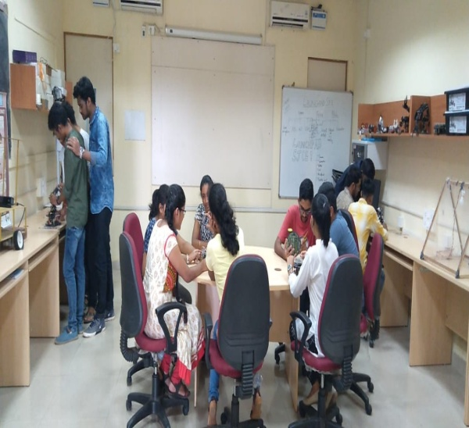
E-Yantra Lab

