

Department of Electronics and communication
Microcontroller LAB (EC420)

Jan-Apr 2020

Staff in Charge

Dr. Shankariah
Prof. Renuka B S

LAB EXPERIMENTS:

Software programs: To be implemented on 8051 microcontroller
1. Problems related with data transfer and exchange.
2. Problems related with arithmetic and logical operations.
3. Problems related with programming timers in all modes with and without interrupts.
4. Problems related with programming serial communication with and without interrupts.
5. Program related with handling external interrupts.
Hardware programs: To be implemented on 8051 and ARM CORTEX-M3 (using Embedded C)
1. Interface LCD.
2. Interfacing of matrix keypad.
3. Interfacing of ADC and DAC.
4. Interfacing of multi digit 7 segment displays.
5. Interfacing of stepper motor and D C motor.

MICROCONTROLLER LAB
Set of experiments
SET I
- Write an 8051 assembly level program to add 10 bytes of data.
- Write an 8051 assembly level program to transfer 10 bytes of data from external RAM location starting with 2000h to internal RAM starting from 30h.
- Write an 8051 assembly level program to transfer 10 bytes of data from location starting at 30h to location 35h.
- Write an 8051 assembly level program to transfer 10 bytes of data from location starting at 35h to location 30h.
- Write an 8051 assembly level program to exchange 10 bytes of data from location starting at 30h with data from location starting from 1000h.
- Write an 8051 assembly level program to transfer 10 bytes of data starting from location 8000h to location 9000h within the external memory.

SET II
- Write an 8051 assembly level program to add ‘N’ bytes of data taking into account the possible carry output.
- Write an 8051 assembly level program to add ‘N’ bytes of BCD numbers taking into account the possible carry output.
- Write an 8051 assembly level program to find the average of ‘N’ bytes of data.
- Write an 8051 assembly level program to subtract two BCD numbers.
- Write an 8051 assembly level program to add two multi-byte numbers.

SET III
- Write an 8051 assembly level program to count the number of even numbers and number of odd numbers in an array of ‘N’ bytes of data.
- Write an 8051 assembly level program to count the number of +ve numbers and number of -ve numbers in an array of ‘N’ bytes of data.
- Check whether the given byte of data is present in an array of ‘N’ bytes of data. If present send 00 in Port 0 else send FF in Port 0.
- Read the data from Port 1. If P1.1 is at logic 0, find the largest number in an array of ‘N’ bytes of data and store in location 40h. If P1.0 is at logic 1, find the smallest number in the array and store in the location 40h.

SET IV
- Write an 8051 assembly level program to arrange an array of ‘N’ bytes of data in ascending order.
- Write an 8051 assembly level program to arrange an array of ‘N’ bytes of data in descending order.
- Write an 8051 assembly level program to find whether the given number is prime or not. If prime send FF to Port 0 else send 00 to Port 0.
- Write an 8051 assembly level program to find the factorial of a given number (using recursive procedure).
- Write an 8051 assembly level program for BCD up counter. Show each count in Port 0 with appropriate delay.
- Write an 8051 assembly level program for BCD down counter. Show each count in Port 0 with appropriate delay.
SET V
- Write an 8051 assembly level program to check whether the given byte of data is palindrome. If ‘yes’ send 00 to Port 0 else send FF to Port 0.
- Write an 8051 assembly level program to check whether the lower nibble is greater than higher nibble of A. If ‘yes’ send 00 to Port 0 else send FF to Port 0.
- Write an 8051 assembly level program to convert 2 digit BCD to ASCII numbers and store them in location 30h(LSB) and 31h(MSB).
- Write an 8051 assembly level program to find the square of a number using look up table technique.
- Write an 8051 assembly level program to find the square root of a number.

SET VI
- Write an 8051 assembly level program to find LCM and HCF of two numbers.
- Write an 8051 assembly level program to check whether the given number is 2 out of 5 code. If ‘yes’ send 00 to Port 0 else send FF to Port 0.
- Write an 8051 assembly level program to generate Fibonacci series.

SET VII
- Write an 8051 assembly level program to generate square wave on P1.5 with 50% duty cycle. Program timers in mode 0, mode1 and mode2 to generate the delay.
- Write an 8051 assembly level program to generate square wave with ON period of 20ms and OFF period of 40ms. Use timers in mode 0, mode 1 and mode 2 to generate the delay.
- Repeat the problems with interrupt for timers.
- Repeat the above problems by writing programs in embedded C.

SET VIII
- A switch is connected to P2.5. write an 8051 assembly level program to read the status of switch and if switch is closed send serially ‘HELLO’, else send ‘WELCOME’ at baud rate 9600.
- Write an 8051 assembly level program to transfer a message SJCE serially by programming serial communication in interrupt mode with baud rate 9600.
- Repeat the problem 1 & 2 using embedded C program.

SET IX
- Interface 4 digit multiplexed 7 segments LED and writes a program to display the message SJCE.
- Interface 4x4 hex keyboards and write a program to read the key closure and display hex code for key pressed on 7 segment display.
SET X
- Interface LCD module and write program to display a message.
- Interface ADC a write a program to sample the signal and convert it into digital
- Interface DAC and write program to generate various waveforms.

SET 1 PROGRAMS

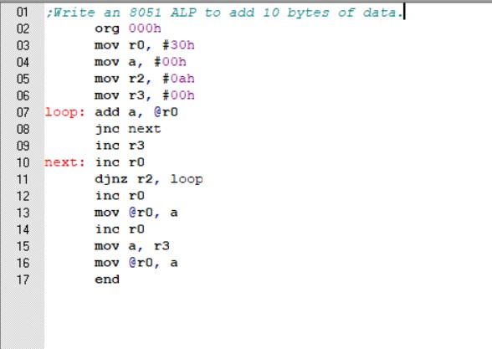
1. WRITE AN 8051 ALP TO ADD 10 BYTES OF DATA

Before Execution:
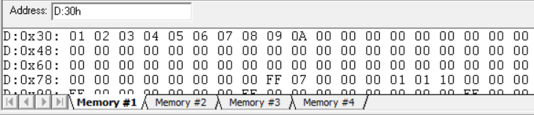

After Execution:

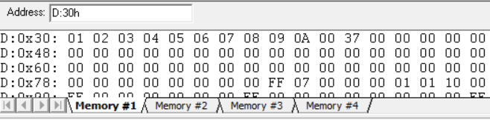

2 Write an 8051 assembly level program to transfer 10 bytes of data from external RAM location starting with 2000h to internal RAM starting from 30h
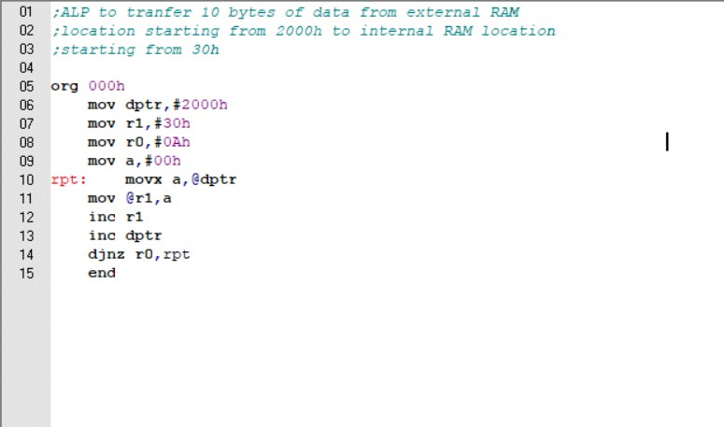

Before Execution:

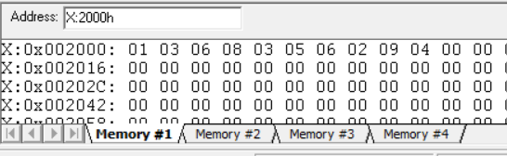
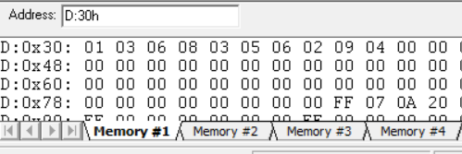
After Execution:

3.Write an 8051 assembly level program to transfer 10 bytes of data from location starting at 30h to location 35h.
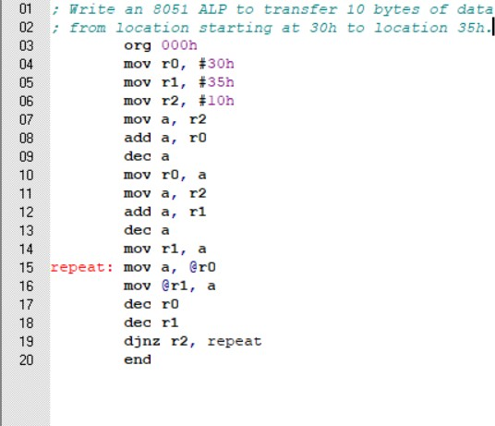

Before Execution :

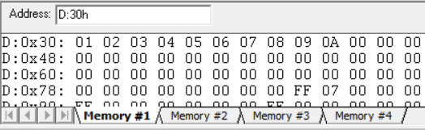

After Execution:
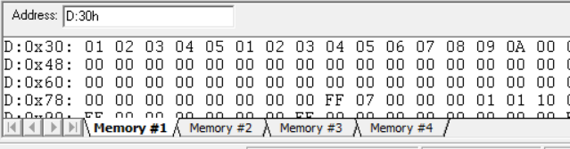

4.Write an 8051 assembly level program to transfer 10 bytes of data from location starting at 35h to location 30h.
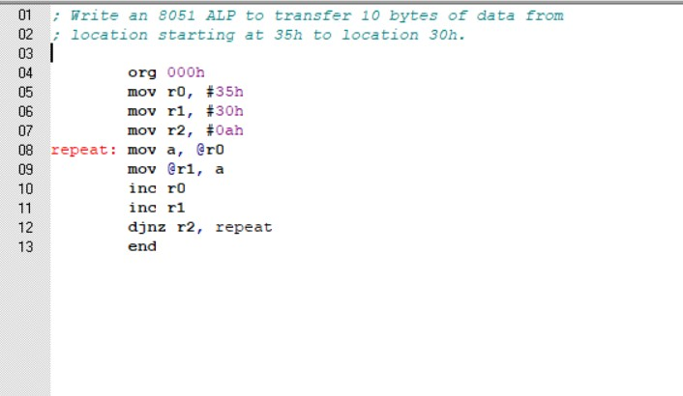
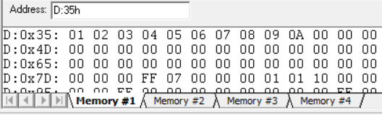
Before Execution:

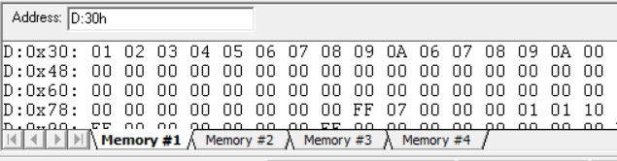
After execution:

3. Write an 8051 assembly level program to exchange 10 bytes of data from location starting at 30h with data from location starting from 1000h.
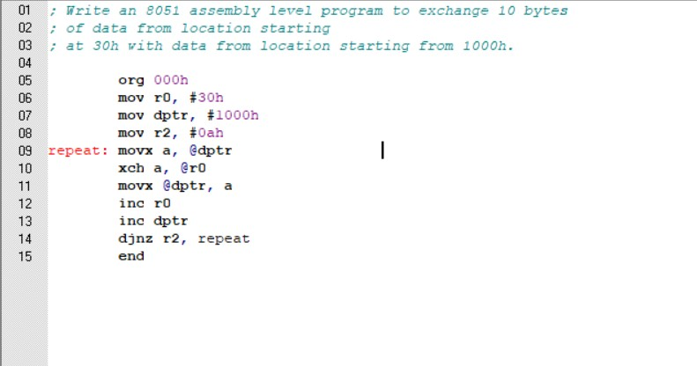

Before Execution
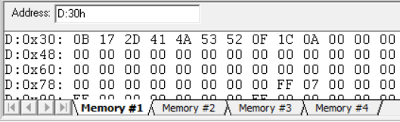
1000h:0BH,17H,2DH,41,4AH,53,52H,0FH,1CH,0AH
30H: 01H,02H,3H,4H,5H,6H,7H,8H,9H,0AH

After Execution:
30H: 0BH, 17H, 2DH, 41, 4AH, 53, 52H, 0FH, 1CH, 0AH
1000H:01H,02H,3H,4H,5H,6H,7H,8H,9H,0AH
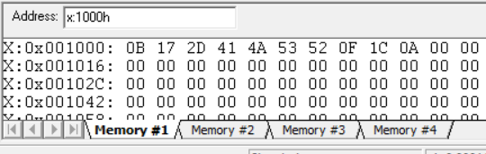

4. Write an 8051 assembly level program to transfer 10 bytes of data starting from location 8000h to location 9000h within the external memory.

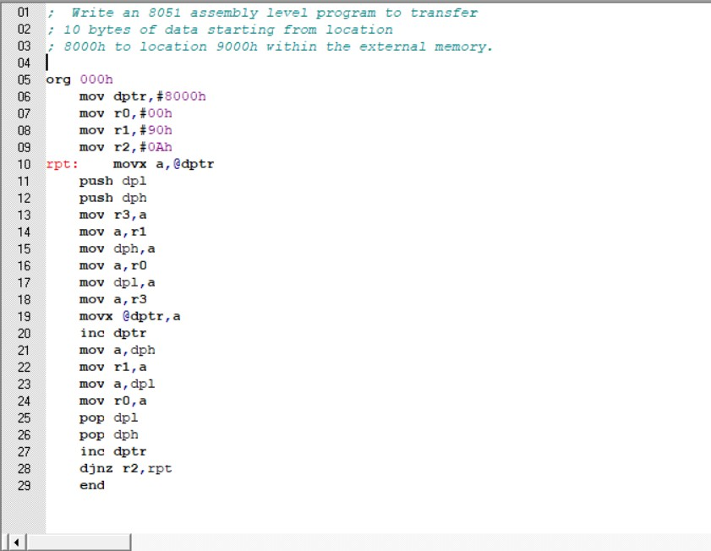

Before Execution:

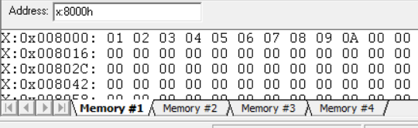

After Execution:

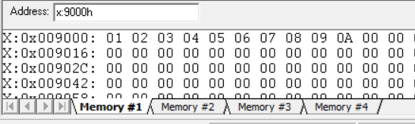

SET 2 PROGRAMS

- Write an alp to add N bytes of data taking into account the possible carry output.
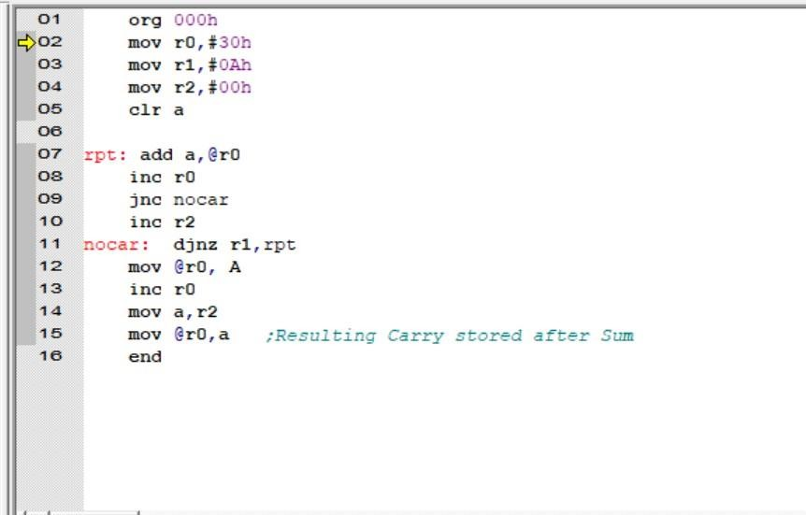

Before Execution:
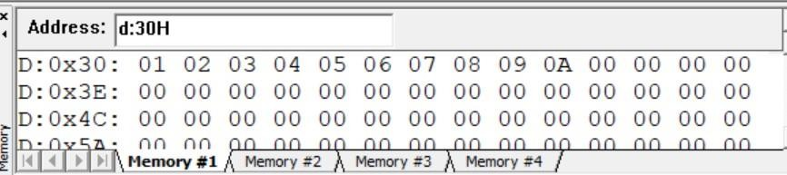
After Execution:

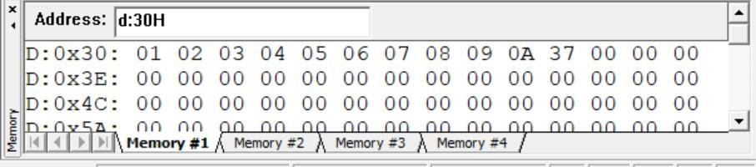

2. Write an alp to add N bytes of BCD numbers talking into account the possible carry output.
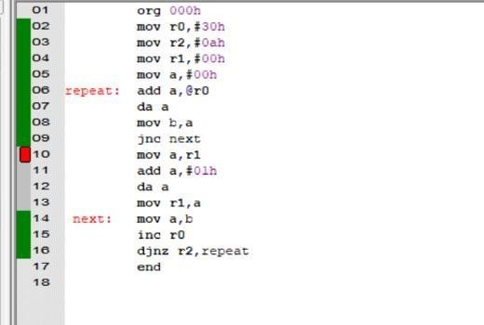

Before Execution:
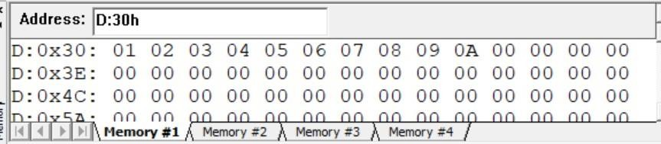

After Execution:

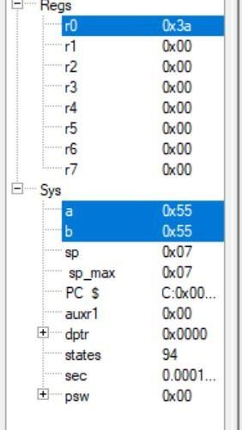

3. Write an alp to find the average of N bytes of data.

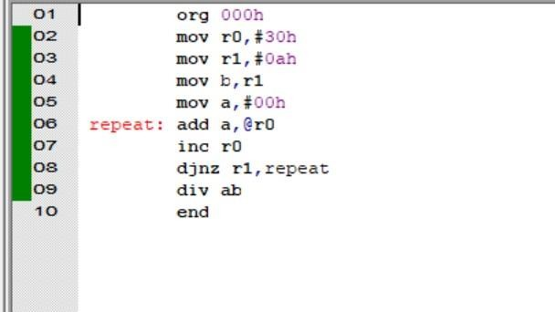
Before Execution:
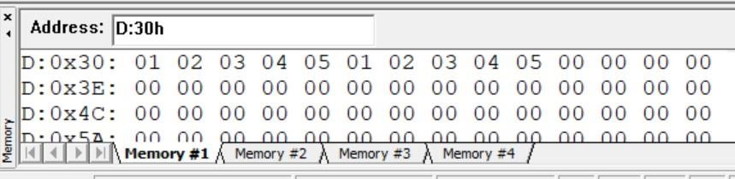

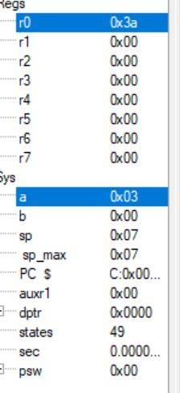
After Execution

4. Write an alp to subtract two BCD numbers.
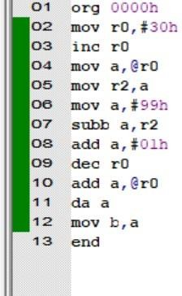

Before Execution:
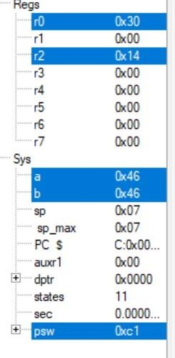
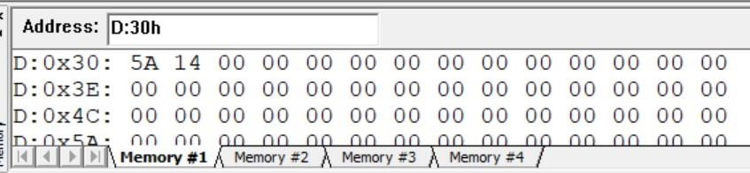

After Execution:
5. Write an alp to add 2 multibyte numbers. Numbers starts from location with address 30h and 40h. Store the results starting from location 30h.

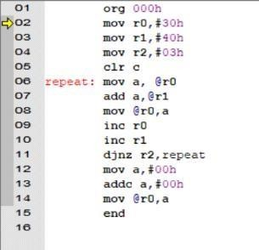

Before Execution:

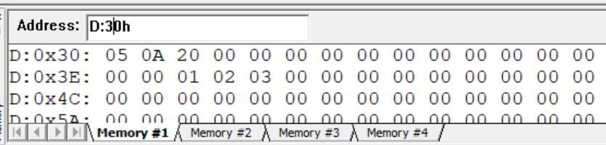

After Execution:
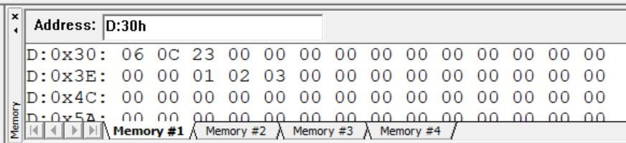

SET 3 PROGRAMS

- Write an 8051 assembly level program to count the number of even
Numbers and number of odd numbers in an array of ‘N’ bytes of data

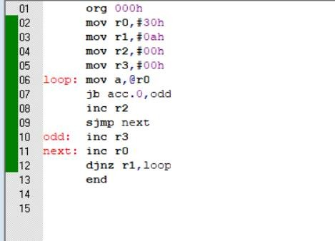

Before execution
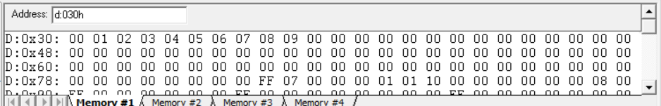

After Execution

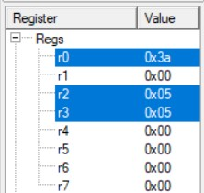
- Write an 8051 assembly level program to count the number of +ve numbers and number of –ve numbers in an array of ‘N’ bytes of data.

MSB bit of data represents sign of the number. If MSB is 1, then the number is negative.
If MSB is 0, then the number is positive
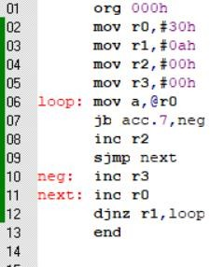

Before execution:

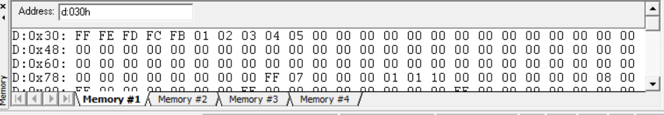

After execution

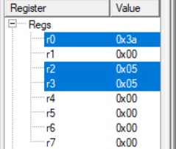

- Check whether the given byte of data is present in an array of ‘N’ bytes of data. If present send 00 in Port 0 else send FF in Port 0
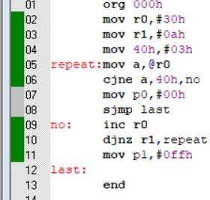

Before execution:
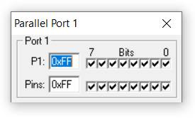
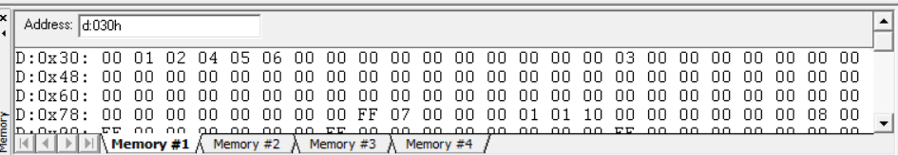

After Execution:

- Read the data from Port1. IfP1.1 is at logic0, find the largest number in an array of ‘N’ bytes of data and store in location 40h. If P1.0 is at logic1, find the smallest number in the array and store in the location 40h

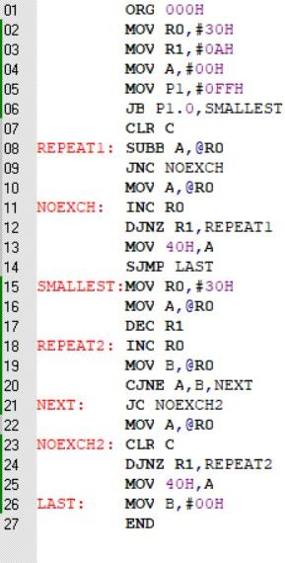

Before execution:
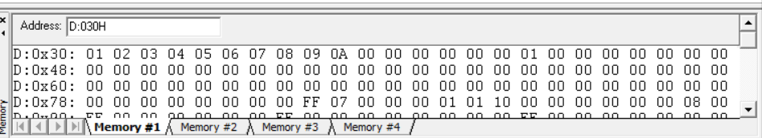
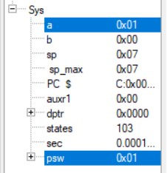

After execution:

SET 4 PROGRAMS

- Write an 8051 assembly level program to arrange an array of ‘N’ bytes of
data in ascending order.
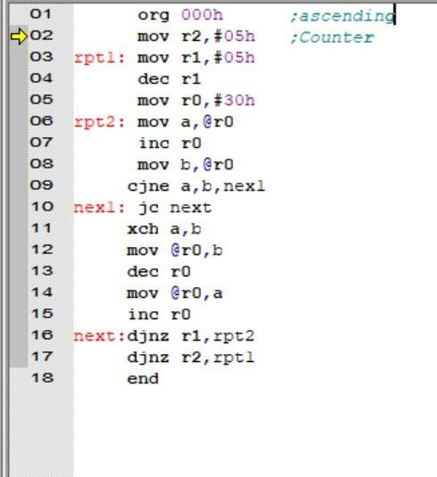

Before Execution:
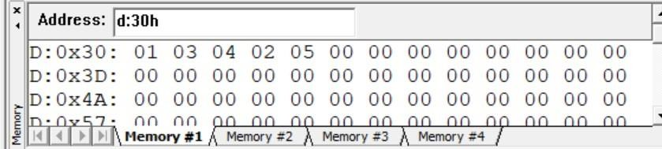

After Execution:
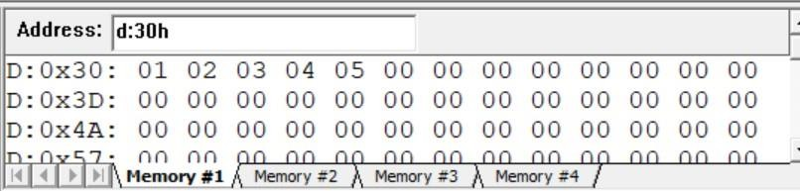

- Write an 8051 assembly level program to arrange an array of ‘N’ bytes of
data in descending order.
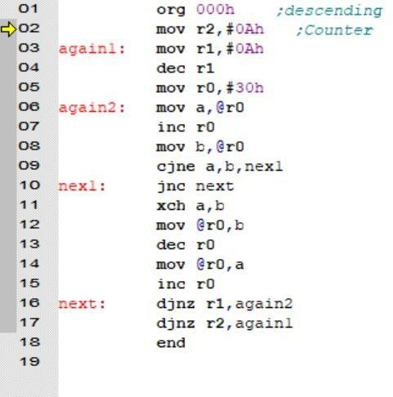

Before Execution:
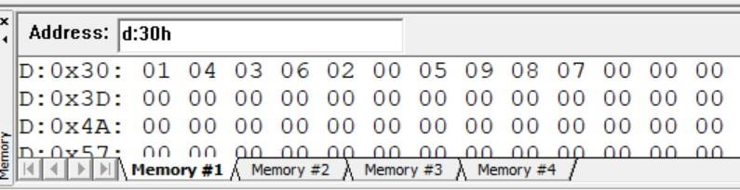

After Execution:
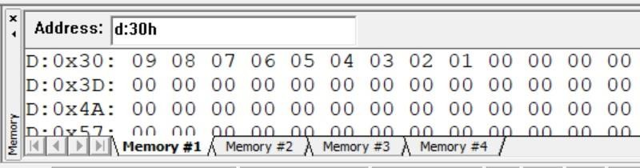

- Write an 8051 assembly level program to find whether the given number is prime or not. If prime send FF to Port 0 else send 00 to Port 0.
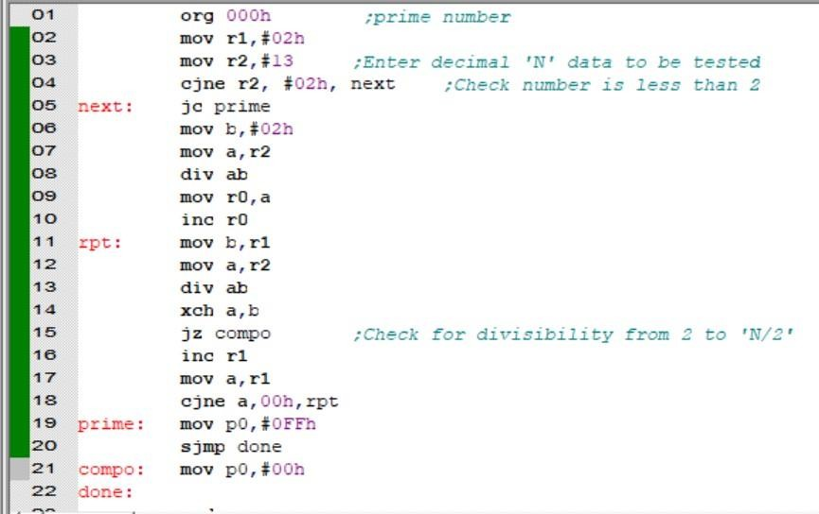

After Execution:
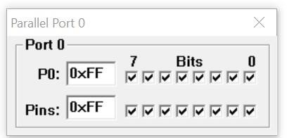

- Write an 8051 assembly level program to find the factorial of a given number (using recursive procedure).
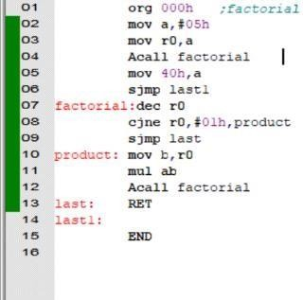

After Execution:

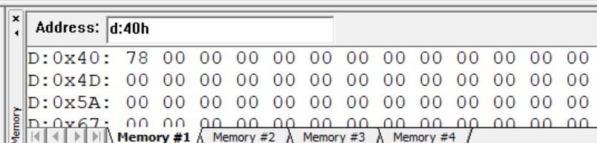

- Write an 8051 assembly level program for BCD up counter. Show each count in Port 0 with appropriate delay.

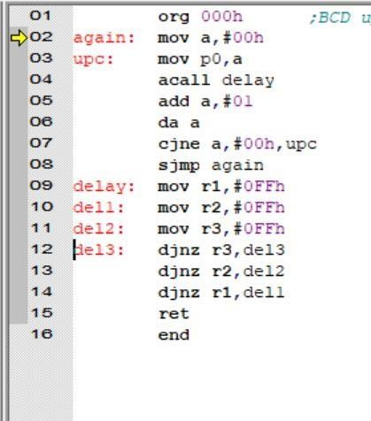
After Execution:

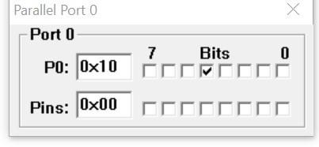

- Write an 8051 assembly level program for BCD down counter. Show each count in Port 0 with appropriate delay.
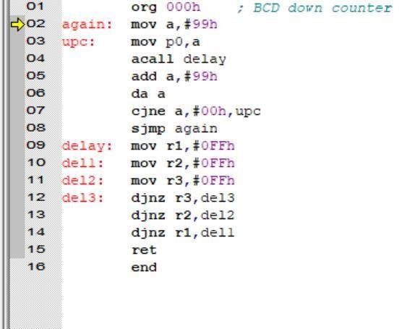

After Execution:

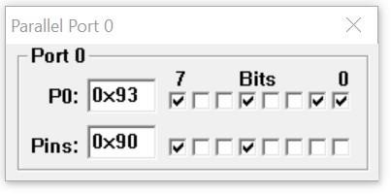

SET 5 PROGRAMS

- 1.Write an 8051 assembly level program to check whether the given
byte of data is palindrome. If ‘yes’ send 00 to Port 0 else send FF to Port 0
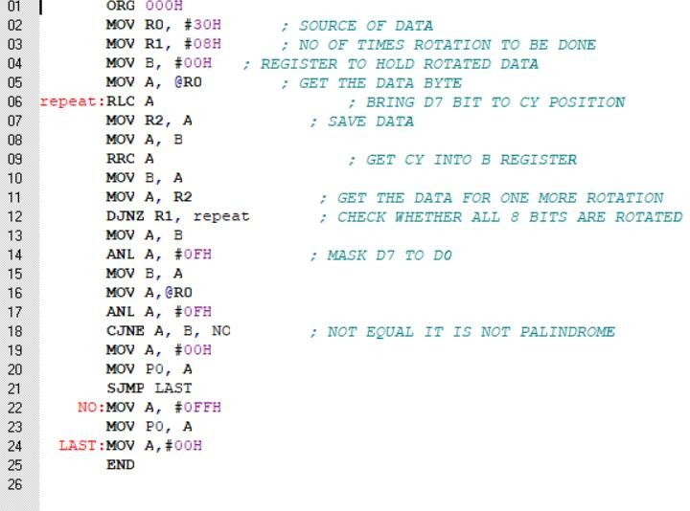

Before and after execution

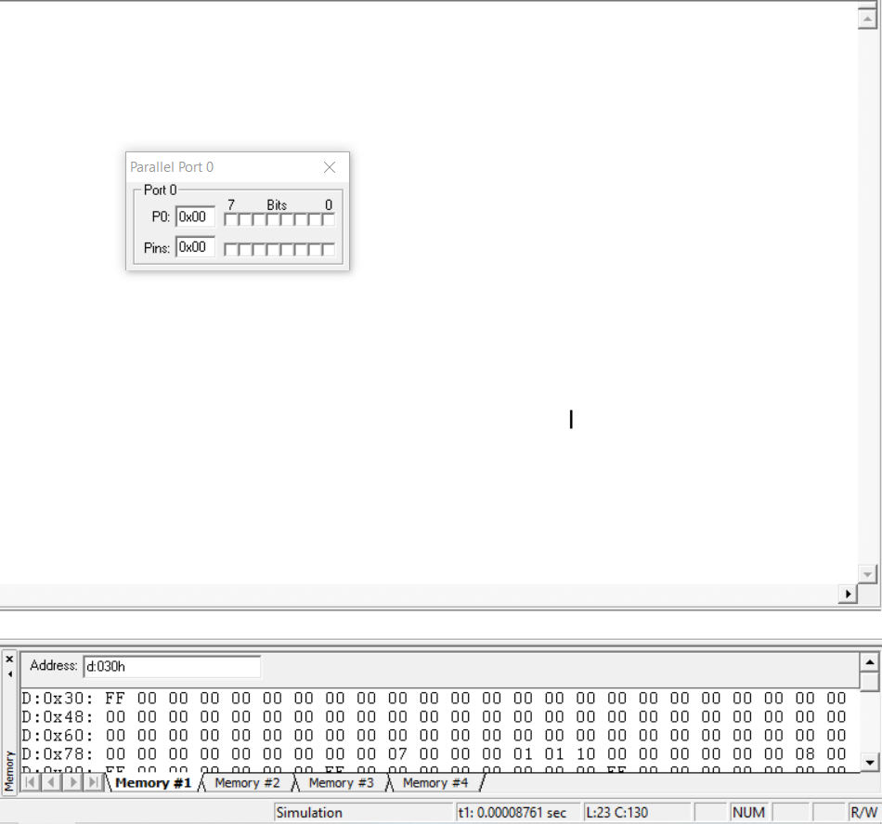

- Write an 8051 assembly level program to check whether the lower
nibble is greater than upper nibble of A. If ‘yes’ send 00 to Port 0 else send FF to Port 0.
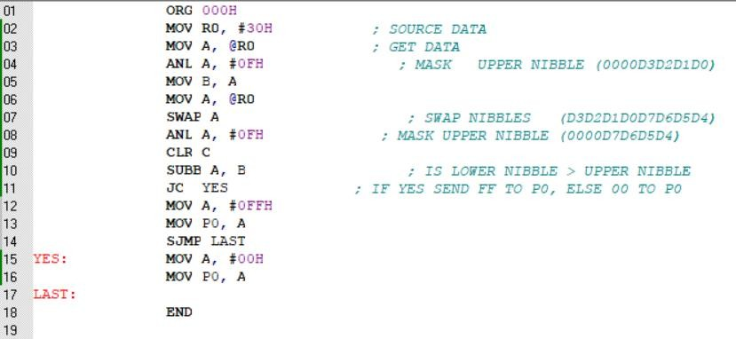

Before execution
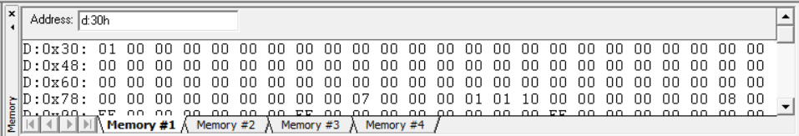

After execution

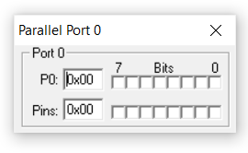

- Write an 8051 assembly level program to convert 2 digit BCD to ASCII numbers and store them in location 30h(LSB) and 31h(MSB)
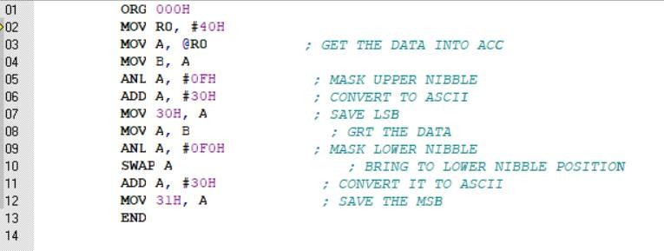

Before execution
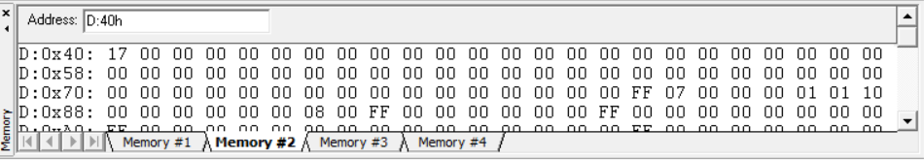

After execution
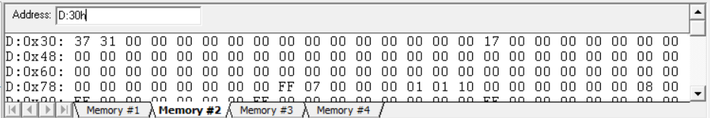

4. Write an 8051 assembly level program to find the square of a number using look up table technique

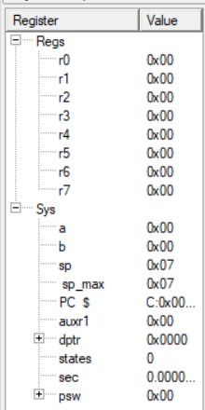
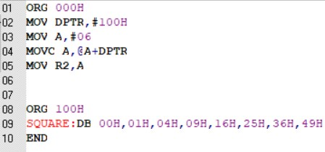

Before execution

After execution

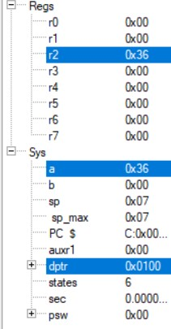

4.Write an 8051 assembly level program to find the square root of a number
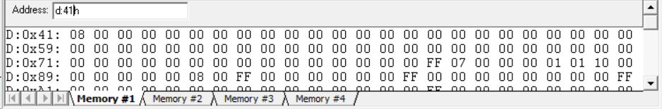
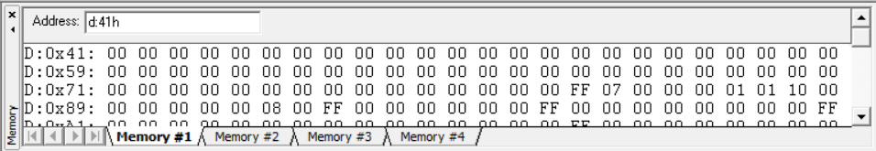
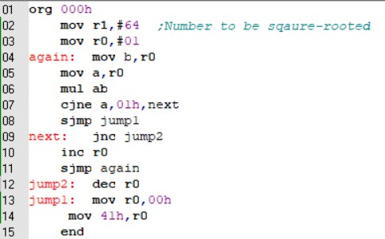

Before execution

After execution
SET 6 PROGRAMS

1.Write a assembly level program (8051) to check if the number is a 2 out of 5 code or not.
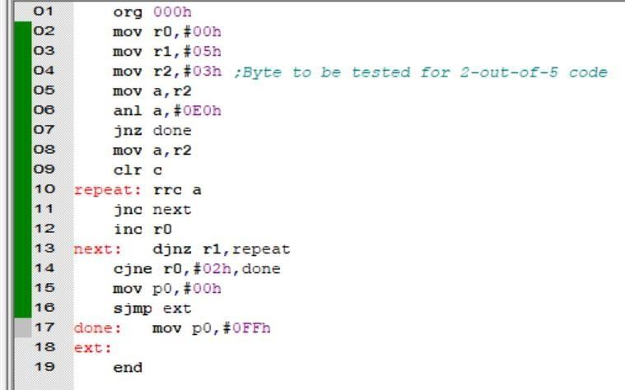
After Execution:
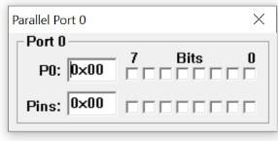

2.Write a assembly level program to find the Fibonacci series.
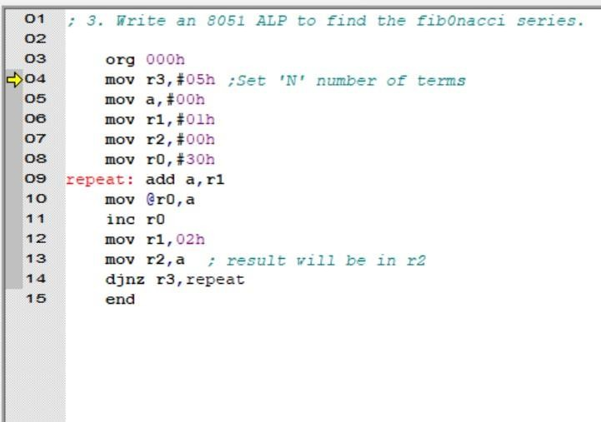

Before Execution:
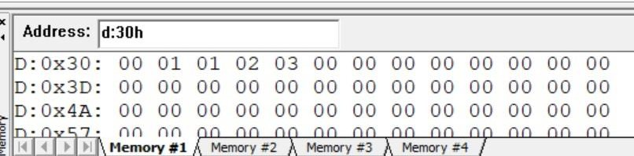

After Execution:
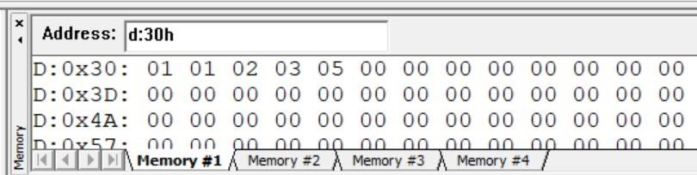

3. Write an assembly level program to find LCM and HCF of 2 numbers.
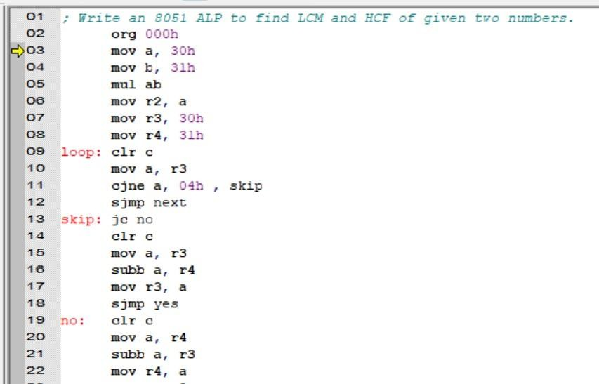
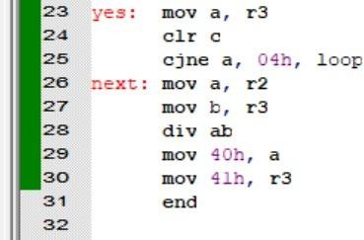

Before Execution:
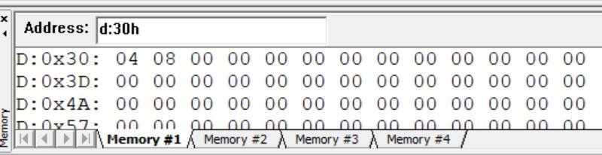

After Execution:

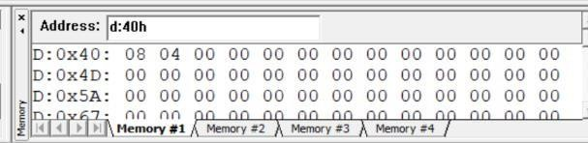

SET 7 PROGRAMS

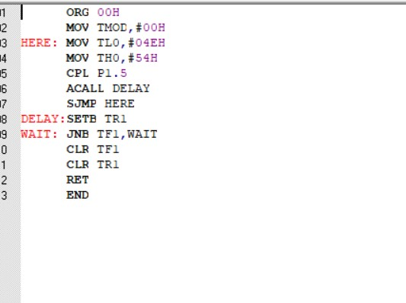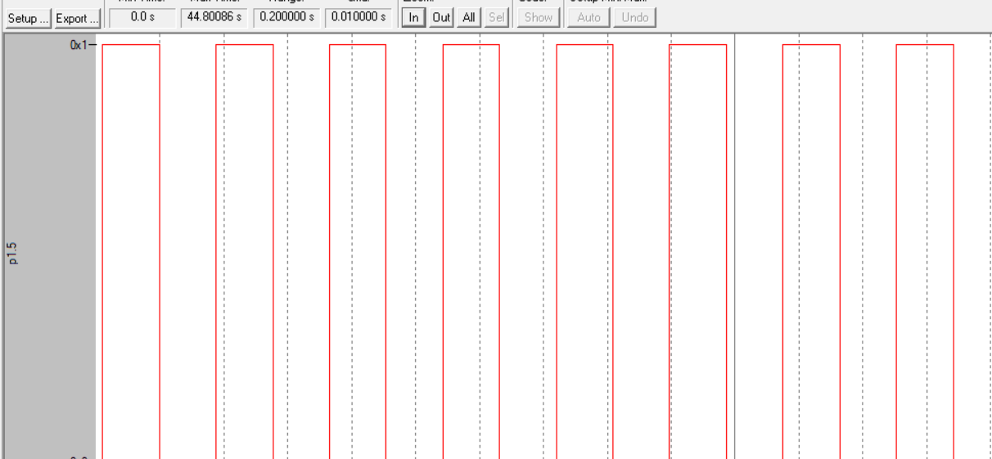
- WAP to generate a square wave on P1.5 with 50% Duty Cycle. Program timers in mode0, mode1 and mode2 to generate delay.
Mode 0

After execution

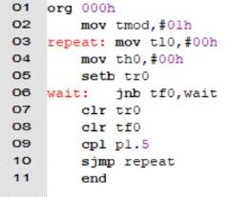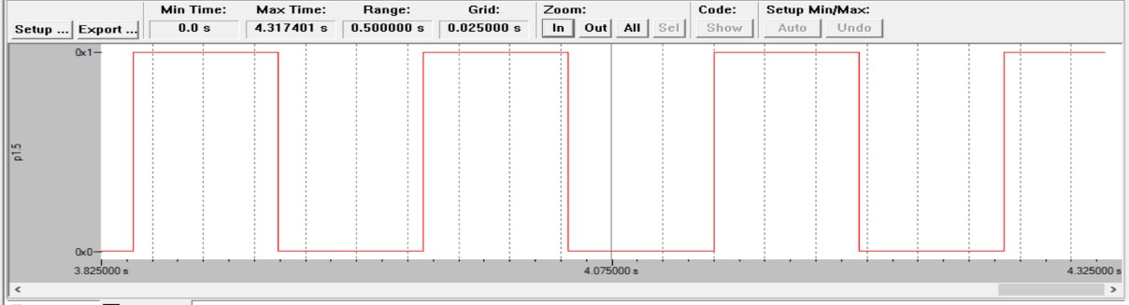

Mode 1

After execution

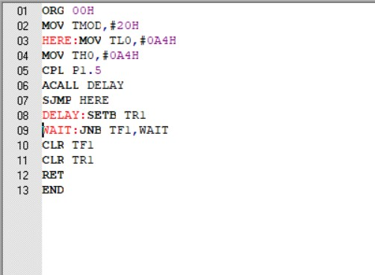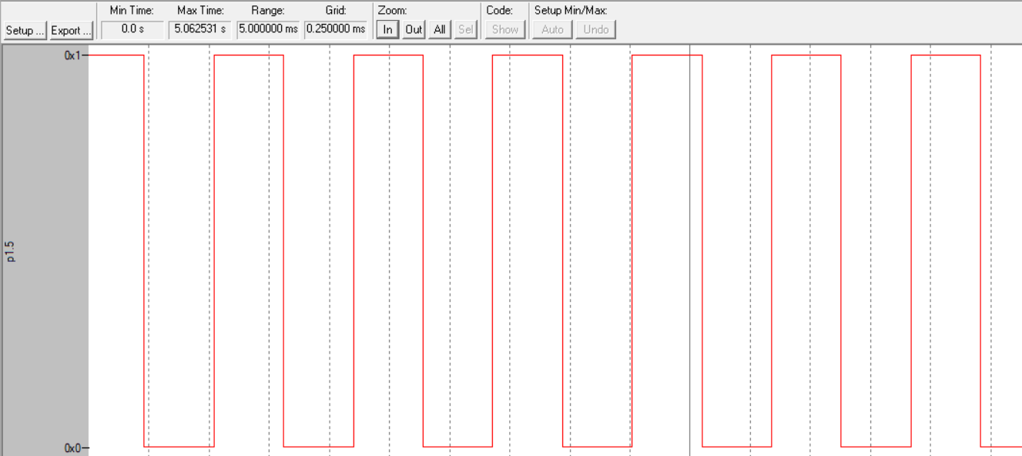

Mode 2

After execution

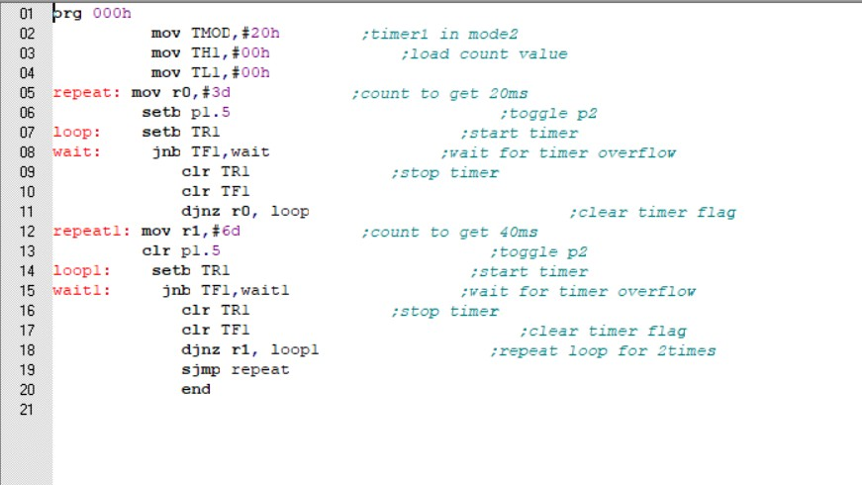

- WAP to generate a rectangular wave with T(on)=20ms and T(off)=40ms. Use Timer0 in mode0, mode1 and mode2 to generate delay.
Mode 0

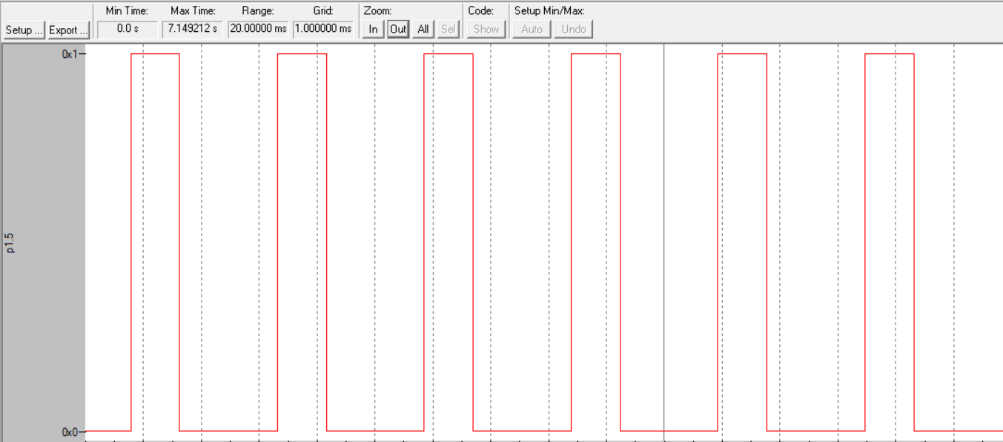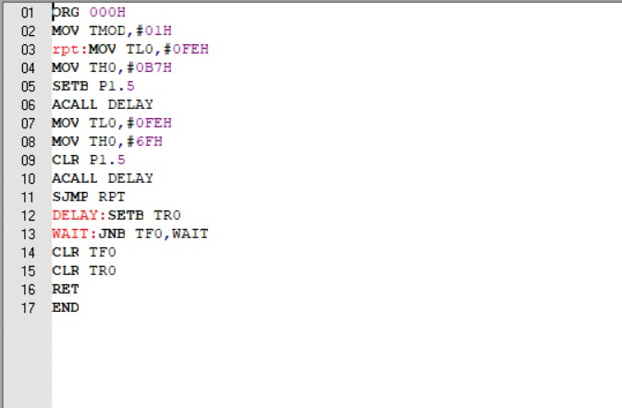

After Execution:

Mode 1

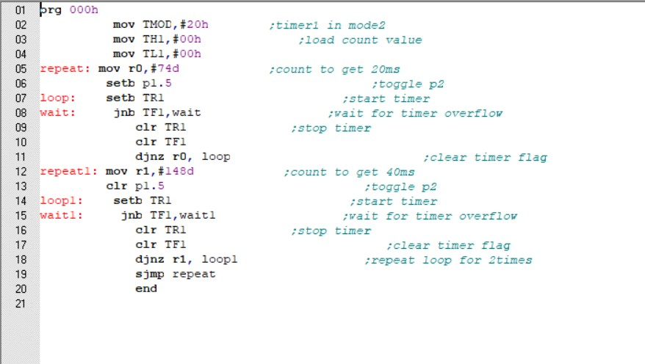

After execution

Mode 2
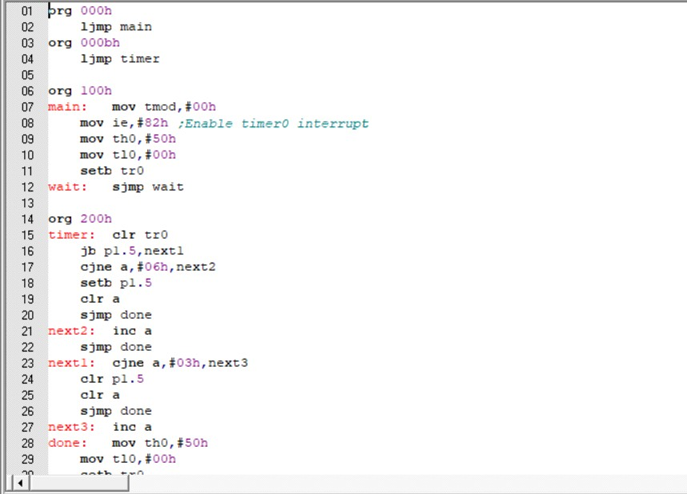

- Repeat above problems to generate square wave with interrupts for timers
Mode 0

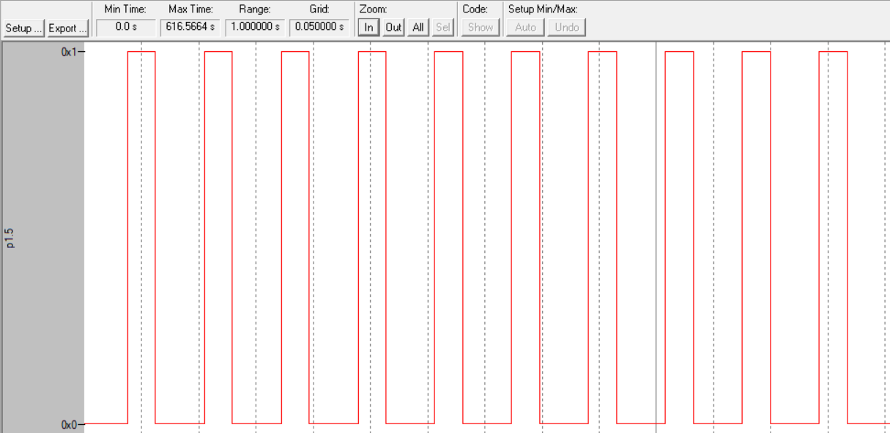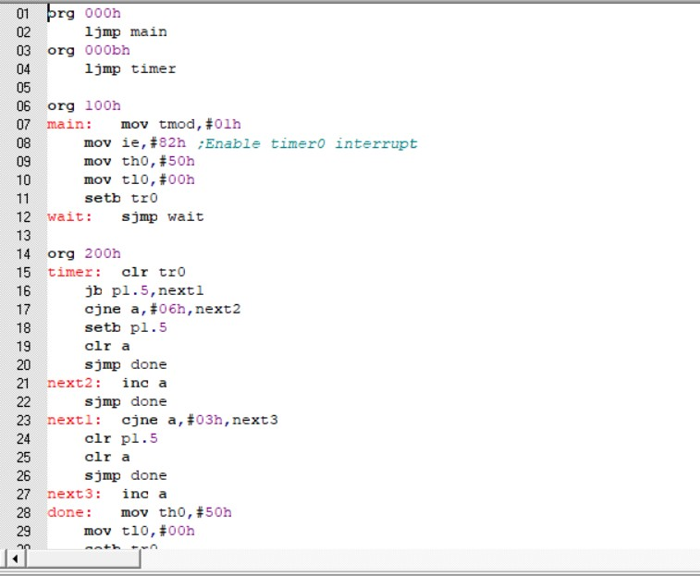

After execution

Mode 1

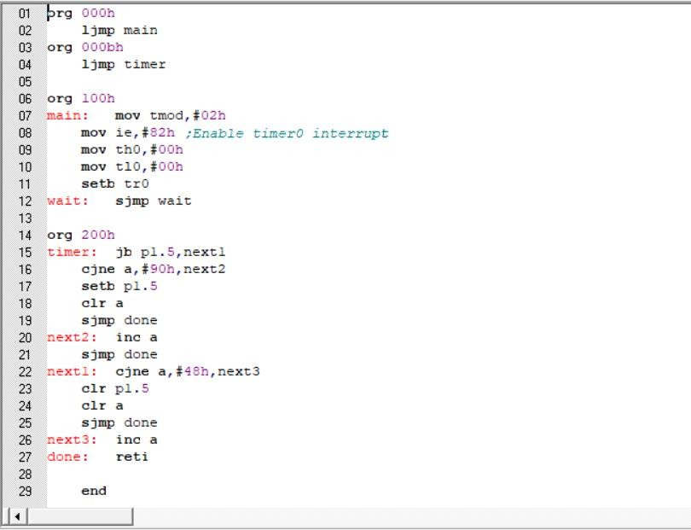

After execution

Mode 2

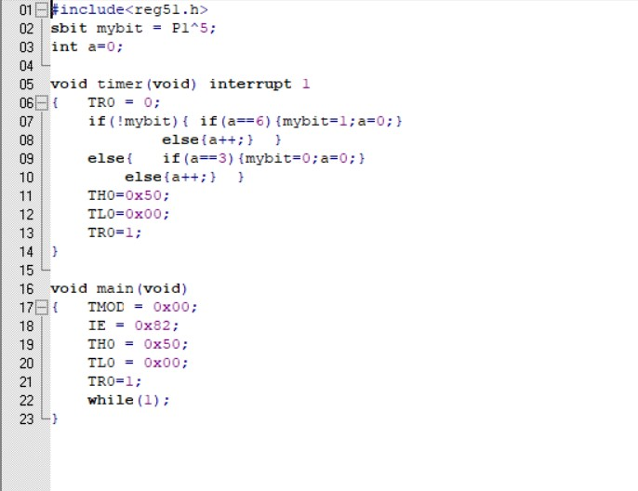

After execution

- Repeat above problems of status check and interrupt methods to generate square wave using embedded c programs.
Mode 0 using interrupt

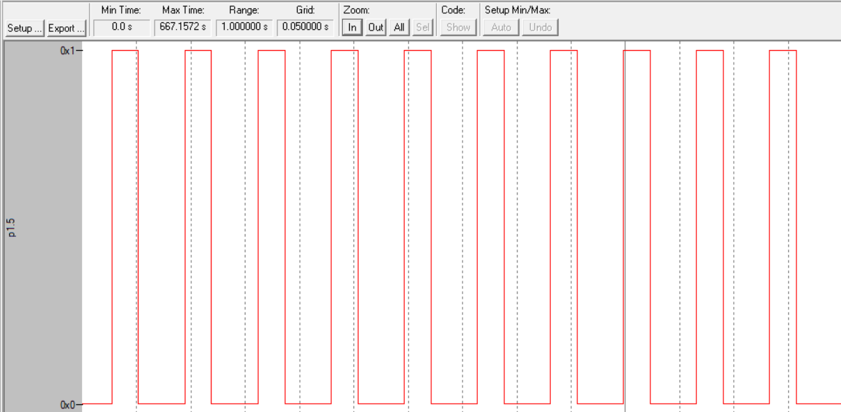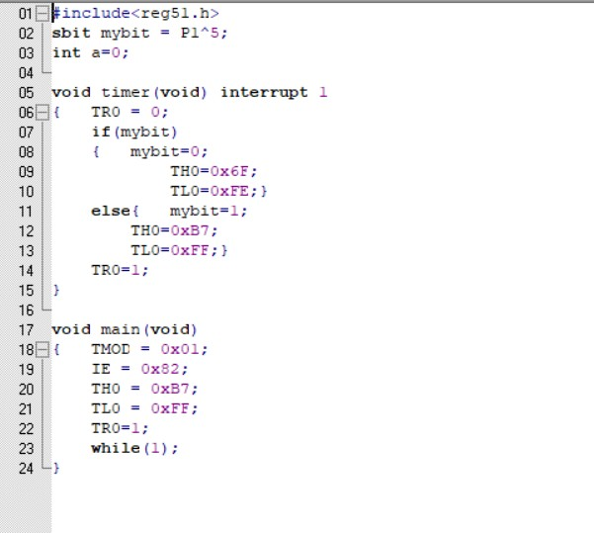

After execution

Mode 1 using interrupt

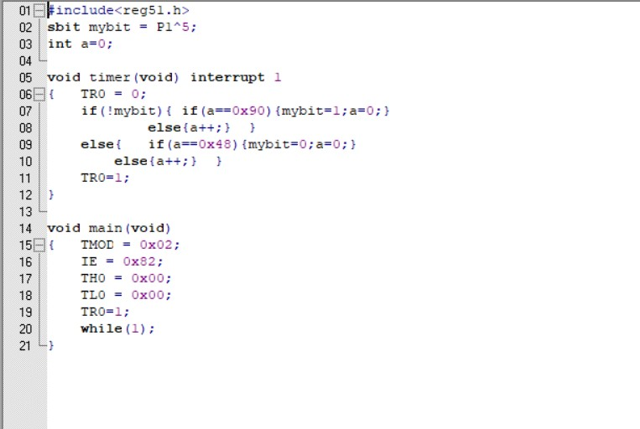

After execution

Mode 2 using interrupt

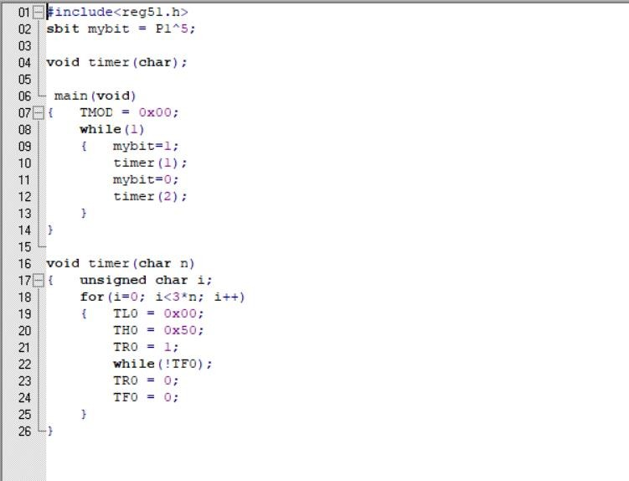
After execution

Mode 0 using status check

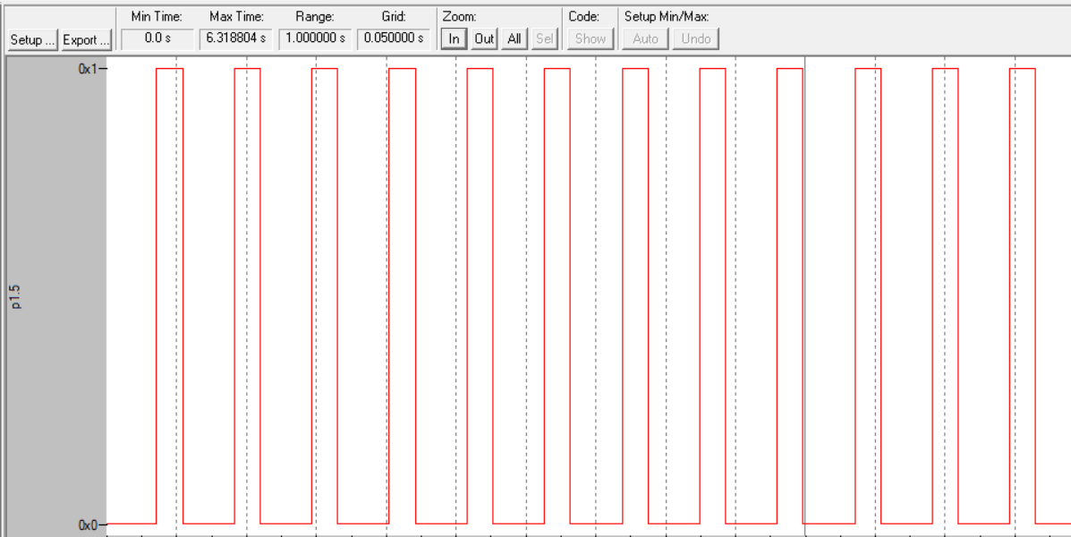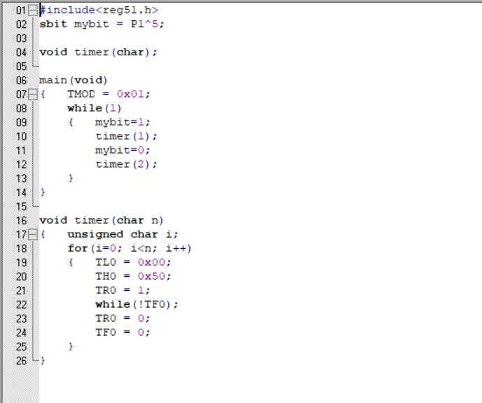

After execution

Mode 1 using status check

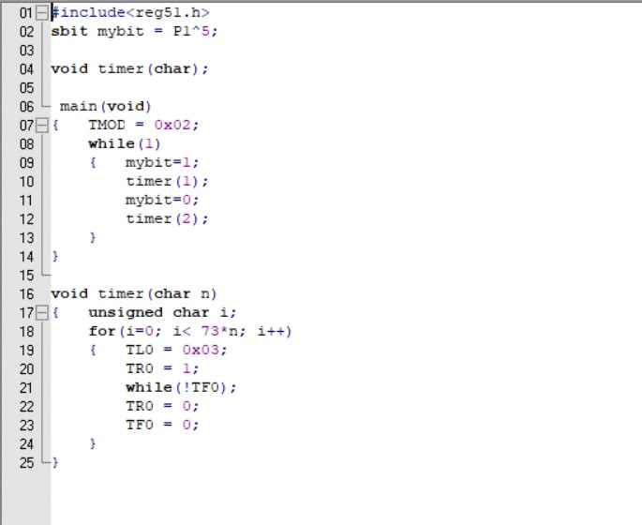

After execution

Mode 2 using status check

After execution

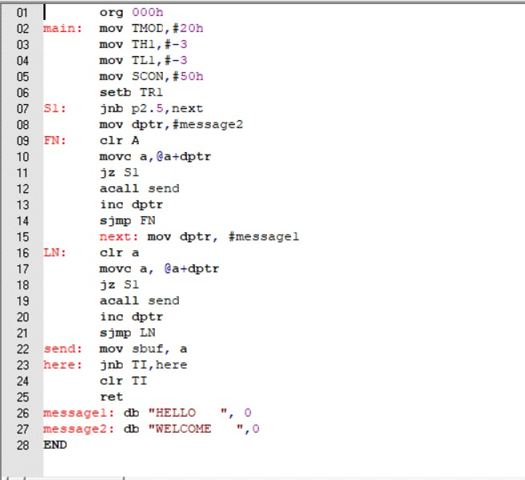

SET 8 PROGRAMS

  - A switch is connected to P2.5. write an 8051 assembly level program to read the status of switch and if switch is closed send serially "HELL0', else send WELCOME' at baud rate 9600.

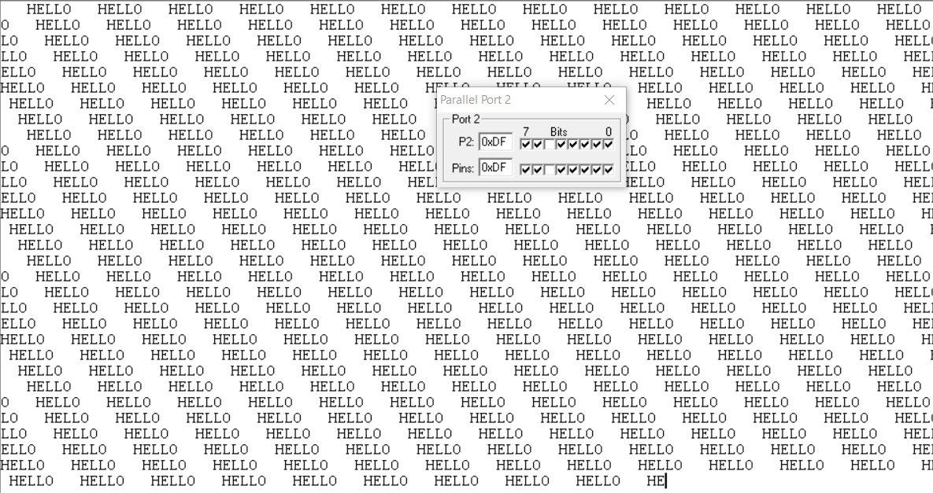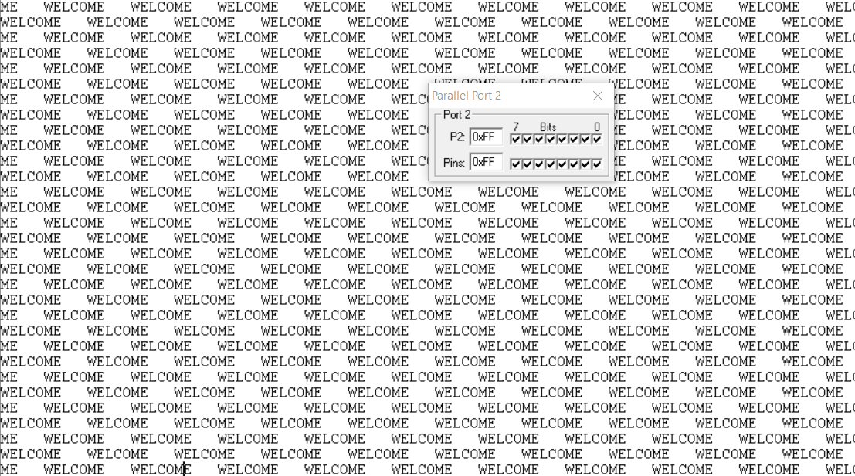

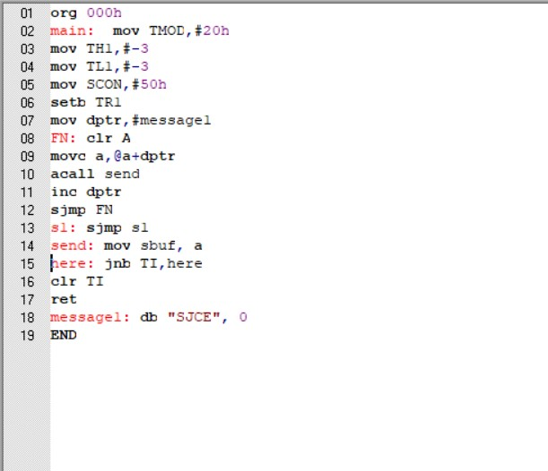
2.Write an 8051 assembly level program to transfer a message SJCE serially by programming serial1 communication in interrupt mode with baud rate 9600.

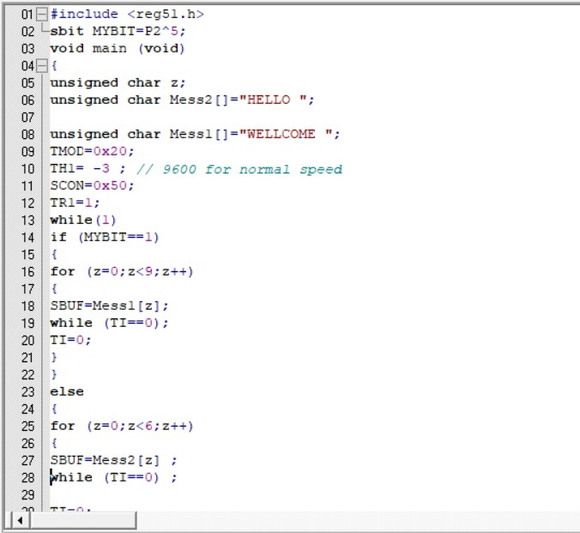

Repeat the problem 1 & 2 using embedded C program. Problem 1

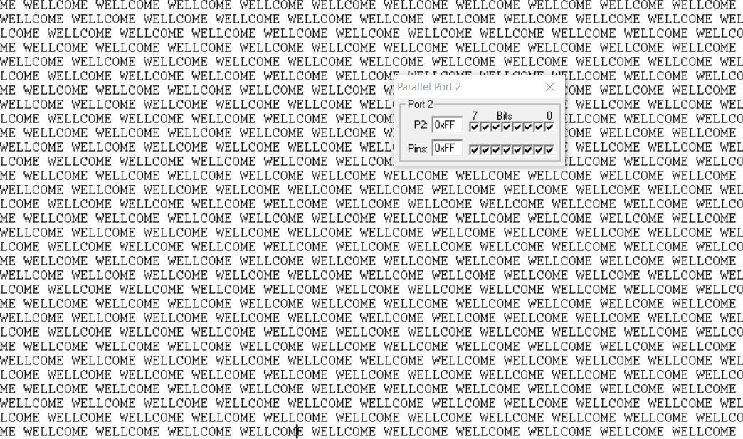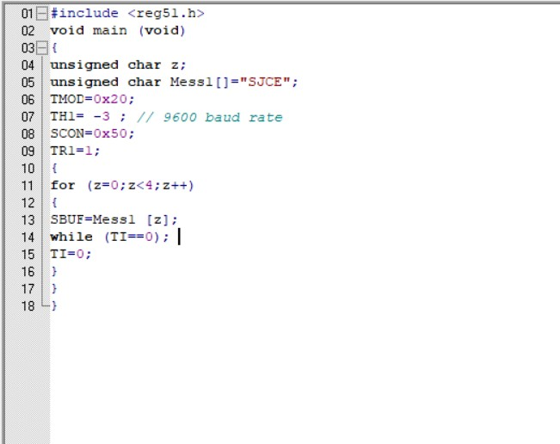

Problem 2



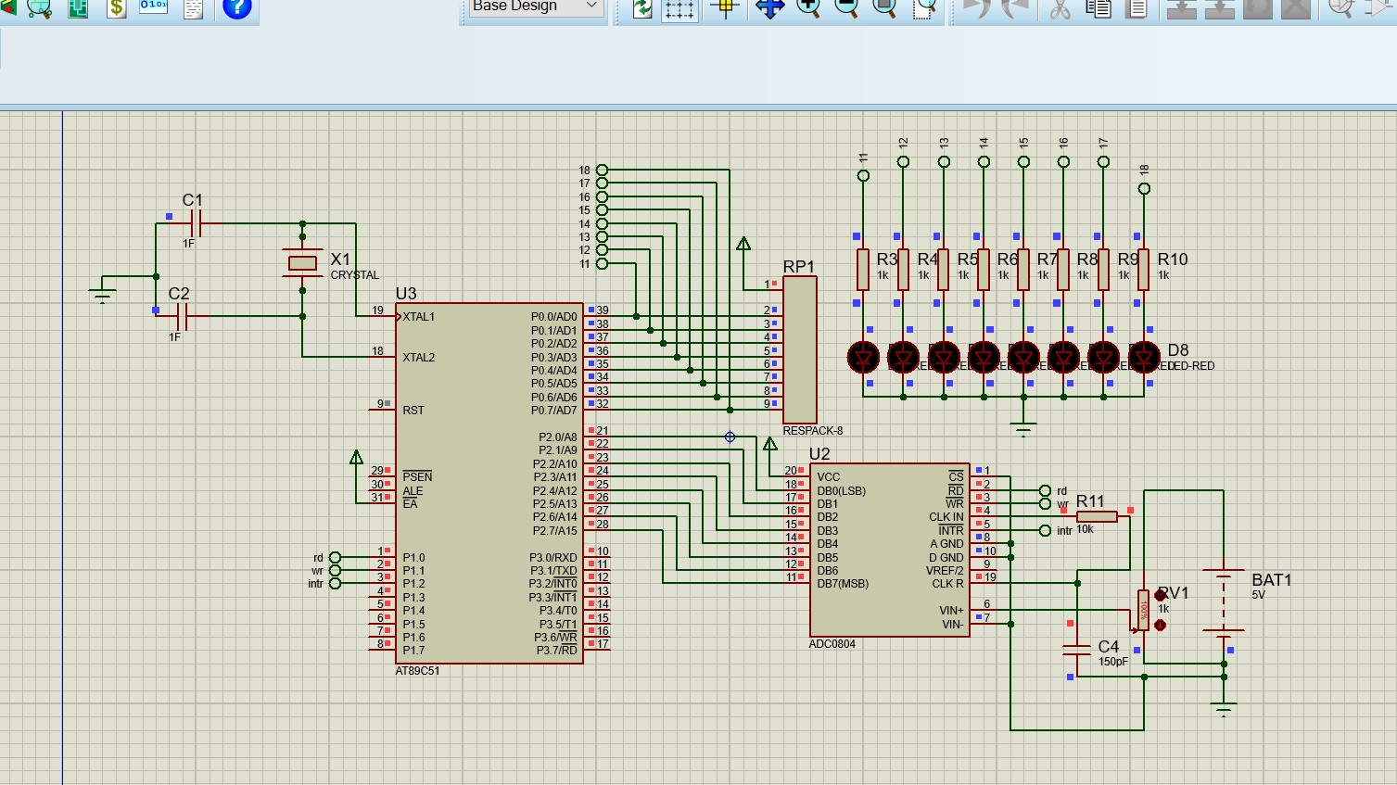 HARDWARE EXPERIMENT

Question Number - 1
Interface a Multichannel ADC to 8051 and develop a program to read the analog data, Convert into digital value and display the digitized value on port 0 connected to leds
Circuit Diagram :

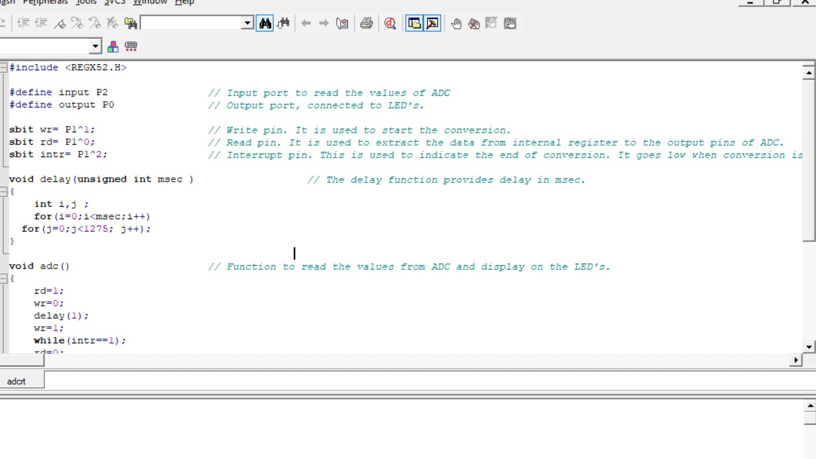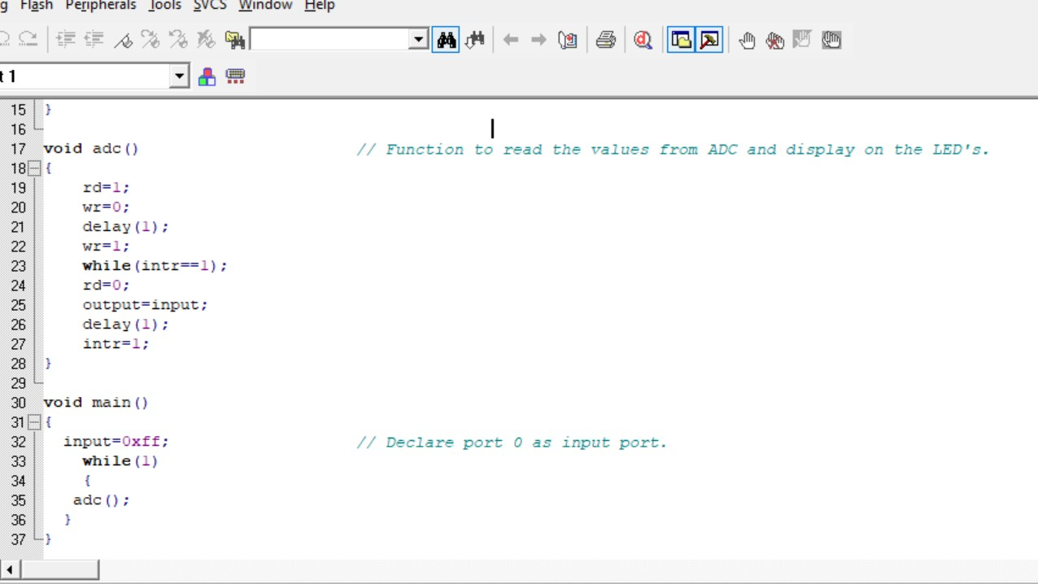

Program

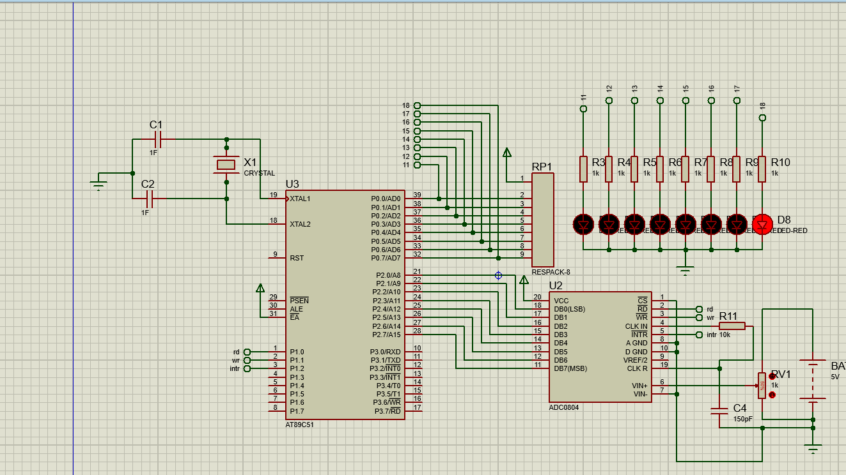

Result :

For the analog voltage of 2.5 volts output is 10000000

LCD interface

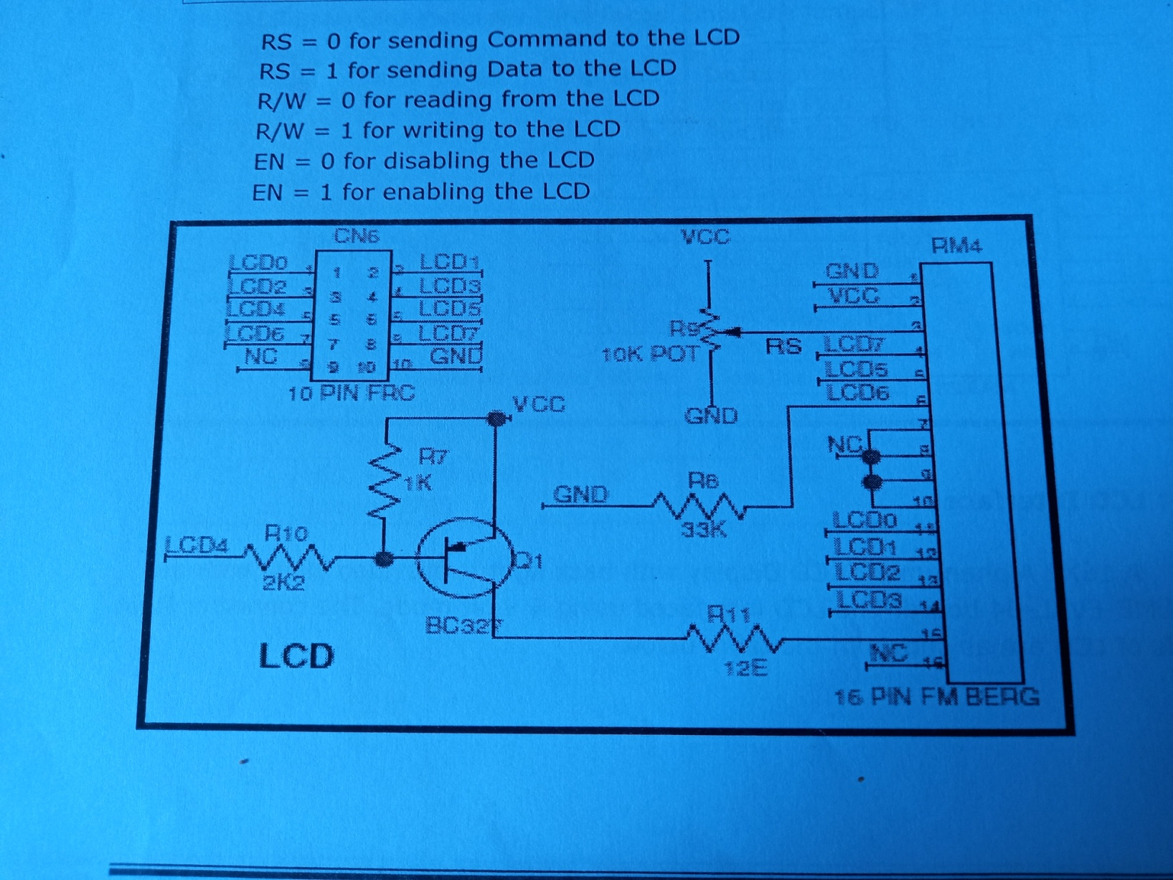

LCD routine:

/* LCD related functions. */
#include "at89c51ed2.h"
#include <intrins.h> //For _nop_();

// LCD FUNCTION PROTOTYPE

extern void lcd_comm(void);
extern void wr_cn(void);
extern void wr_dn(void);
extern void lcd_data_cmnd(char, char);
void delay(int);

extern unsigned char temp1;
extern unsigned char temp2;
unsigned char var;

void lcd_init(void)
{
temp1 = 0x30; // D5(P3.3)=1,D4(P3.2)=1
wr_cn();
delay(500);

temp1 = 0x30; // D5(P3.3)=1,D4(P3.2)=1
wr_cn();
delay(500);

temp1 = 0x30; // D5(P3.3)=1,D4(P3.2)=1
wr_cn();
delay(500);

temp1 = 0x20; // D5(P3.3)=1
wr_cn();
delay(500);

temp1 = 0x28; // Set
lcd_comm();
delay(500);

temp1 = 0x0f; //display on, cursor on, cursor blinking
lcd_comm();
delay(500);

temp1 = 0x06; //shift cursor right with auto increment
lcd_comm ();
delay (500);

temp1 = 0x80; //clear display with cursor on first position
lcd_comm ();
delay (500);

temp1 = 0x01;
lcd_comm ();
delay(500);
}

// Function to pass commands to LCD
void lcd_comm(void)
{
var = temp1;
temp1 = temp1 & 0xf0;
temp1 = temp1 >> 4;

wr_cn ();

temp1 = var & 0x0f;
wr_cn ();

delay (60);
}

// Function to pass data to LCD
Void lcd_data (void)
{
var = temp2;
temp2 = temp2 & 0xf0; // convert the byte into nibble
temp2 = temp2 >> 4;
wr_dn();

temp2 = var & 0x0f;
// temp2 = temp2 << 2;
wr_dn();

delay(60);
}

// Function to write to command reg of LCD
void wr_cn(void)
{
temp1 = temp1 & 0x7f; // RS(P3^7)=0
temp1 = temp1 & 0xDF;
temp1 = temp1 | 0x40; // EN(P3^6)=1, TXD(P3^1)=1, RXD(P3^0)=1

P2 = temp1;

_nop_();
_nop_();
_nop_();
_nop_();
_nop_();

temp1 = temp1 & 0xbf; // EN(P3^6)=0,
P2 = temp1;

}

// Function to write to data reg of LCD
void wr_dn(void)
{
temp2 = temp2 | 0xc0; // RS(P3^7)=1,EN=1,TXD=1,RXD=1
temp2 = temp2 & 0xDF;
P2 = temp2;

_nop_();
_nop_();
_nop_();
_nop_();
_nop_();

temp2 = temp2 & 0xbf; // EN = 0
P2 = temp2;
}

// Function to clear the LCD display
/*void clear_lcd()
{
temp1 = 0x01;
lcd_comm();
delay(500);
}
*/
void delay(int count)
{
int i;

for(i=0;i<count;i++);
}
/*
void lcd_data_cmnd(char cmnd, char l_data)
{
char check;

check =cmnd;
var = l_data;

l_data = l_data & 0xf0;
temp1 = l_data >> 2;
if(check == 1)
wr_cn();
else if(check == 2)
{
temp2 = temp1;
wr_dn();
}
l_data = var & 0x0f;
temp1 = l_data << 2;
if(check == 1)
wr_cn();
else if(check == 2)
temp2 = temp1;
wr_dn();

delay(60);
}

KEYBOARD INTERFACE:

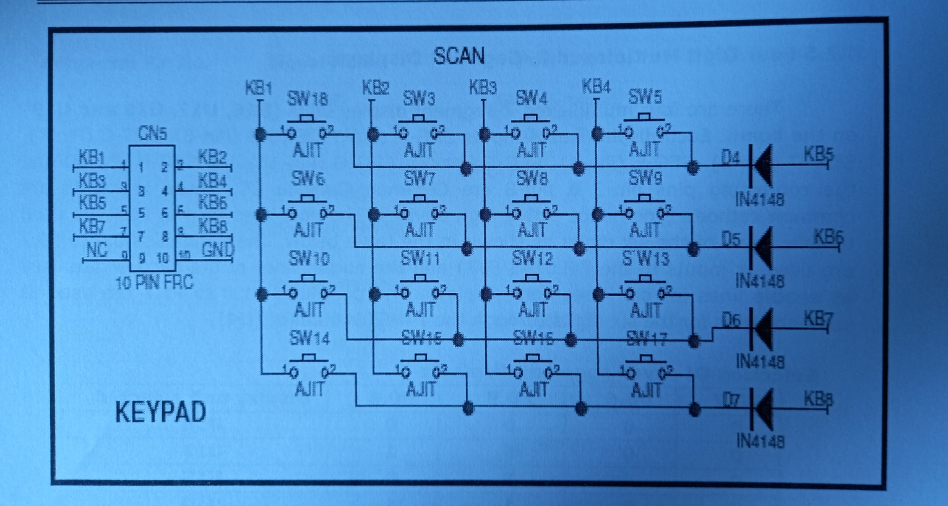/*

Program to demonstrate keyboard operation
Takes a key from key board and displays it on LCD screen*/

#include "at89c51xd2.h"

// This project includes the following files:
// 1. kbdisp.c the source program to keypad
// 2. LCD_routine.c to display the key read

void scan(void);
void get_key(void);
void display(void);
void delay_ms(int i);
void uart_init(void);

/******* LCD FUNCTION PROTOTYPE*******/
void lcd_init(void);
void lcd_comm(void);
void lcd_data(void);
void clear_lcd(void);
void delay(int);

unsigned char temp1=0x00;
unsigned char temp2;

idata unsigned char row,col,key;

unsigned char scan_code[16]={0xEE, 0xDE, 0xBE, 0x7E,
0xED, 0xDD, 0xBD, 0x7D,
0xEB, 0xDB, 0xBB, 0x7B,
0xE7, 0xD7, 0xB7, 0x77 };

unsigned char LED_CODE[16]= {0x3f,0x66,0x7f,0x39,
0x06,0x6d,0x6f,0x5e,
0x5b,0x7d,0x77,0x79,
0x4f,0x07,0x7c,0x71};

unsigned char LCD_CODE[16] = {'0','4','8','C',
'1','5','9','D',
'2','6','A','E',
'3','7','B','F' };

idata unsigned char temp,temp4,temp3,res1,flag,result=0x3F;
/* in this key pad program keypad lines are not kept high .we will make them high
low throgh writing data to port.*/
void main ()
{
lcd_init();

while(1)
{
get_key();
display();
P3 = 0xFF;
}
} //end of main()

void get_key(void) // get_key() function calls scan() function
{ // on sensing a key from scan() function it
int i; // will compare the received scan code with
display(); // scan code lookup table and returns ASCII code
flag = 0x00; // rows are read from Port P0 is scan() function
while(flag == 0x00) // this function is in an eternal loop
// wiil return to main() only after getting a key
{
for(row=0;row<4;row++) // This for loop makes the one of the ROW low at
{ // one time .Then scan function is called
if( row == 0)
temp3=0xFE;
else if(row == 1)
temp3=0xFD;
else if(row == 2)
temp3=0xFB;
else if(row == 3)
temp3=0xF7;
P0 = temp3; // each time temp3 value is put into this
scan();
delay_ms(10); // on sensing a key scan() function will make flag = 0xff
if(flag == 0xff)
break;
} // end of for

if(flag == 0xff)
break;
} // end of while

P3 = 0x00; // Enable U21
for(i=0;i<16;i++) // in this for for loop scan code received which is in res1
{ // variable is compared with
if(scan_code[i] == res1) // the lookup table for array scan code[] and when a match is
// found will return the correspoding led code for the key pressed
{
temp1 = 0x87;
lcd_comm();
temp2 = LCD_CODE[i];
lcd_data();
result = LED_CODE[i];
break;
}

}
} // end of get_key();

void scan(void) // will return the scan code for the key pressed
{ // Both row lines and column lines are connected to
unsigned char t; //Port 0 only.Columns are connected to P0.0-P0.3
temp4 = P0; // P0.4-P0.7 are connected to rows
temp4 = temp4 & 0xF0; //read port0 ,mask with 0xF0h

if(temp4 != 0xF0) // Means a key is sensed
{
delay_ms(30);
delay_ms(30); // give some delay for debouncing

temp4 = P0; // read the port again
temp4 = temp4 & 0xF0;

if(temp4 != 0xF0) // debounce
{
flag = 0xff; // set the flag denoting a key is received
res1 = temp4;
t = temp3 & 0x0F;
res1 = res1 | t; // and OR it with column value
} // to get the scan code of the key pressed
else
{
flag = 0x00;
}

}
}

// end of scan()

void display(void)
{
P1 = result;
}

void delay_ms(int i)
{
int j;
for(j=0;j<i;j++);
}

DAC INTERFACE:
- Interfacing DAC with 8051 and developing an algorithm to generate the following outputs
  - Square wave with 50% duty cycle
  - Square wave with 75% duty cycle
  - Triangle wave.
  - Ramp(+ve &-ve)
  - Sine wave
  - Staircase
  - Staircase triangle

Solution:

Interfacing Circuit:

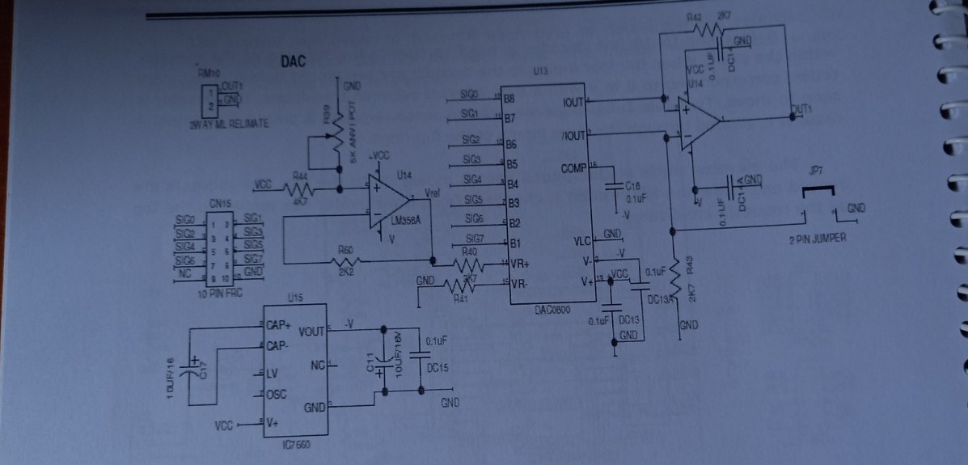

Generation of square wave with 50%duty cycle.

- Solution:

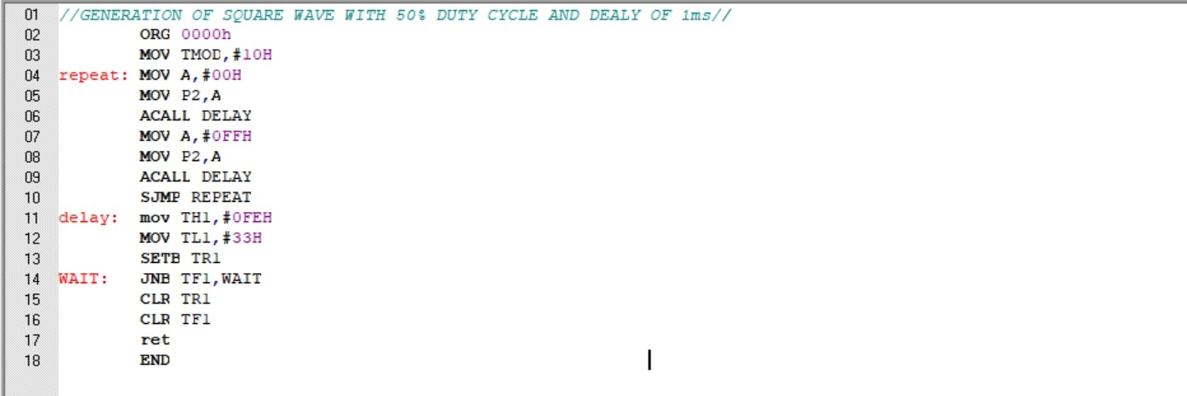

RESULT:

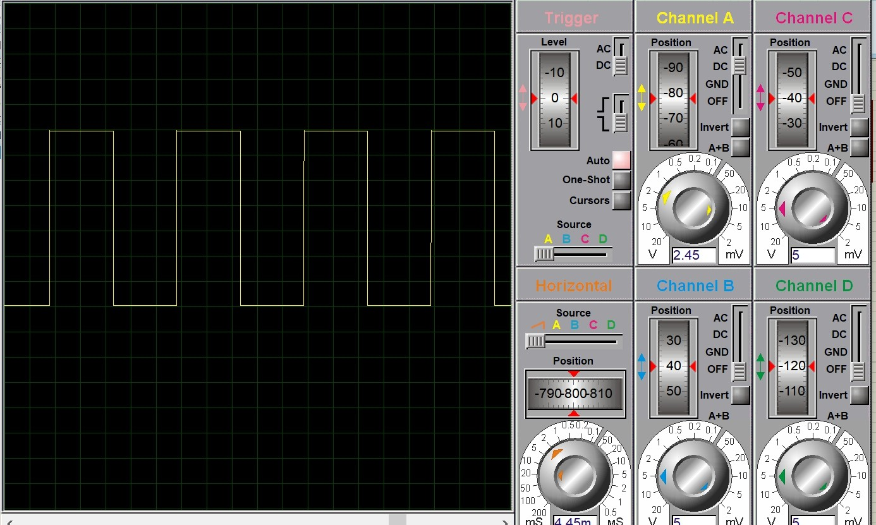

2.Generation of square wave with 75%duty cycle.

- Solution:
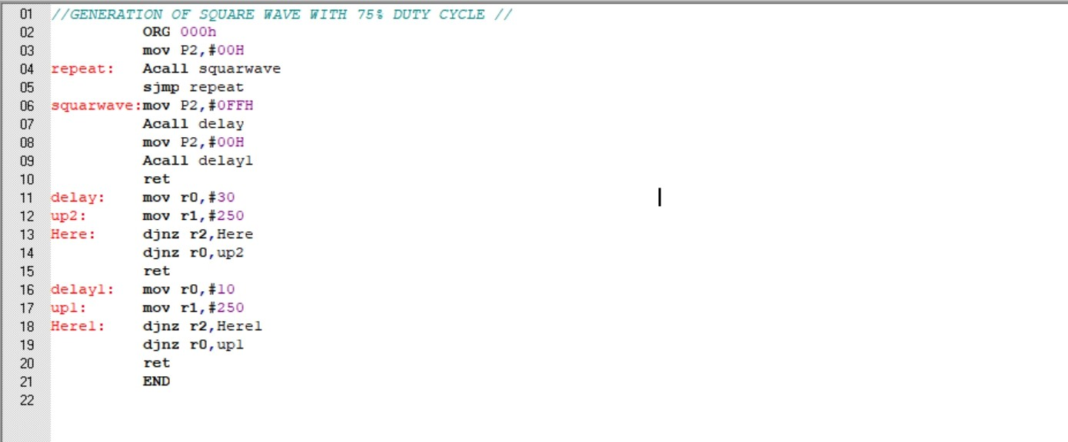

RESULT:

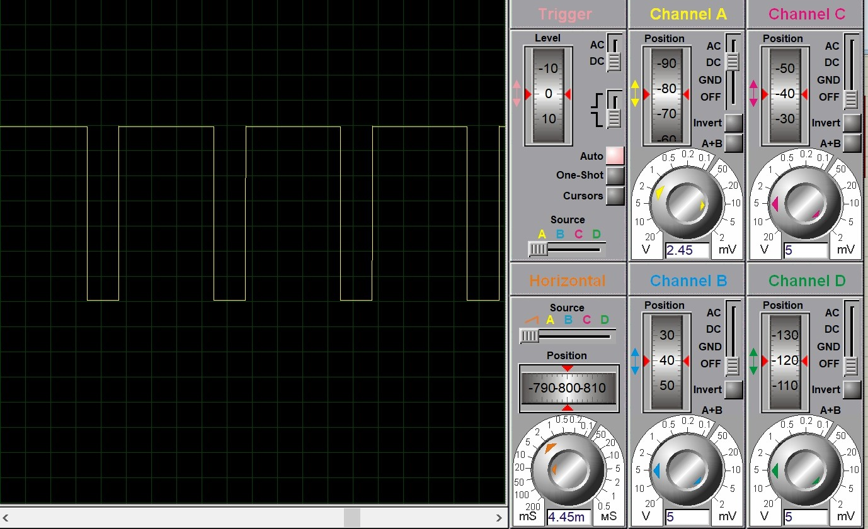

Generation of Triangular wave.
  - ALGORITHM
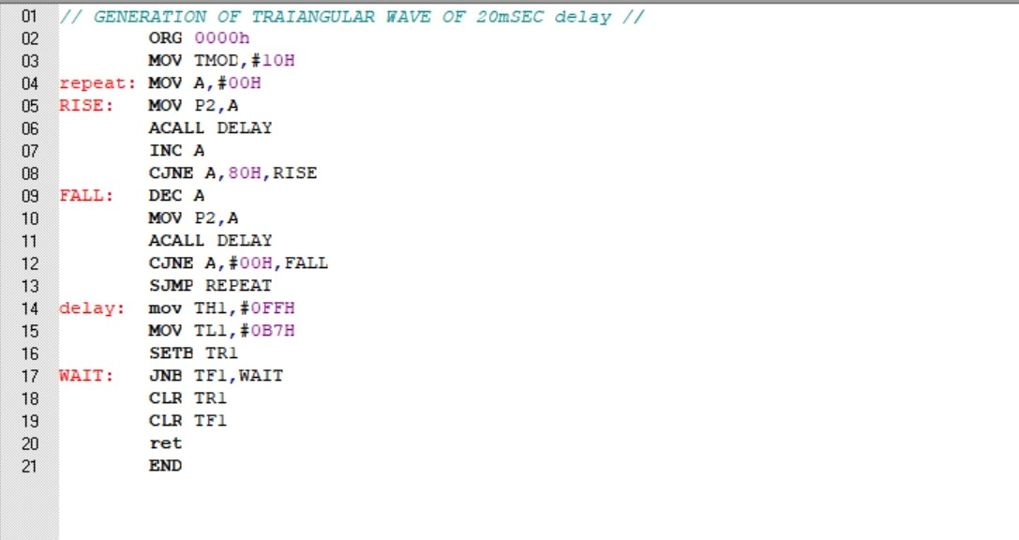
RESULT:

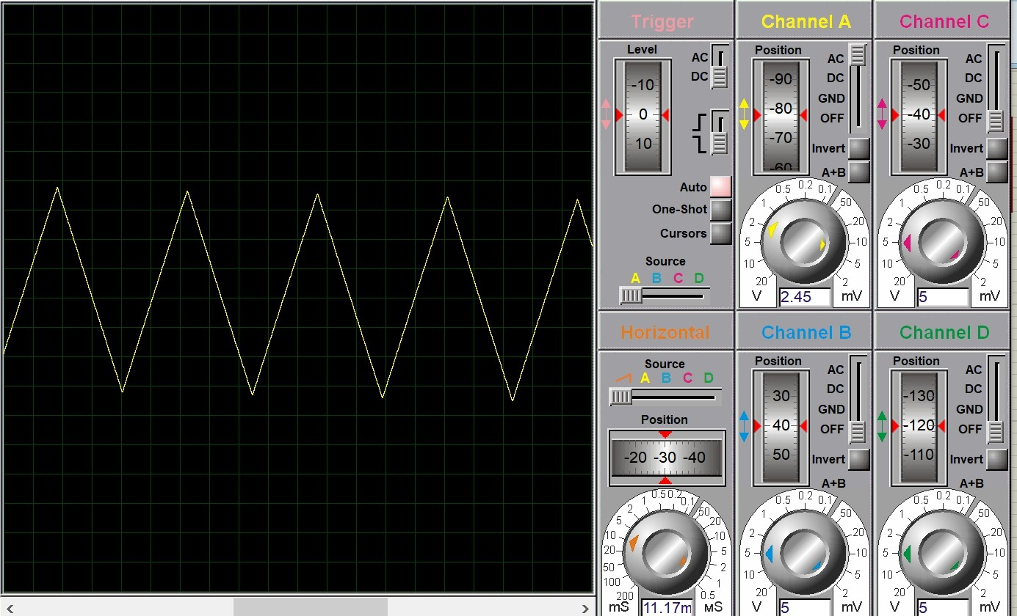

A. Generation of positive Ramp with signal.

- ALGORITHM

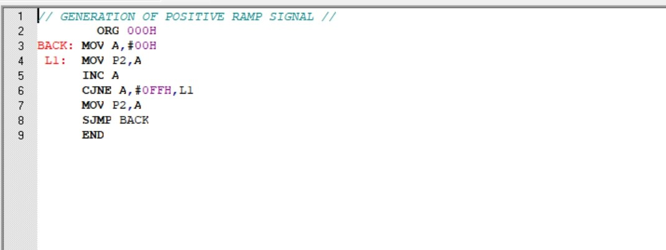

RESULT:

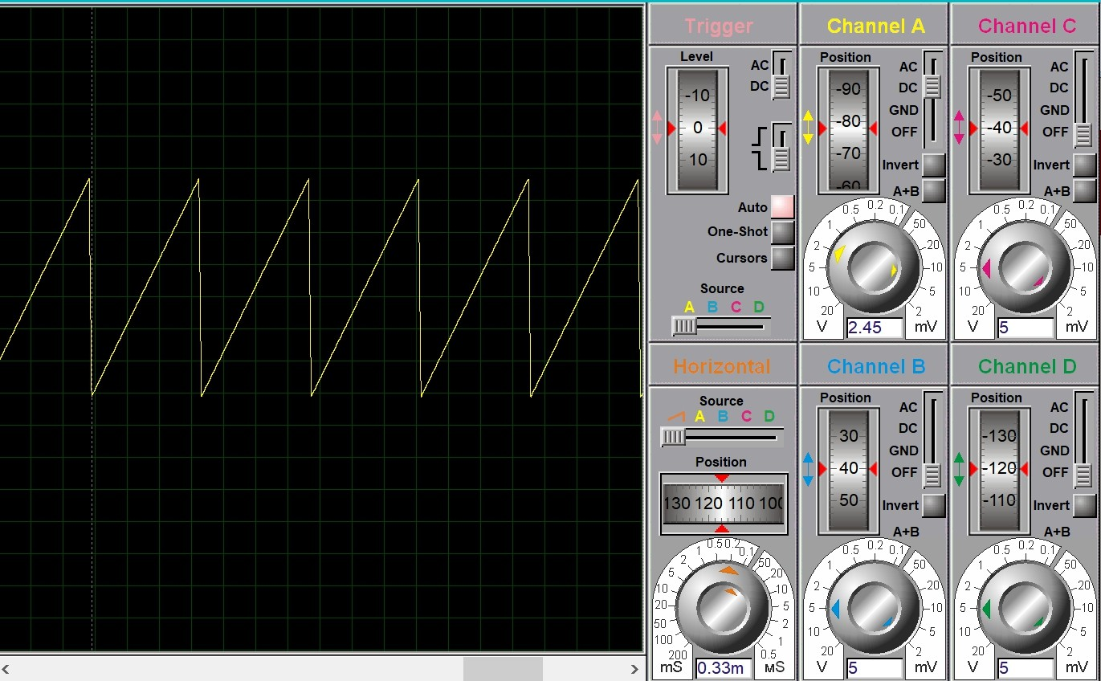

B. Generation of negative Ramp with signal.
- ALGORITHM

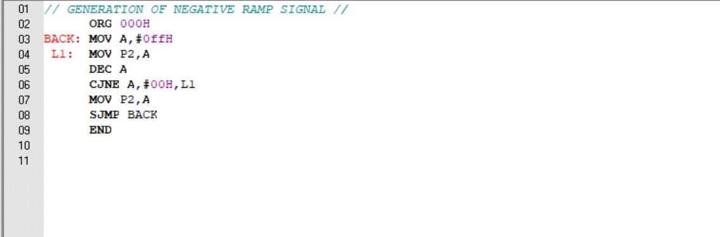

RESULT:

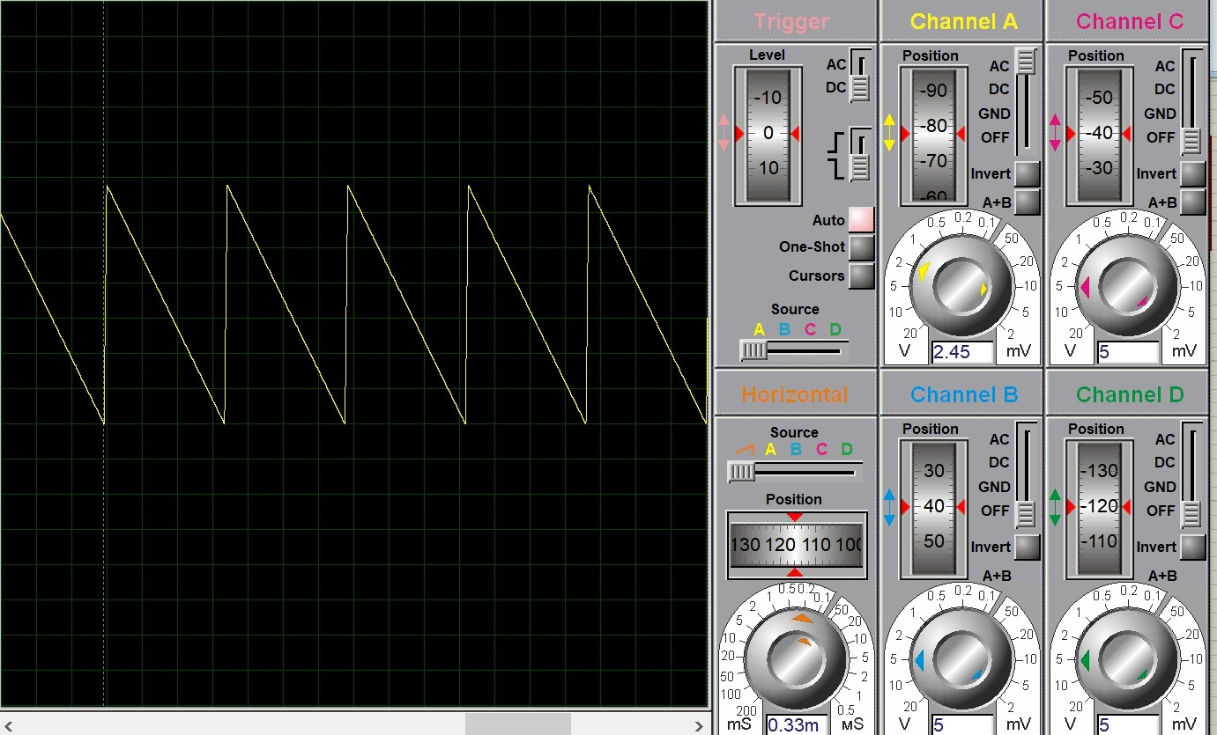

- GENERATION OF SINE WAVE
- ALGORITHM

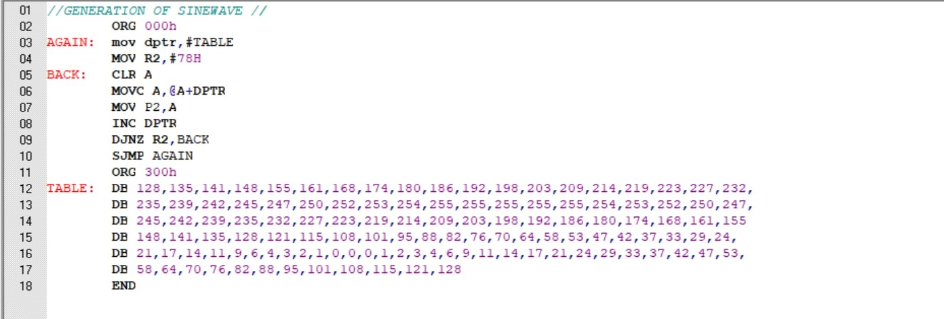

RESULT

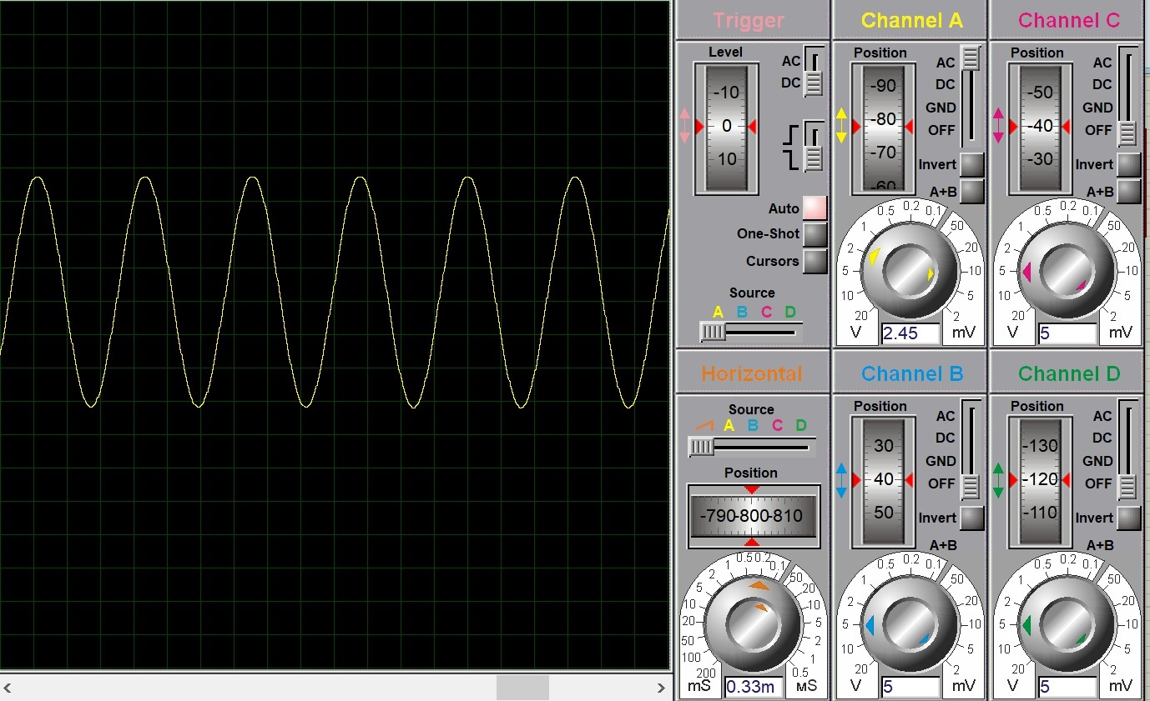

Generation of the following waveform.

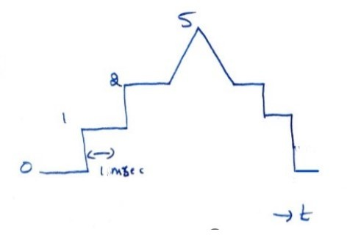

- ALGORITHM
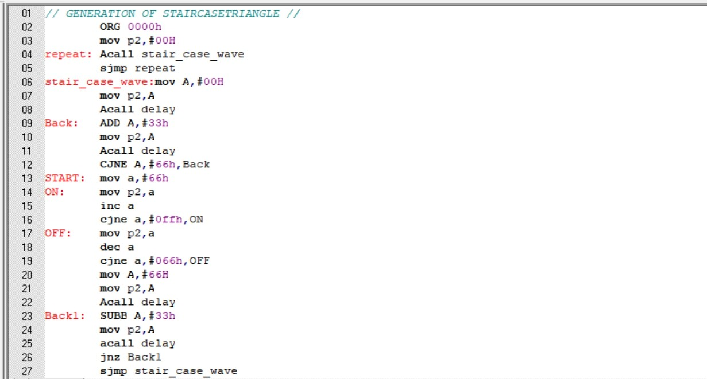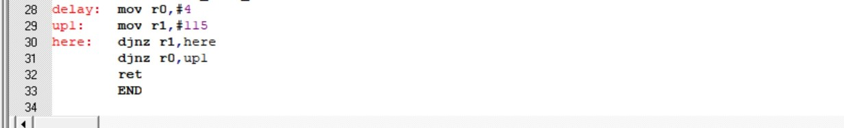

RESULT

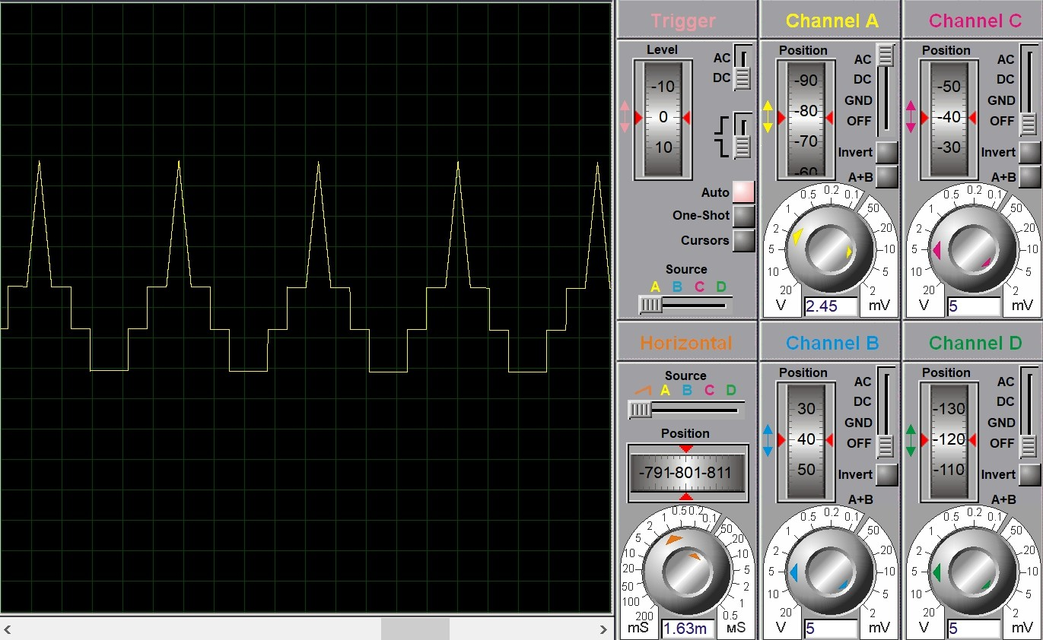

Assignment question:
1. Write an 8051 ALP to send message HELLO serially once in every 2 sec. Program timer and serial communication in interrupt mode

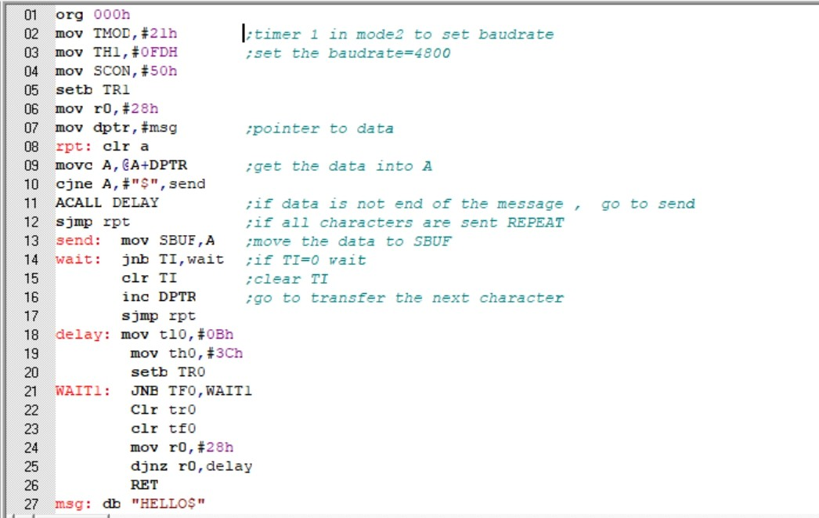

RESULT:

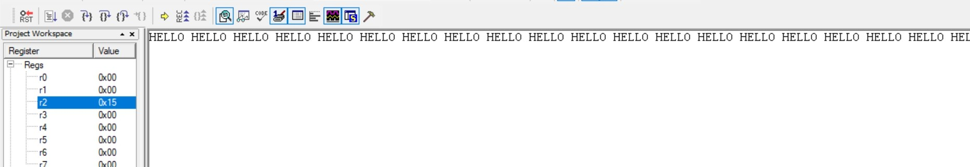

END

