JSS MAHAVIDYAPEETHA
JSS SCIENCE AND TECHNOLOGY UNIVERSITY
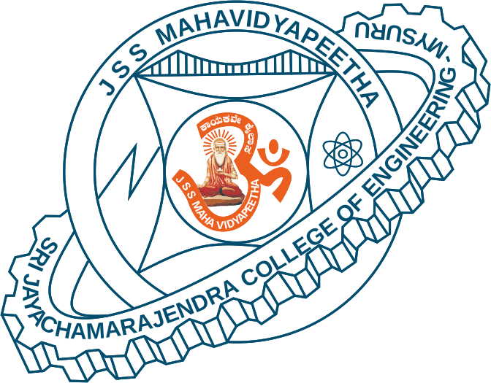
SRI JAYACHAMARAJENDRA COLLEGE OF ENGINEERING


- Constituent College of JSS Science and Technology University
- Approved by A.I.C.T.E
- Governed by the Grant-in-Aid Rules of Government of Karnataka
- Identified as lead institution for World Bank Assistance under TEQIP Scheme

Department of Electronics and Communication Engineering
Department Advisory Board -2020

Sl. No. | Name of the Members | Designation
1. | Dr. M. N Jayaram | Associate Professor and Head,  ECE Department, SJCE – Mysuru. | Internal Member
2. | Dr. Shankaraiah | Professor, ECE Department,  SJCE – Mysuru. | Internal Member
3. | Dr. U B Mahadevaswamy | Professor, ECE Department,  SJCE – Mysuru. | Internal Member
4. | Dr. Sudarshan Patil Kulkarni | Professor, ECE Department,  SJCE – Mysuru. | Internal Member
5. | Dr. S Gayathri | Associate professor, NBA Coordinator  ECE Department, SJCE – Mysuru. | Internal Member
6. | Dr. Maheshappa H D | Principal, Acharya Institute Of Technology, Bangalore Urban. | External Member
7. | Dr. Muralidhar Kulkarni | Professor, Dept. of ECE,  NITK Suratkal. | External Member
8. | Dr. K. N Muralidhar | Professor, Dept. of ECE,  PESCE Mandya | External Member

