JSS MAHAVIDYAPEETHA
JSS SCIENCE AND TECHNOLOGY UNIVERSITY
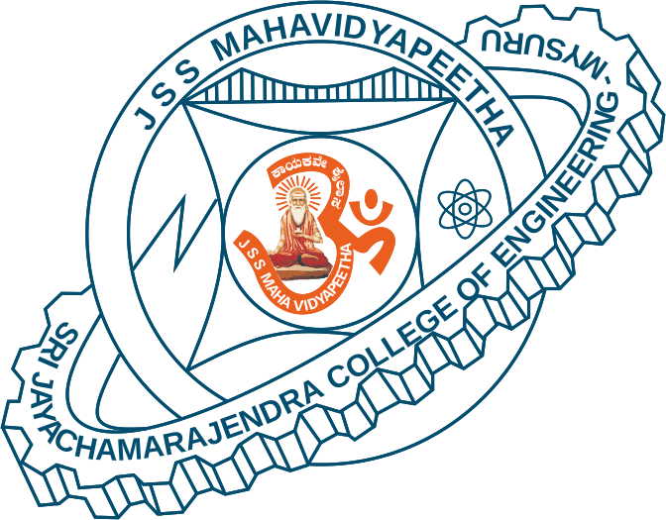
SRI JAYACHAMARAJENDRA COLLEGE OF ENGINEERING


- Constituent College of JSS Science and Technology University
- Approved by A.I.C.T.E
- Governed by the Grant-in-Aid Rules of Government of Karnataka
- Identified as lead institution for World Bank Assistance under TEQIP Scheme

Department of Electronics and Communication Engineering
Department Advisory Board
Sl. No. | Name of the Members With Designation | Category
1. | Dr. M. N Jayaram  Associate Professor and Head, ECE Department, SJCE – Mysuru. | Internal Academician Chairman
2. | Prof. Halesh M R  Assistant Professor, ECE Department,  SJCE – Mysuru. | Internal Academician Convener
3. | Dr. Bindu A. Thomas  Professor and Head,  ECE Department - Vidya Vikas Institute of Engineering and Technology Mysore, Karnataka.  Ph: 9341888801  e-Mail: binduvviet@gmail.com | External Academician
4. | Dr. Parameshwara S  Assistant Professor,  ECE Department, NIE Mysore.  Ph: 9731139739  e-Mail: param2004@nie.ac.in, parameshwara_nie@yahoo.co.in | External Academician
5. | Dr K A Radhakrishna Rao  Professor, Dept. of ECE,  PESCE Mandya.  Ph: 9886064102  e-Mail: karkrao@gmail.com | External Academician
6. | Sri. Srinivasarao Udara  Assistant Professor, Dept. of ECE,  S T J Institute of Technology  Ranebennur.  Ph: 6361679489  e-Mail: dsrudara@gmail.com | External Academician
7. | Kiran Marathe  Founder at Deshila Technology Research Institute, SJCE-STEP, JSS Technical Institutions Campus,  Manasagangothri, Mysuru, Karnataka 570006,  e-Mail: connect@dtri.in | Industry
8. | Akash Patil  Automotive Applications Engineer at Infineon Technologies. Bangalore | Alumni
9. | Dr. Shankaraiah Professor, ECE Department,  SJCE – Mysuru. | Internal Academician Member
10. | Dr. U B Mahadevaswamy Professor, ECE Department,  SJCE – Mysuru. | Internal Academician Member
11. | Dr. Sudarshan Patil Kulkarni Professor, ECE Department,  SJCE – Mysuru. | Internal Academician Member
12. | Dr. S Gayathri Associate Professor, ECE Department, SJCE – Mysuru. | Internal Academician Member
13. | Mr. Sanjay Tippannavar | Student

Dr. M. N Jayaram
HOD, E&CE

